1. From www.cse.buffalo.edu/~mikeb, download BotanicalWebDevelopment.zip and websites.zip, and extract them.
2. The BotanicalWebDevelopment folder goes into:
C:\Users\your name\Documents\Visual Studio 2015\Projects or
C:\Users\your name\Documents\Visual Studio 2017\Projects
3. The websites folder goes on your C drive. You should end up with
C:\websites\Website10 and
C:\websites\Website11
4. Locate the solutions file in the BotanicalWebDevelopment folder:
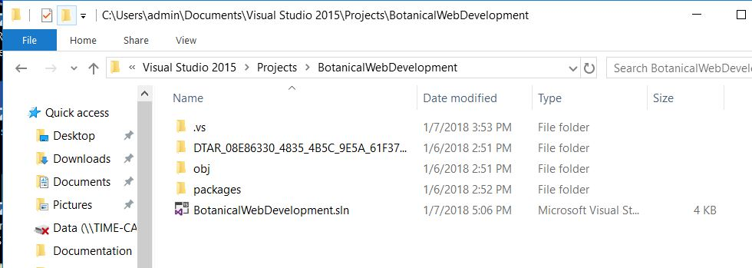
Double-click on it. Visual Studio will begin by opening our project. Note the RED selections below.
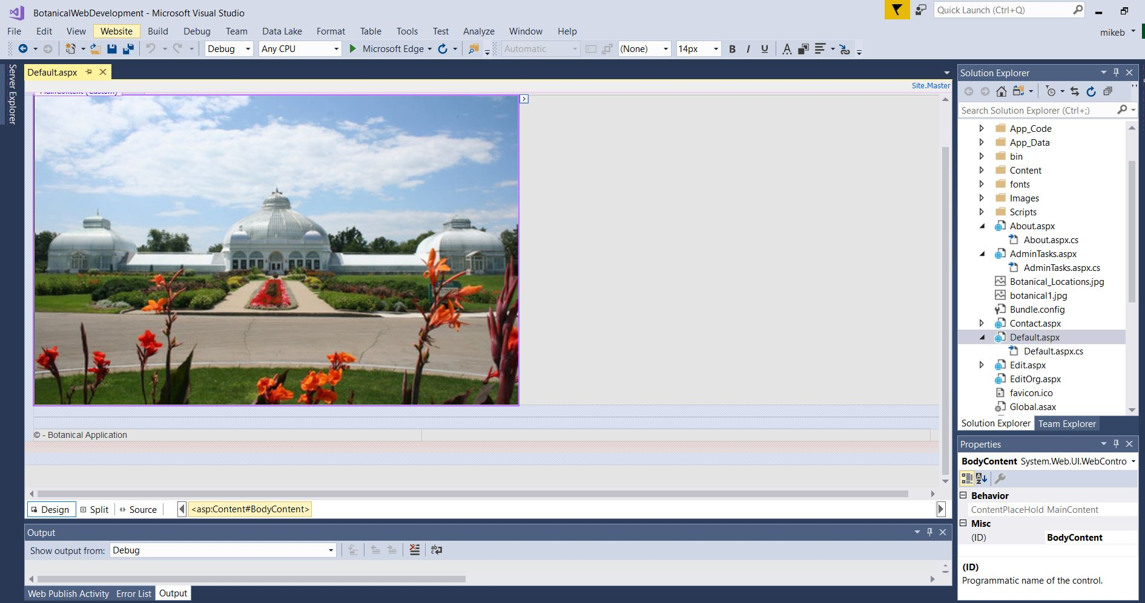
5. Locate the Default.aspx file, click on it to display it in the edit window (choose Design mode).
6. Under the Build main heading, select Build Solution. The project should successfully compile.
7. Select the green “play” button. Your browser should then display the project website. However, if you attempt to search the database, you will get an SQL error. There are some changes you need to make to the code.
The error may look something like this:
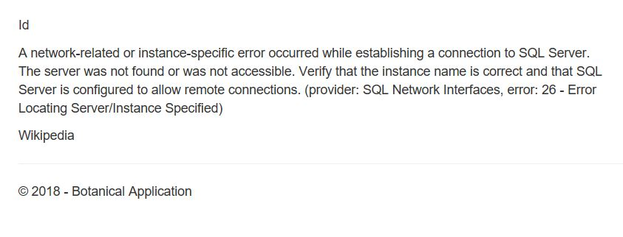
8. In the App_Code folder, edit GlobalVariables.cs. You need to change the name of the SQL server from my computer (MBUCKLEY16) to yours. Your SQL server name is the name of your laptop, found in Control Panel/System on your in your Windows10 Control Panel.

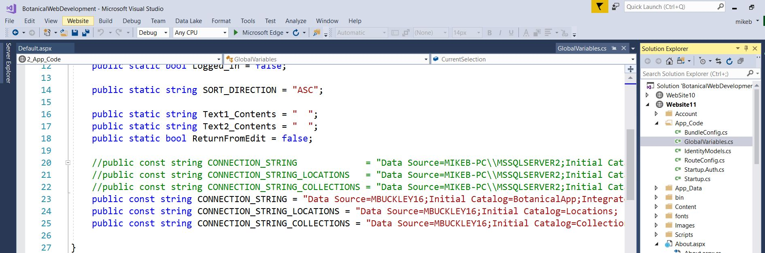

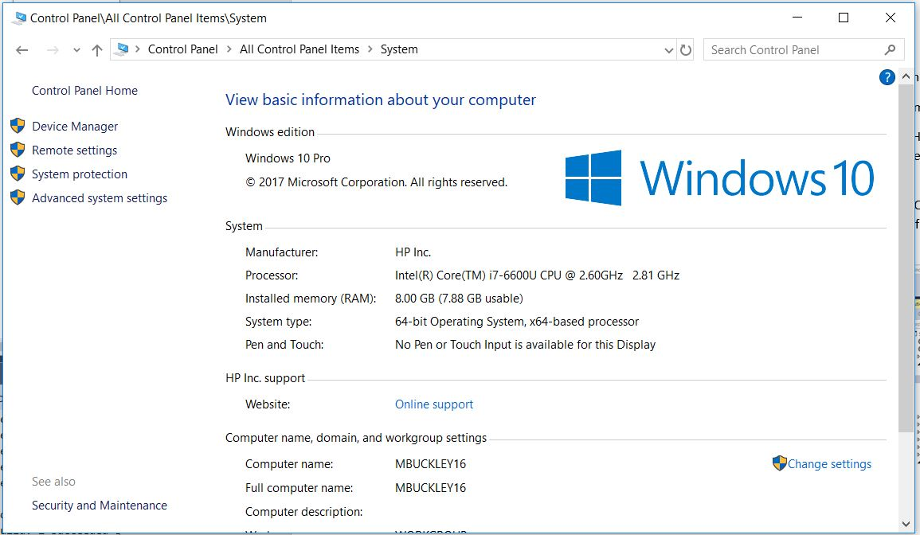

It also shows up when you start SQL Server Management Studio:
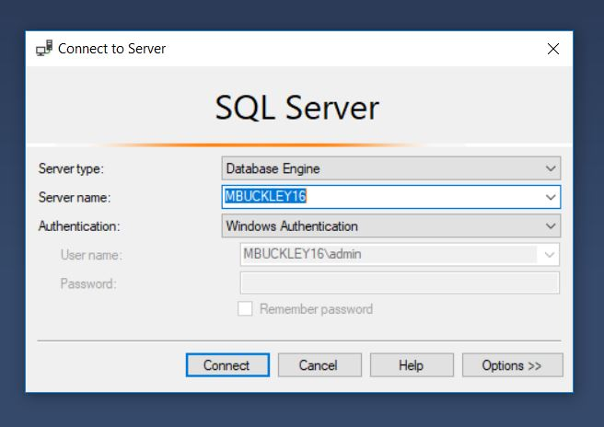
9. Do the same in the Web.Config file:
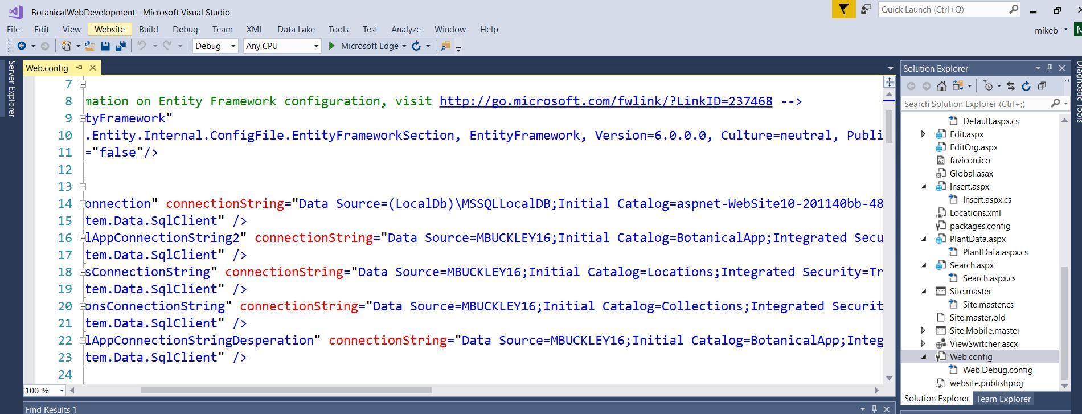
10. Now compile and run the project. You should be able to go to the Search page, click Ivy Collection on the map, and see the database! This is the Search page:
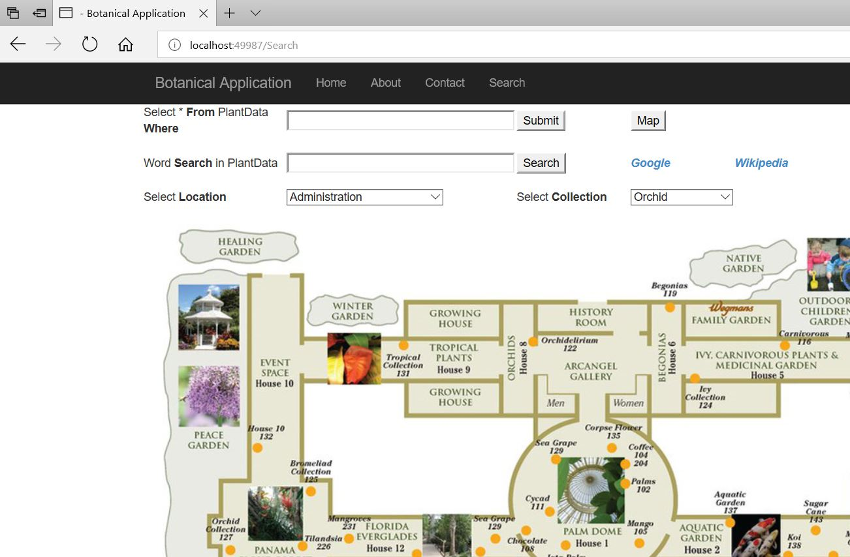
This is the Search results page:
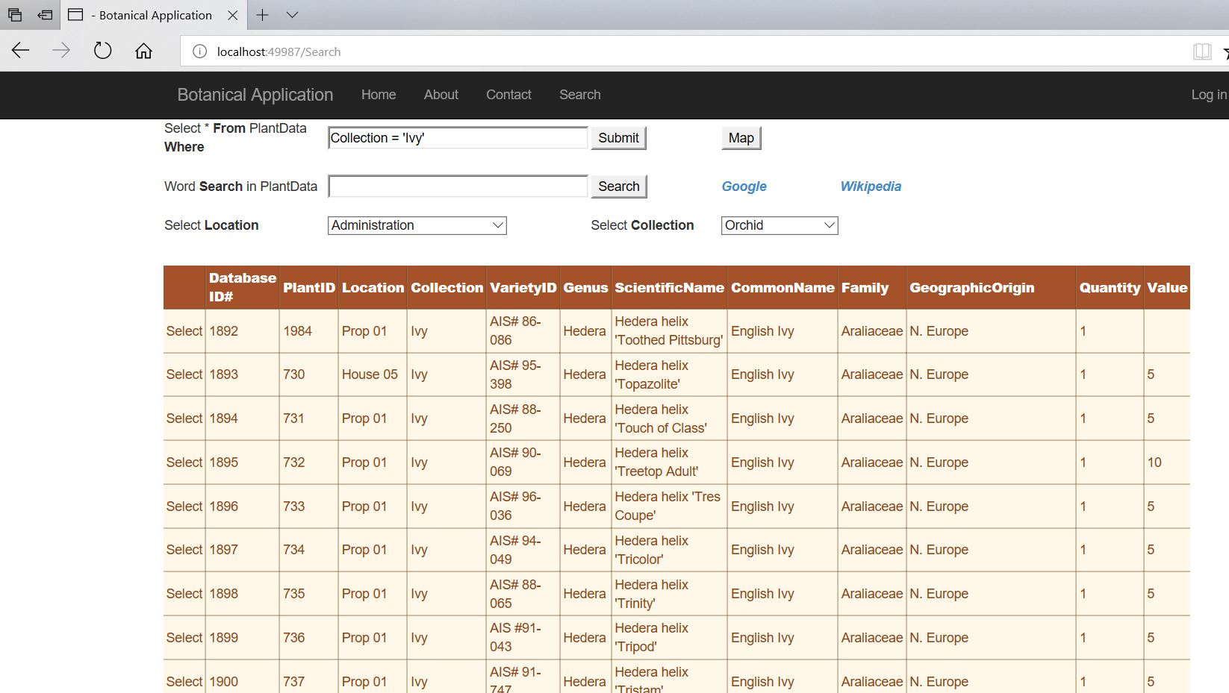

IF THE DATABASE DOES NOT DISPLAY: your SQLServer Agent may not be running in the background. To check this, go to the Windows Search bar (lower left of your display) and type “services.msc”. This brings up the services that Windows is currently running. Scroll down to the SQL settings and make sure that all SQL-related services are running. If not, select each one, go to the Action tab, and select START. Once the SQL Server services are running, you can retry running the project.
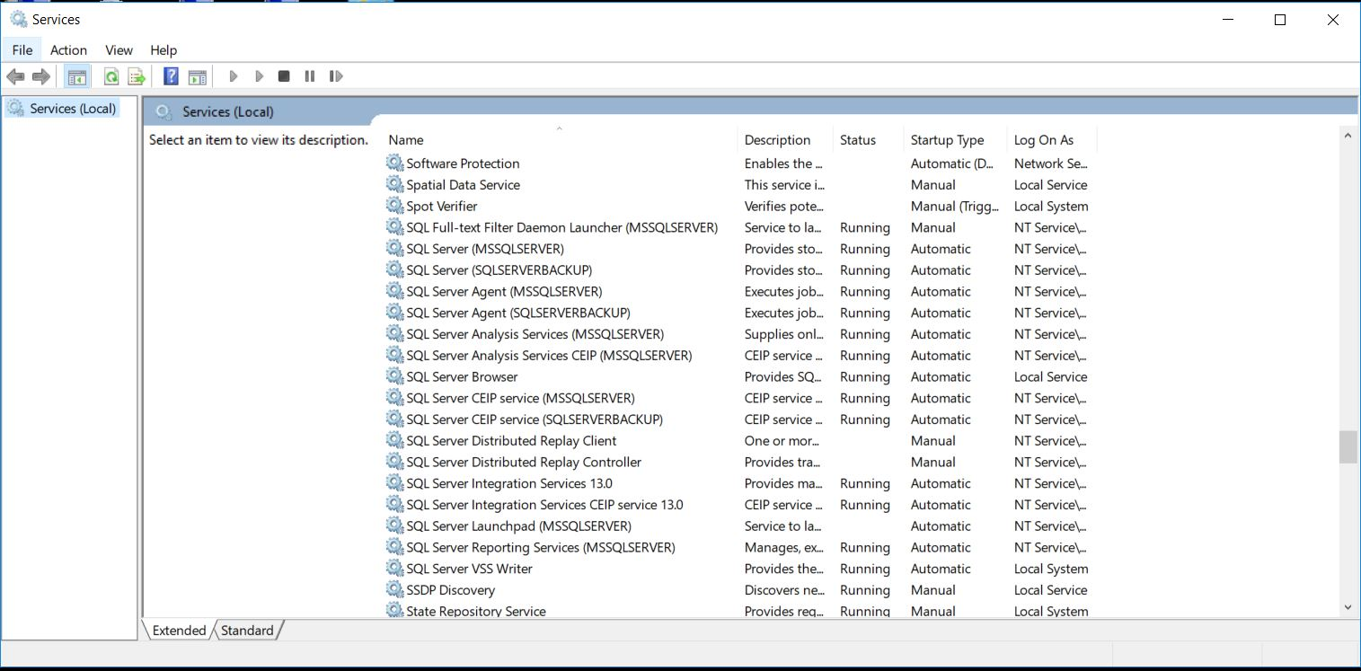

11. Congratulations

