Instructions for setting up Microsoft SQL Server and Visual Studio to support the Botanical Gardens Database project.
Development of the database and supporting web pages requires three Microsoft products:
SQL Server (Standard Edition or greater). Note: SQL Server Express is not sufficient.
Visual Studio with Web Developer and SQL Data Tools installed.
SQL Server Management Studio
1. The software can be obtained free (and legal) for UB CS students at the Microsoft Academic Alliance website:
https://portal.azure.com/?Microsoft_Azure_Education_correlationId=c74a2d5e-6653-4610-9b54-243e53e65680#blade/Microsoft_Azure_Education/EducationMenuBlade/software
You have to create a Microsoft account (seems very benign). Your UB email address gets you access to all Microsoft software, legally with registration numbers. Once you’re logged in, search for “Education Software”
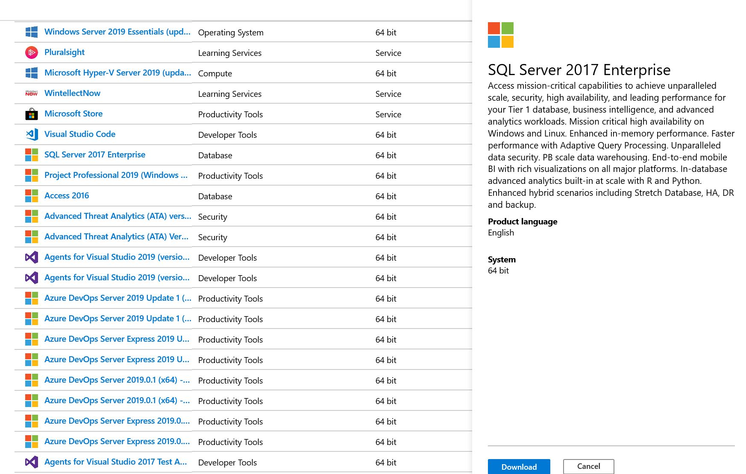

2. The Microsoft website supplies “iso” files for download. They are intended for burning DVDs, but you can use a free utility to mount the iso file as a disk in order to run the install or setup command. Here is a good utility for that: https://www.elby.ch/products/vcd.html

After the download, the file
en_sql_server_2017_enterprise_x64_dvd_11293666.iso
will be in your download directory. The file (an ISO file) cannot be opened. It is intended to be used to burn a CD or DVD. So we’ll need some help. Go to this site and download virtual clone drive: https://www.elby.ch/en/products/vcd.html
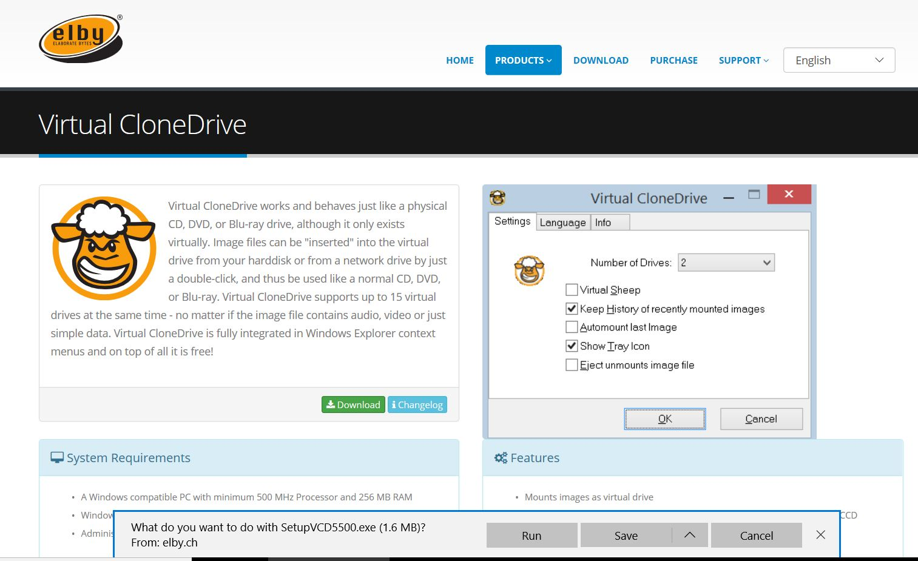
After you download VirtualCloneDrive, this file will be in your download directory: SetupVCD5500.exe
RUN THAT FILE.

You will see a window like this:
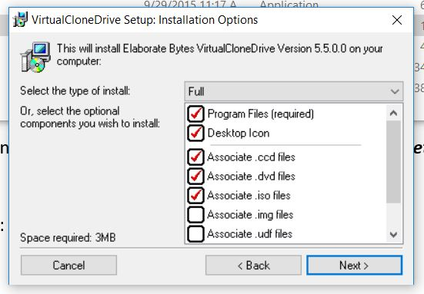
Keep selecting NEXT until the software is installed. Once installed, you can go back to the file
en_sql_server_2017_enterprise_x64_dvd_11293666.iso
in your download directory. Right click on it, and select MOUNT

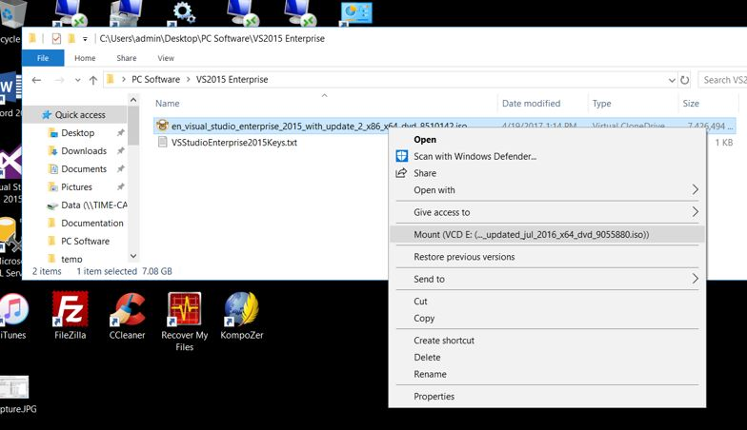
After you mount the ISO file, you will have a new “drive” that contains the installation files for SQL Server.
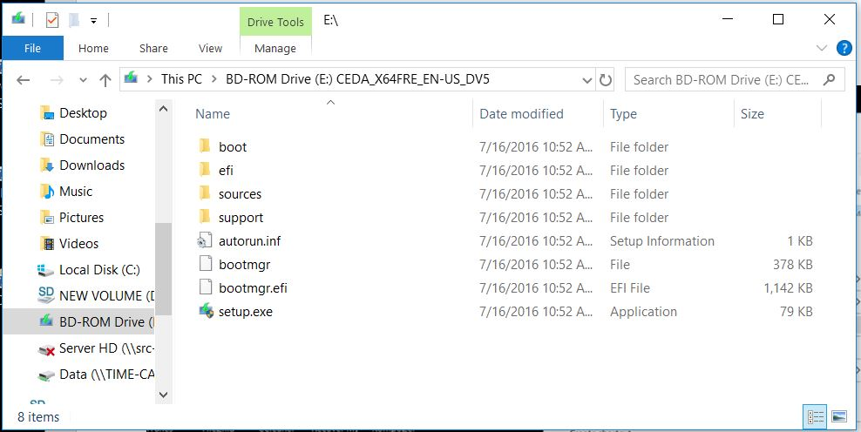
Run the setup file to install SQL Server.
3. Microsoft SQL Server –
- The installation is long and extensive, but take all of the defaults and it should install fine. Note: “unmount” the iso file when you are finished, so that you can delete it from your computer.
- The installation program has a number of steps and options. This is the basic install choice:

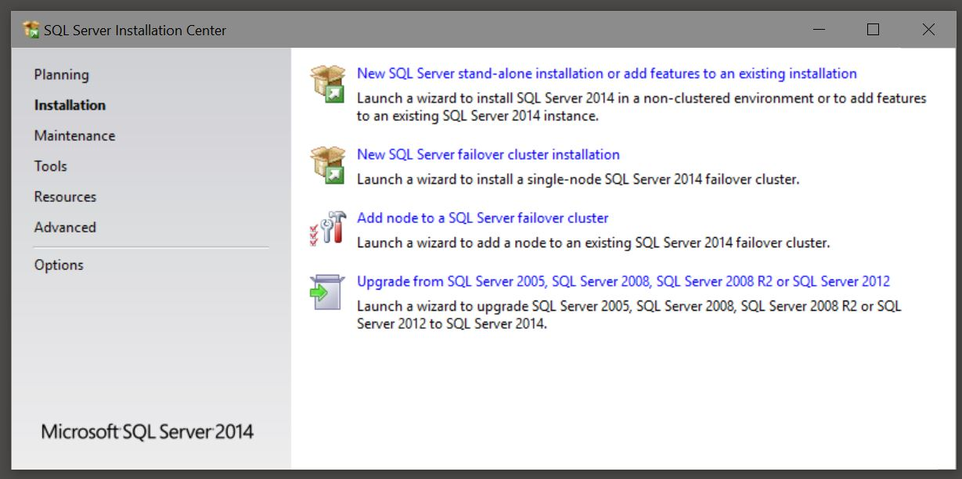
- After installing SQL Server, make note of this directory (or one very similar, depending on your SQL Server version):
C:\Program Files\Microsoft SQL Server\MSSQL12.MSSQLSERVER\MSSQL\DATA
This is where the database files (*.mdf) are kept, and installing the Botanical Gardens database will involve copying files there.
4. Visual Studio –
- go to the Microsoft website and download Visual Studio Enterprise Edition, 2015 or later.

- The installation program should look something like this:

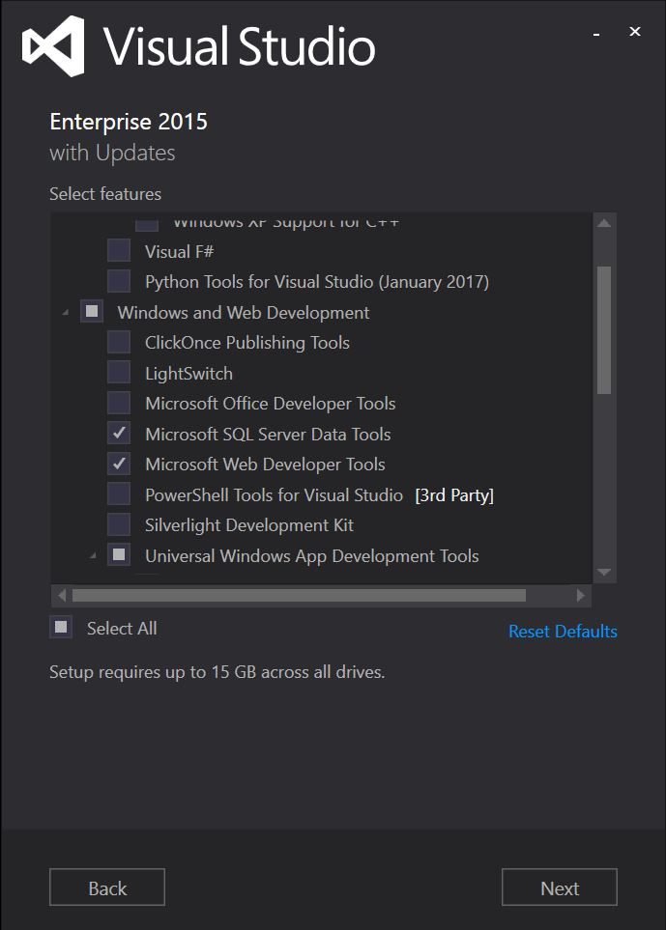

Make sure you install Web Developer Tools (this includes ASP.NET and C#) and SQL Server Data Tools.

Note: later versions look like this:
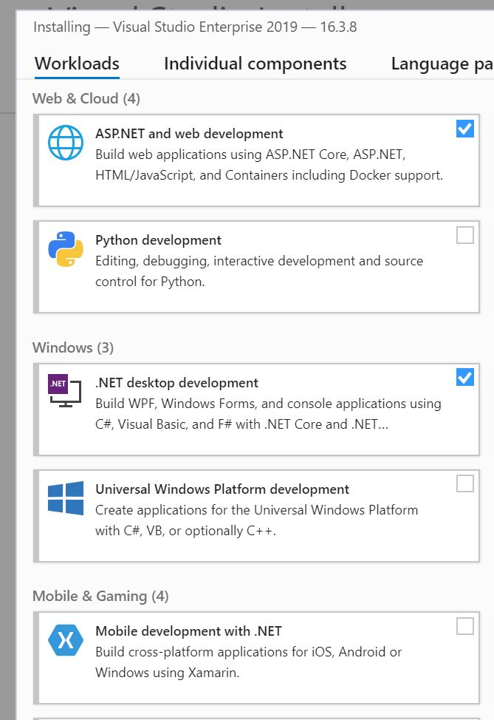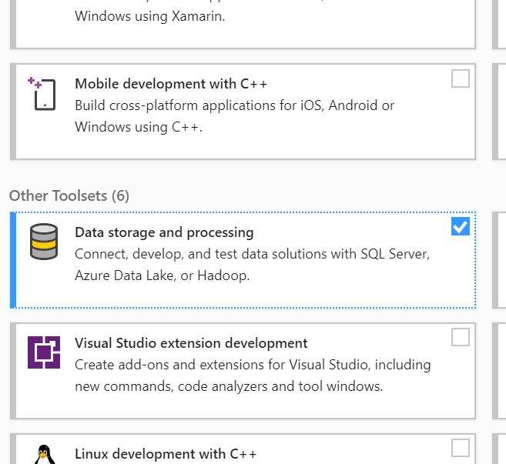

Make sure you install ASP.NET, .NET desktop, Windows Platform (optional, but useful), and Data Storage/SQL Server development tools.

5. SQL Server Management Studio –
- SQL Server Management Studio is the front-end for SQL Server. Since it requires both SQL Server and Visual Studio, it must be installed last. You can obtain it here: https://docs.microsoft.com/en-us/sql/ssms/download-sql-server-management-studio-ssms
- The installation program is an exe file which can be run directly. Again, installing the defaults should be fine.
- This is what Management Studio looks like if all previous steps were correct:
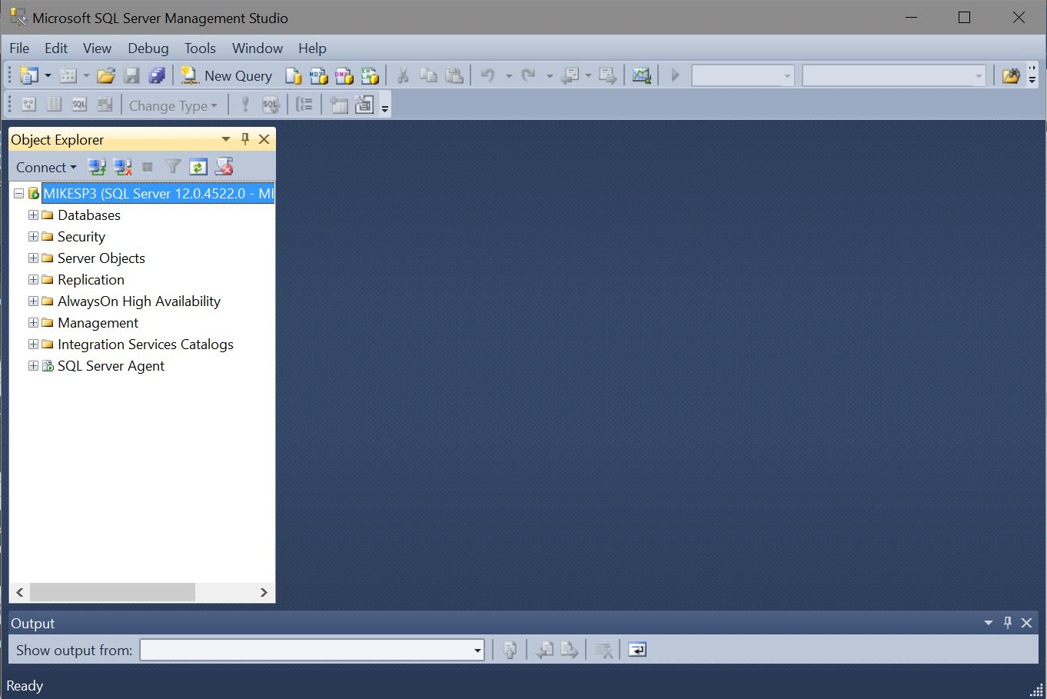

6. Installing the Botanical Gardens database and web pages will happen later.

