Microarray Data Analysis
Lei Shi, Yanen Li
{lshi2, yanenli}@cse.buffalo.edu

Part I: Time Series Data Analysis
In this part, we are required to implement one clustering algorithm from Partition based clustering, Hierarchical clustering and Density-based clustering. We choose K-means, AGNES(Agglomerative Nesting), and DBScan for each catergory and we implemented them in Matlab.

Partition Based Clustering: K-means
- Algorithm description:
K-means is one the main partition based clustering methods. Although this algorithm is simple, the result sometimes is very meaningful. In the following we will see how good K-means can achieve on time-series microarray data.
First, K-means arbitrarily choose k objects as the initial cluster centers. Then it reassign each object to the cluster the which the object is the most similar based on the mean of the objects in the cluster and update the cluster mean. The reassignment and updating is end when the cluster mean is not changing. The distance we choose is Euclidean distance, and the number of clusters k is specified by the user.
- Implementation:
The main file is Kmeans.m , the other related files are initMeans.m. The files for demo are testChoKmeans.m for cho.txt dataset and TestIyerKmean.m for iyer.txt dataset.

- Result:
Cho: 386 genes, 16 time points, 5 original clusters.
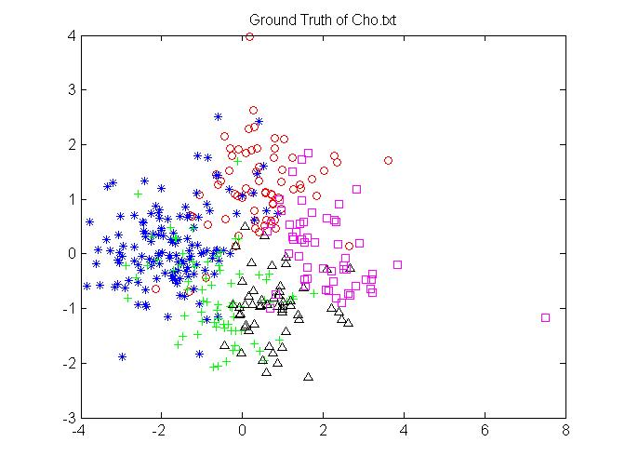
K=5: 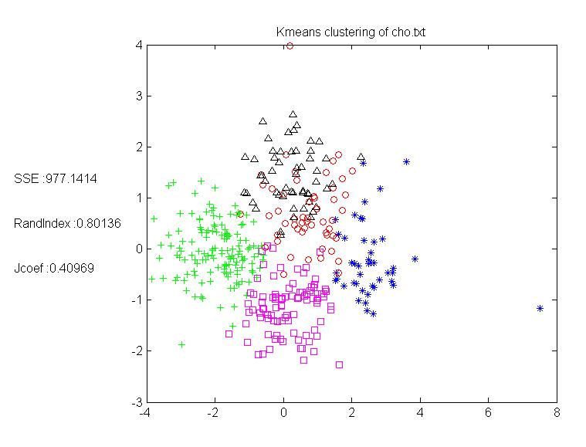
Iyer: 517 genes, 12 time points, 10 original clusters.

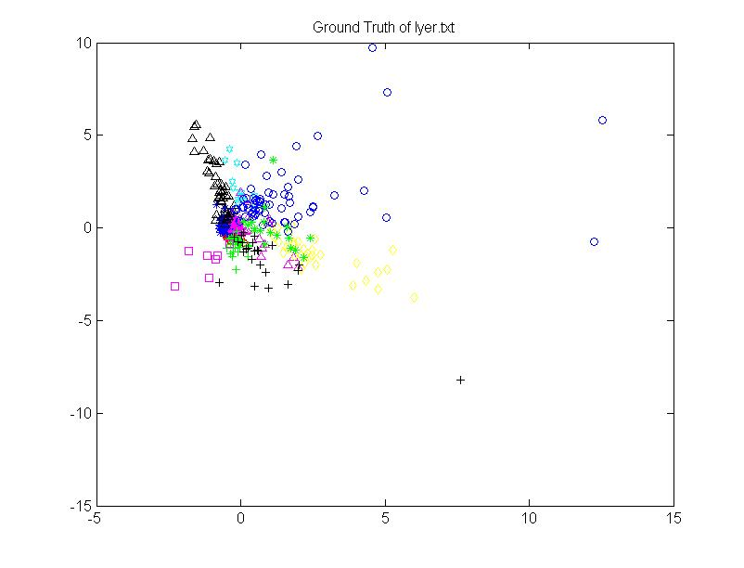
K=10;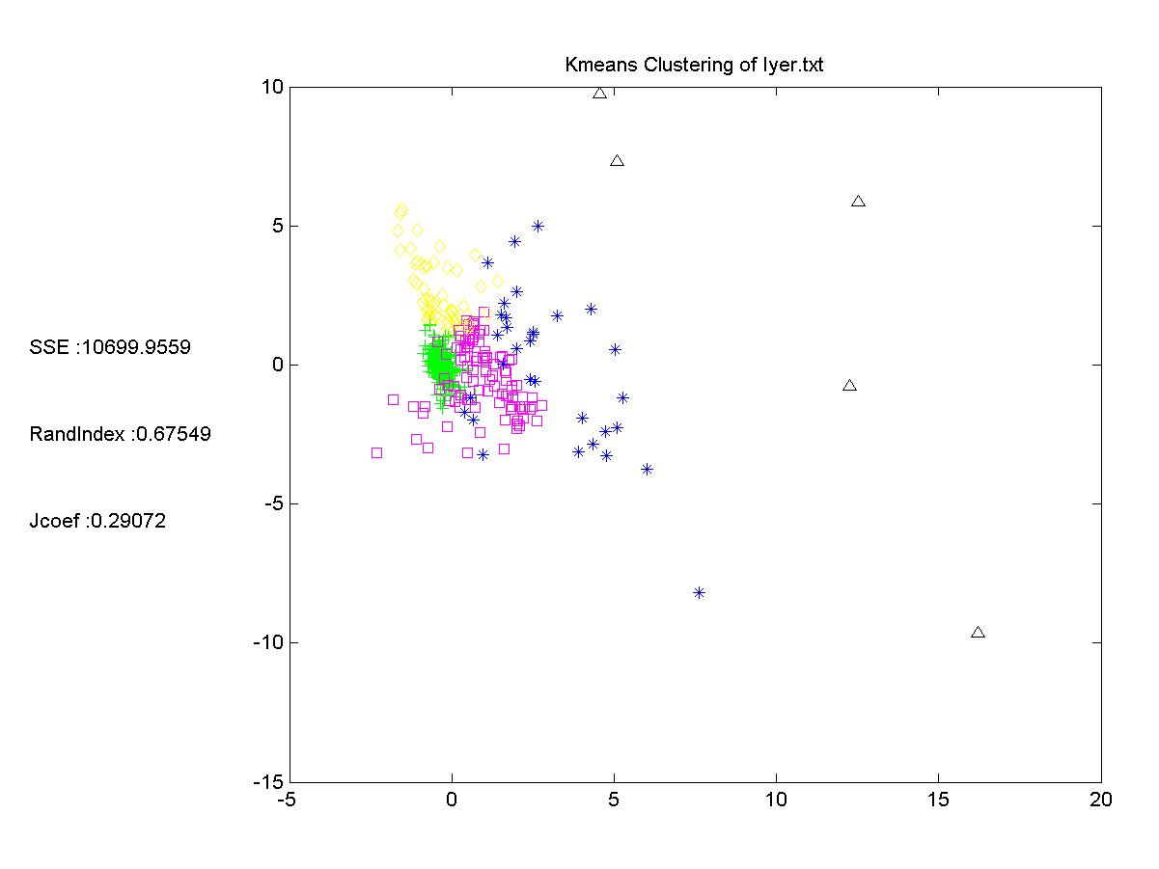

Evaluation:
Pros:
- It is relatively efficient for large datasets since its running time is O(t*k*n) where n is the number of objects, k is the number of clustes, and t is the number of iterations;
- It oftern terminates at a local optimum
Cons:
- Applicable only when mean is defined.
- Unable to handle noisy data and outliers.
- Need to specify k, the number of clusters in advance.

Hierarchical Clustering: AGNES (Agglomerative Nesting)
- Algorithm Description:
Hierarchical clustering includes agglomerative (Bottom-up) and divisive approaches (Top-down). We choose to implement AGNES, which is agglomerative method.

Initially, each objects is one cluster. At each step, the nearest two cluster merged together into one cluster. Finally, all cluster merged into one cluster. A clustering of a data objects is obtained by cutting the dendrogram at the desired level. So each connected component forms a cluster.

There are 4 kinds of ways to define Inter-Cluster Distance, single-link, Complete-link,
Centroid distance and Average-link, I implement the first three ways, the single-link is too sensitive to the outlier, the other two ways works well.
- Implementation:
The key file is Agnes.m. The files for demo are testChoHieri.m for cho.txt dataset and TestIyerHieri.m for iyer.txt dataset.Result:
The result when K=5 in the dataset of cho.txt.
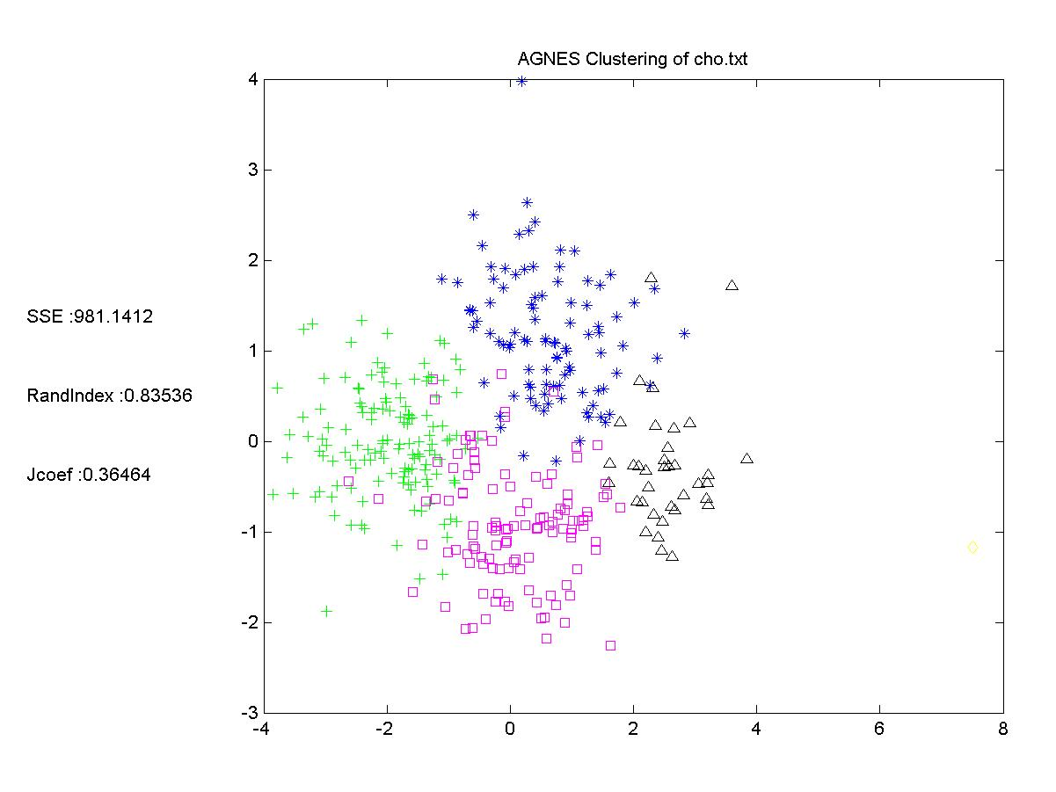
The result of k=10 in the dataset of iyer.txt
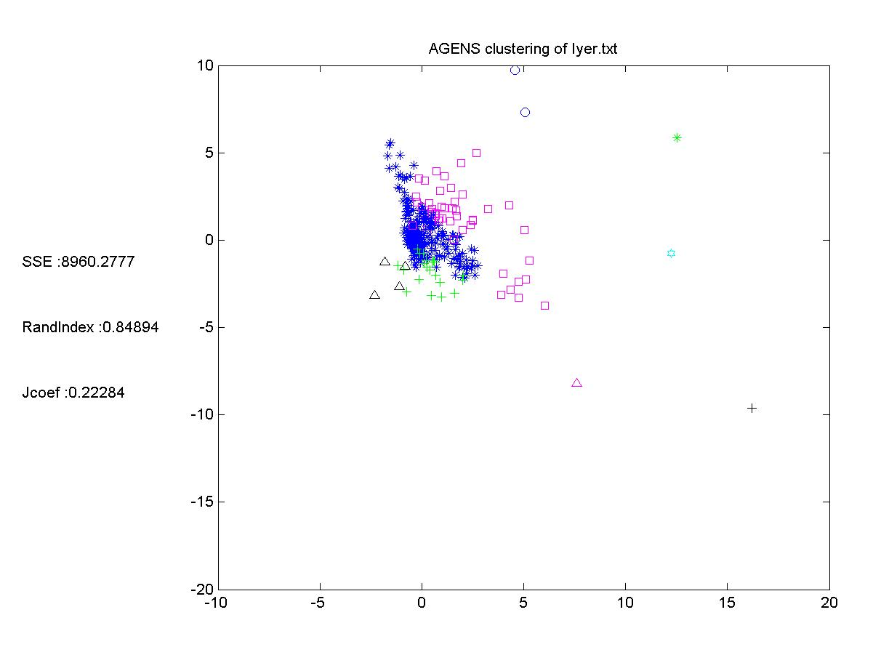
Evaluation:
Pros:
- Suitable for data sets with inherent hierarchical structure, e.g. microarray data.
Cons:
- Not scale well since it is O(N^3).
- It cannot handle non-convex shape data.
- Too sensitive to the outliers if you choose single distance to measure distance between different clusters.

3. Density-based clustering: DBSCAN approach
- Algorithm Description
The main idea of the density-based clustering method is that for each object in one cluster there are at least a minimum number of Min-pts objects with some given radius eps. This area is so called the eps-neighborhood for the object.
- Implement
The key file is DBSCAN.m and the files for Demon are TestChoDbscan.m and TestIyerDbscan.m.
- Result:
Minpts = 4, Eps = 0.9

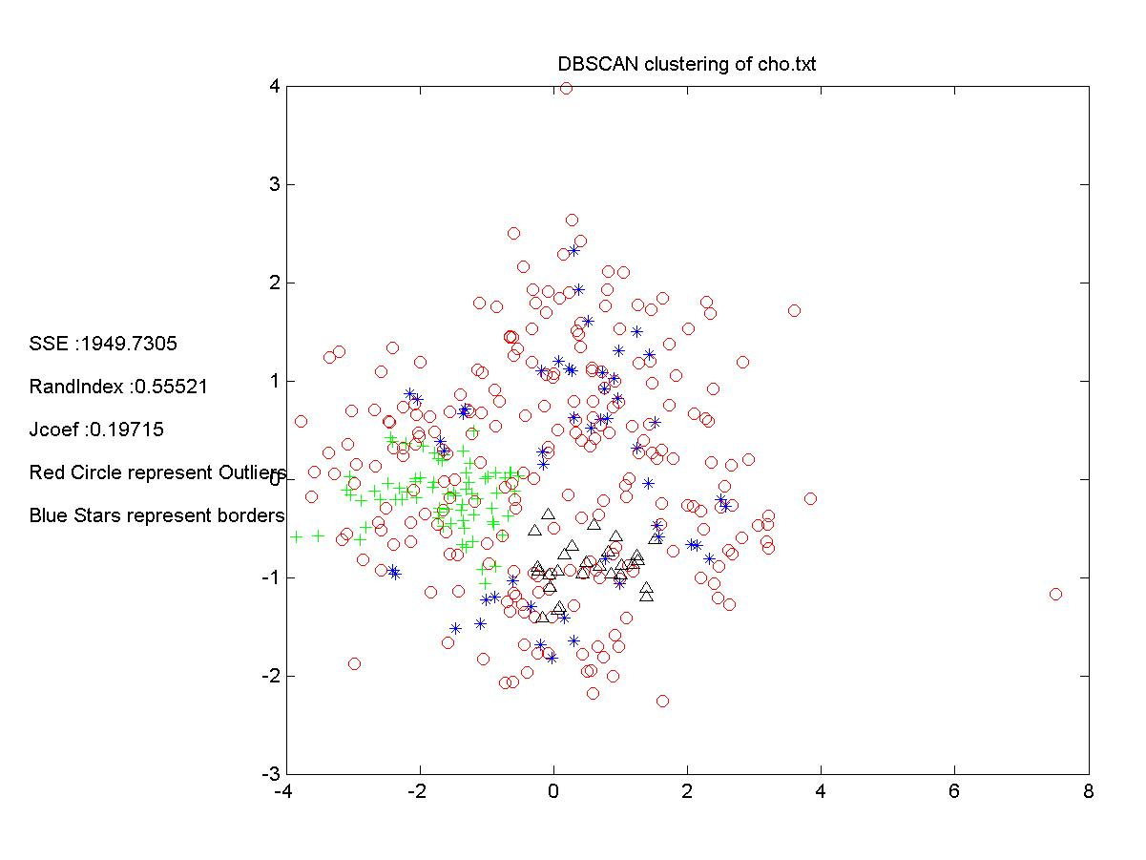
Minpts = 4, Eps = 1.0
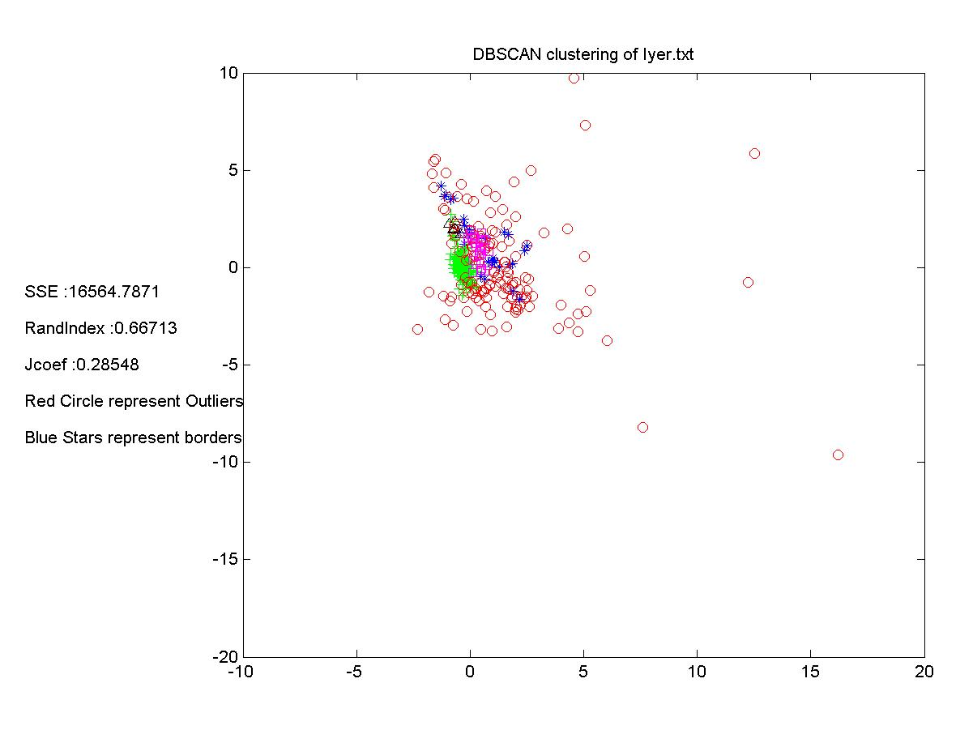
- Evaluation
Pros:
- Clusters can have arbitrary shape and size
- Number of Clusters is determined automatically.
- Can separate clusters from surrounding noise.
- Can be supported by spatial index structures.
Cons:
- Input parameters may be difficult to determine.
- In some situations very sensitive to input parameter setting.

Part II: Class prediction
In part two, we implement the molecular classification algorithm proposed by Golub. et
al. Our work includes tow main steps: Informative gene selection and validity test. The training data set consists of 38 samples. 27 of these samples are ALL, while the other
11 is AML. There are 7128 genes in the data set.

- Informative gene selection
In this part, we formulate the modified T-test to select the informative genes.
In golub’s approach, they define:
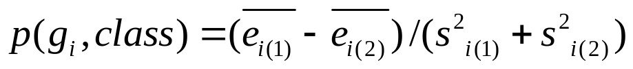

However, there are two major limitations in this approach. First, it does not take into account of the size of group 1 and 2. Second, it does not consider the relationship between genes. To overcome these limitations, we define the gene-specific variance of gene i as:
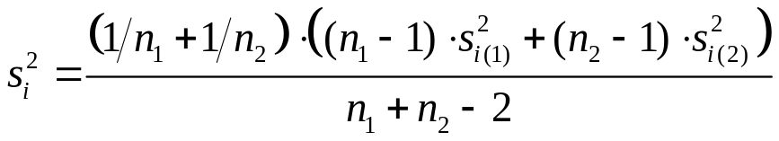

And overall global average variance as:
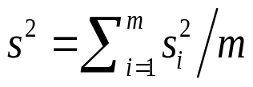

And we define the modified T-test value as:
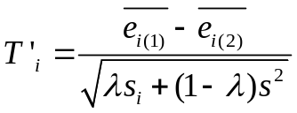

Then, we choose the genes with top n/2 positive and bottom n/2 negative values as informative genes. In order to get the highest accuracy in the training data, here we set the parameter =0.7, and n=50.

We make predictions using our approach to the golub’s test set, and found that our approach get a good result, a little better than the golub’s approach (table shown below)

Method | No of Samples | PS<0.3 | No of correct predictions | accuracy
Golub’s | 34 | 5 | 20 | 58.6
Our approach | 34 | 6 | 21 | 60.7

Part III: Visualization

As humans, we are only used to acknowledging up to three dimensions of perception. However, a lot of problems that we encounter in reality have more than three dimensions. Microarray data has exactly this property. The high number of dimensions of such data makes it next to impossible to relate the genes without some kind of aid. Visualization allows for the conversion of multi-dimensional data into 3 or less dimensions such that we can intuitively see how the data relates to each other.

In this part, we make modification on the visualization tech introduced by Zhang Li. Li formulate the the first Fourier transform function as:
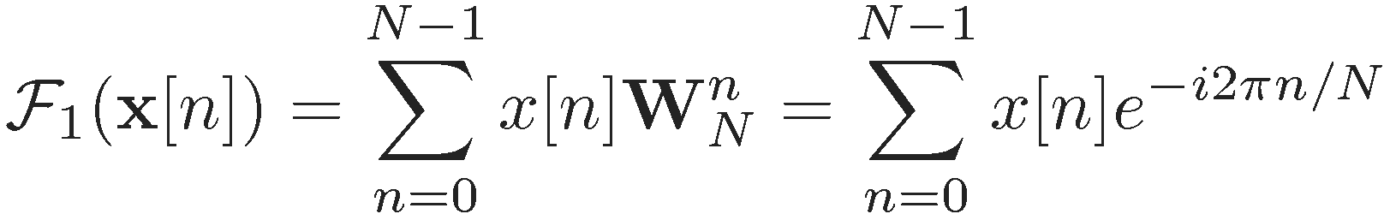

This approach takes as input an array x of n real values and maps it to a complex number. This complex number, a + ib, is then used to derive two real numbers for coordinates of the mapping from n dimensions to two. But the major limitation of this approach is that all dimensions (genes) are treated equally. So, we can modify the above formular as
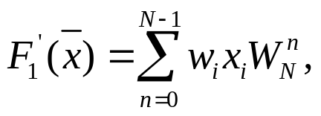

And we deduce the 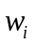 as below:
Recall the PCA and the Gene shaving method For the first principle component (eigen vetor), we could obtain the Super1 Gene, And, the second principle component: Super2 Gene … For each super gene, we compute the correlation of this super gene to other (n-1) genes:
Super1 Gene: r1(g₁), r1(g₂), r1(g₃),…,r1(g_{n})
Super2 Gene: r2(g₁), r2(g₂), r2(g₃),…,r2(g_{n})
Super3 Gene: r3(g₁), r3(g₂), r3(g₃),…,r3(g_{n})
Super4 Gene: r4(g₁), r4(g₂), r4(g₃),…,43(g_{n})

And, in order to distinguish the contribution of each component, we add the eigen values into the formulas:

S1 G: λ1r1(g₁), λ1r1(g₂), λ1 r1(g₃),…, λ1r1(g_{n})
S2 G: λ2 r2(g₁), λ2 r2(g₂), λ2 r2(g₃),…,λ2 r2(g_{n})
S3 G: λ3r3(g₁), λ3r3(g₂), λ3r3(g₃),…, λ3r3(g_{n})
S4 G: λ4r4(g₁), λ4r4(g₂), λ4r4(g₃),…, λ4r4(g_{n})

We define:

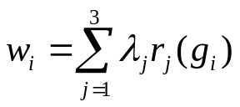

The magnifies the coordinate that has higher correlations to the super genes, to reflect the importance of this direction. The bigger the is, the significant the corresponding gene is, so that it is more likely to separate the samples when the samples are projected to the lower dimensions.

Results. We compare our approach (Weighted First Fourier Harmonic Projection) to the First Fourier Harmonic Projection (FFHP) and PCA drawing approach, and found that our approach is effective to give good intuitive visualization of the data. And after careful comparison between our approach and the FFHP approach, we found that the result of these two approach are similar, and our approach seems better than the FFHP approach because our approach makes the truly grouped samples get closer than the FFHP approach. The specific results are as follows:
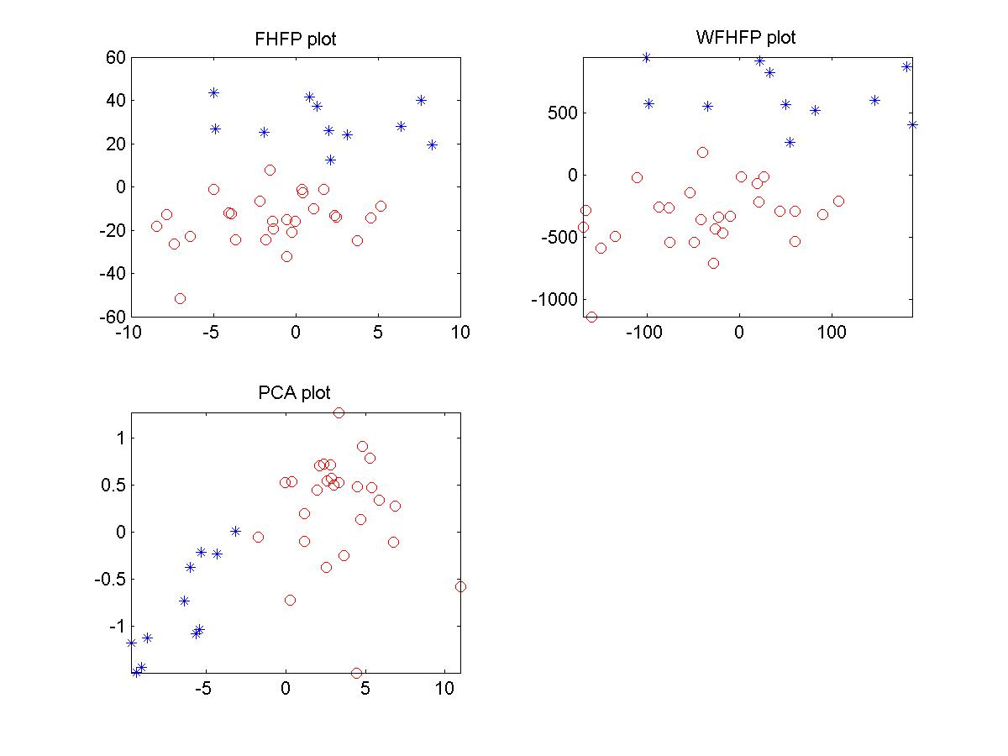
Fig. 3.1 Comparison of three visualization approaches on the Golub’s training data (ground truth)

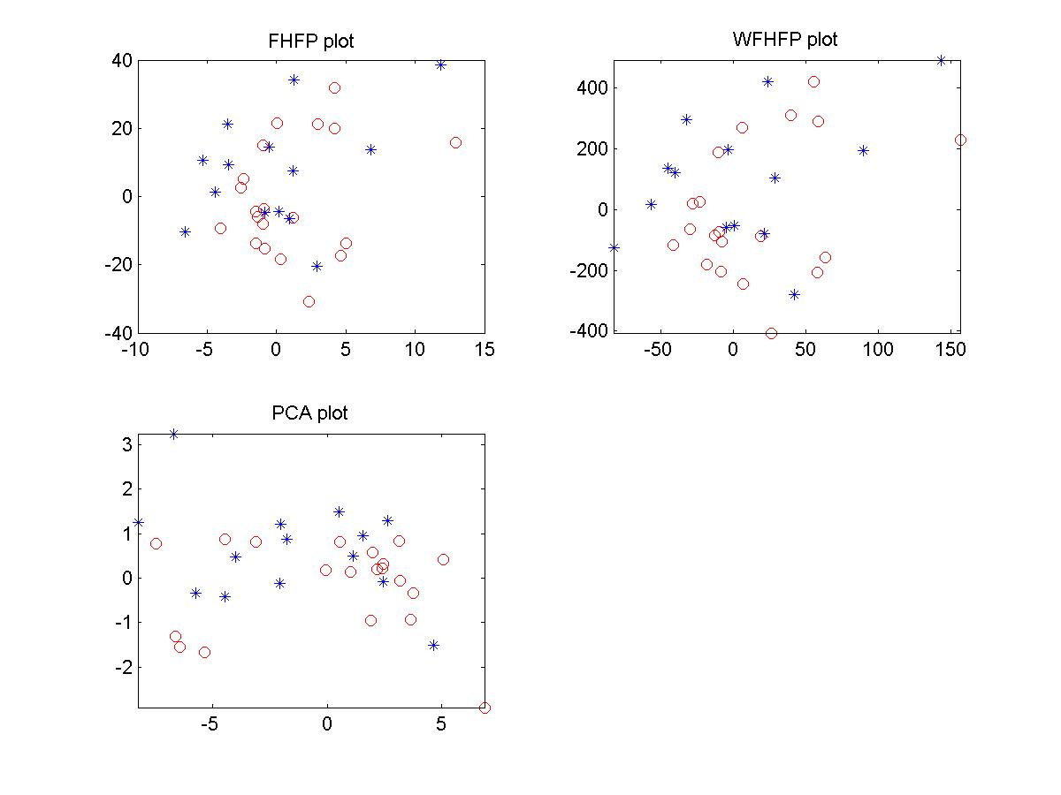
Fig. 3.2 Comparison of three visualization approaches on the Golub’s test data (ground truth)

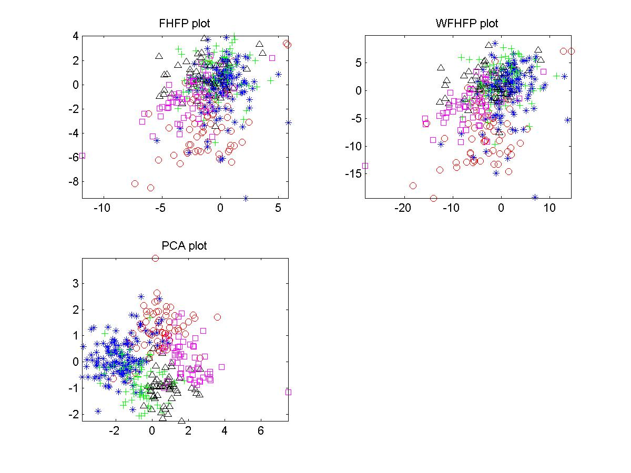
Fig. 3.3 Comparison of three visualization approaches on the Cho’s data (ground truth)
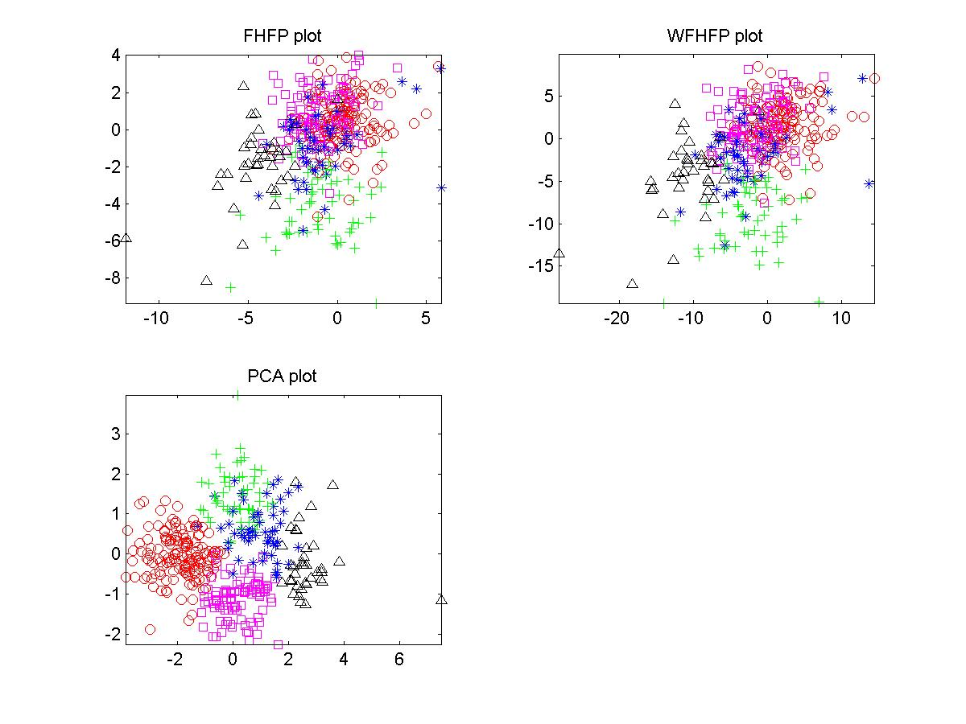
Fig. 3.4 Comparison of three visualization approaches on the Cho’s data (after clustered by K-means approach)
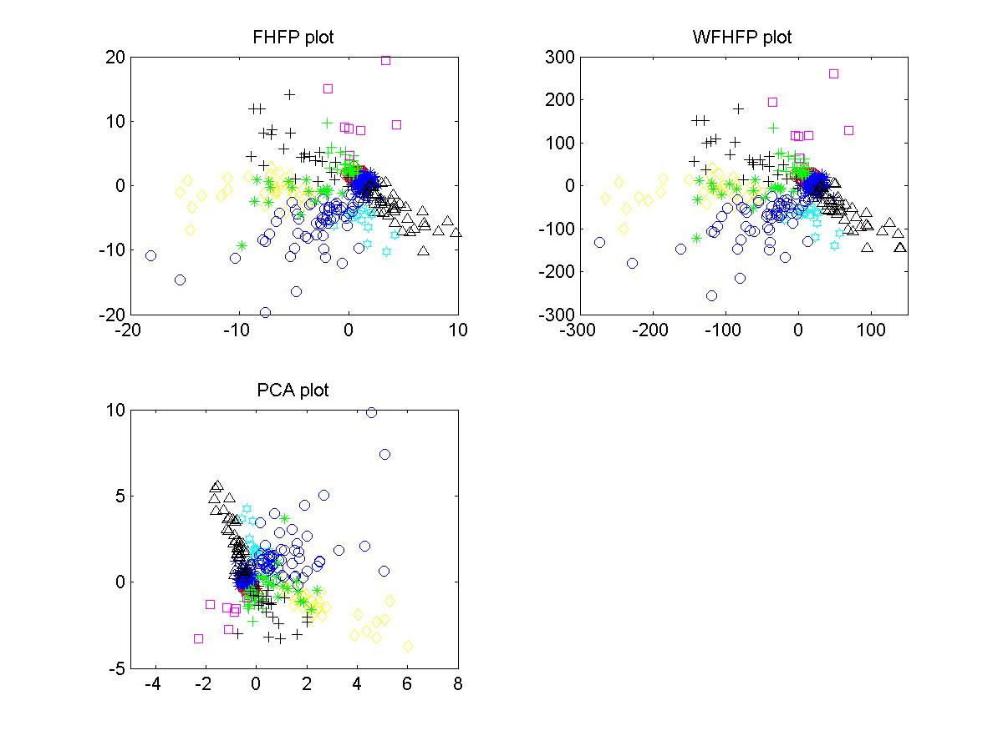
Fig. 3.5 Comparison of three visualization approaches on the Iyer’s data (Ground truth)

Part IV: Validation
Validation is a very important step of any such clustering algorithm. It helps rank clustering results, so that we will know the quality and reliability of the clustering results. I can even help determine the right parameters to some clustering algorithm.

In this project, we chose Random Index and Jaccard Coefficient to calculate external index of the clusters. We also used SSE (Sum of Squared Error) to calculate an internal index for the results. Then a statistical framework was established to compare the internal index of our clustering results to the internal indices of 500 runs of the same algorithm for random datasets of about the same size as the real data. Then we can generate a histogram for the correlation of the distance and incidence matrices of the 500 random datasets. Finally, we can see that the algorithm is no just assigning clusters by chance. In all the cases the random data clustering results were very poor compared with the actual data.
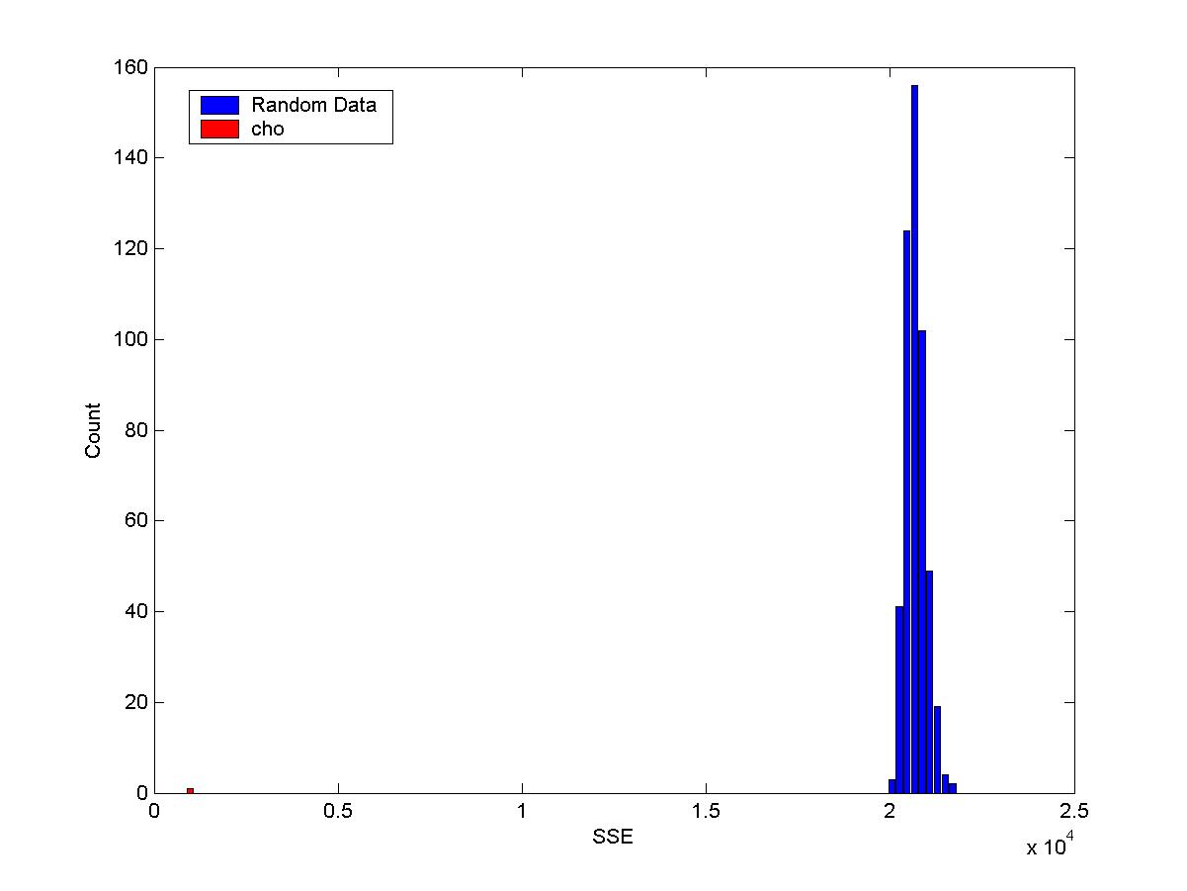
Figure 4.1 Framework of Kmeans for cho.txt
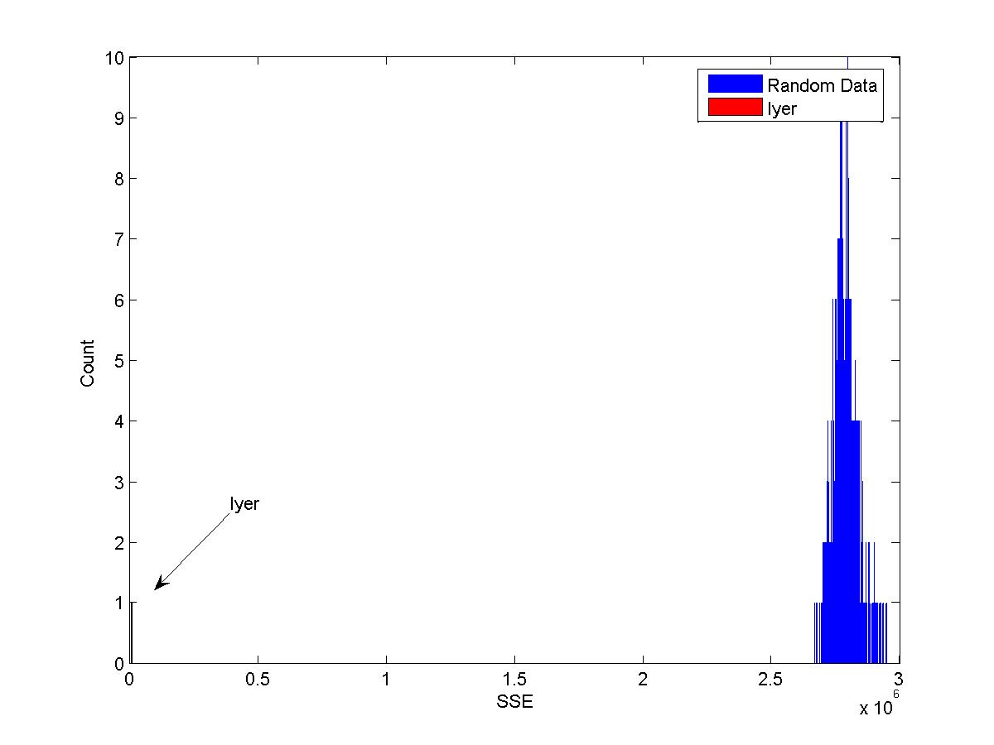
Figure 4.2 Framework of Kmeans for iyer.txt

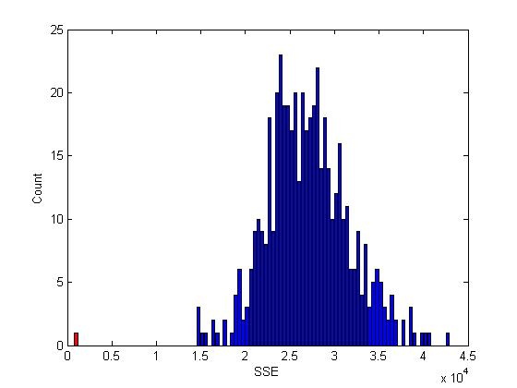
Figure 4.3 Framework of Agnes for cho.txt
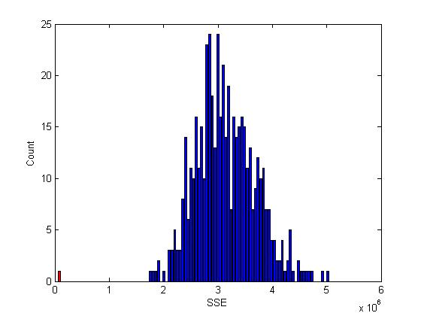
Figure 4.4 Framework of Agnes for iyer.txt

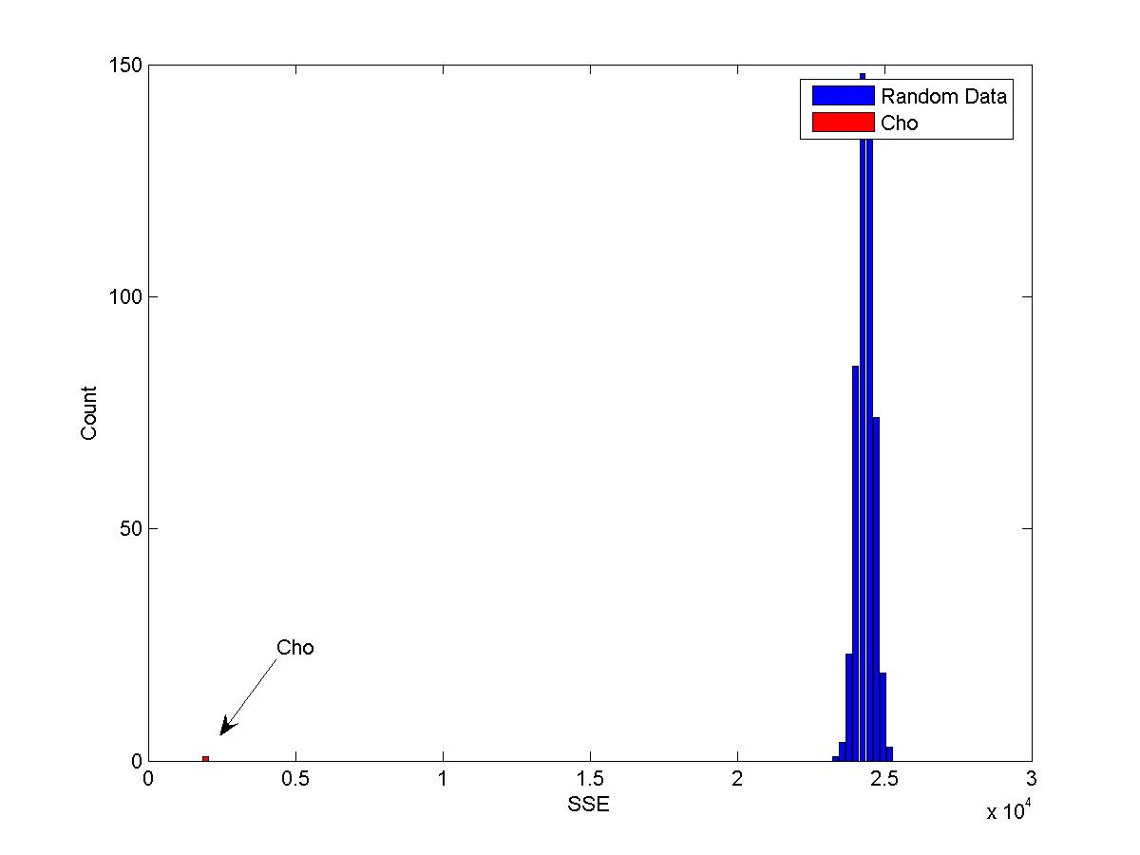
Figure 4.5 Framework of Agnes for cho.txt
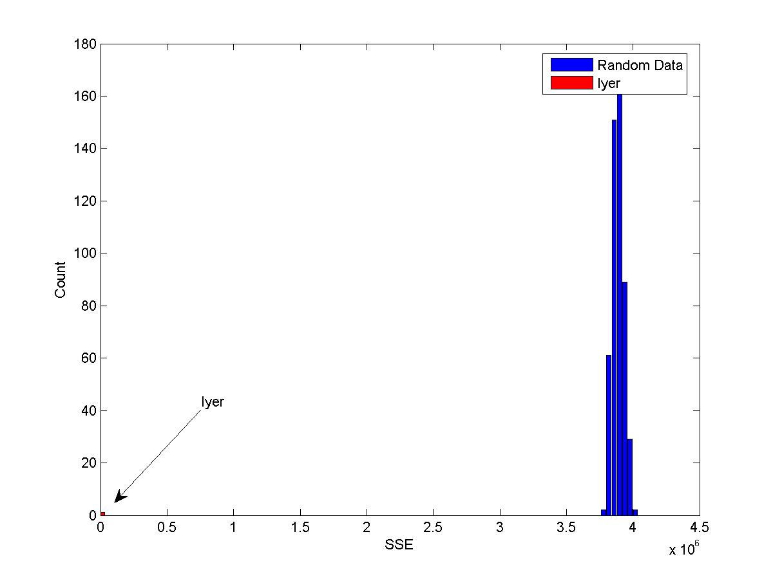
Figure 4.6 Framework of Agnes for iyer.txt

As you can see in the diagrams above, different algorithms worked better on one dataset but not good in another. Using the validation and statistics framework, we can help ourselves in taking an educated guess toward picking the answer that is most reliable and closer to truth.

