CSE651 Emerging Applications and Platforms (EAP) Summer 2014
B. Ramamurthy
Goal: Deploy a DHTML (HTML + CSS + Javascript) project on Google App Engine. (We will not include a CSS file in this project, you can always add that on).
Prerequisite: A DHTML project created and tested either using notepad++ or a similar editor or an Eclipse environment. For example the hangman project we created has hangman.html, hangman.js and the images (within a folder images).
Instructions:
- We have already installed Eclipse ADT (Android development tools). This is actually Eclipse Kepler 4.3 version with Android plug-ins installed.
- Next install the Google app Engine plug-in for the Eclipse you installed. (If you already have a version of Eclipse running, you may use that and get the right version of the plug-in).
- Run Eclipse, go to the Help top line menu, in the drop-down list select Install New Software and window shown below appears. Fill in https://dl.google.com/eclipse/plugin/4.3 for the Kepler version of Eclipse and select the other options as shown below:
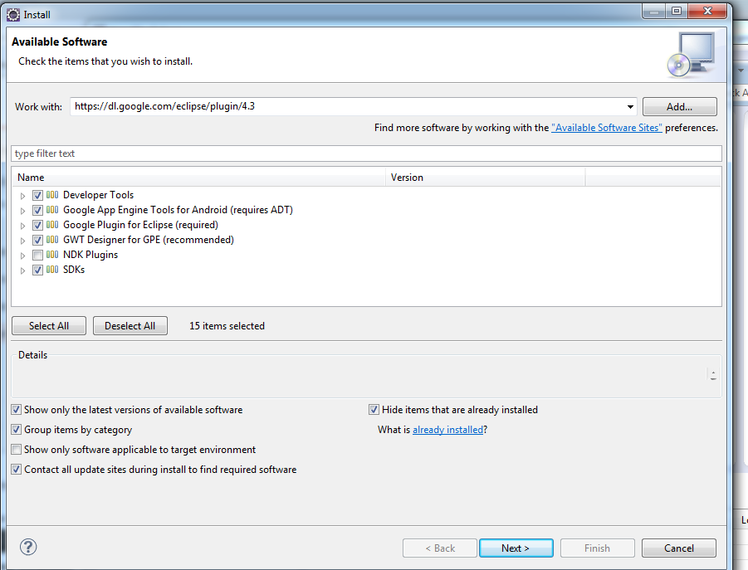
- Click Next and accept/okay in the next few pop-up Windows. Wait for the installation to complete; it will take some time. See instructions here: https://developers.google.com/eclipse/docs/install-eclipse-4.3
- Now gather all the artefacts (files, images etc.) of the application you want to deploy in a google app project. File New Project Google Web Application project and fill in the details as shown below. You are filling these details: name of the project (for this use your naming convention and make it a meaningful one.) Then the package name: com.google.appengine.yourappname. The rest as shown below. Also select a universally unique name for you app as it shows up on the web and also for providing the link to the app.
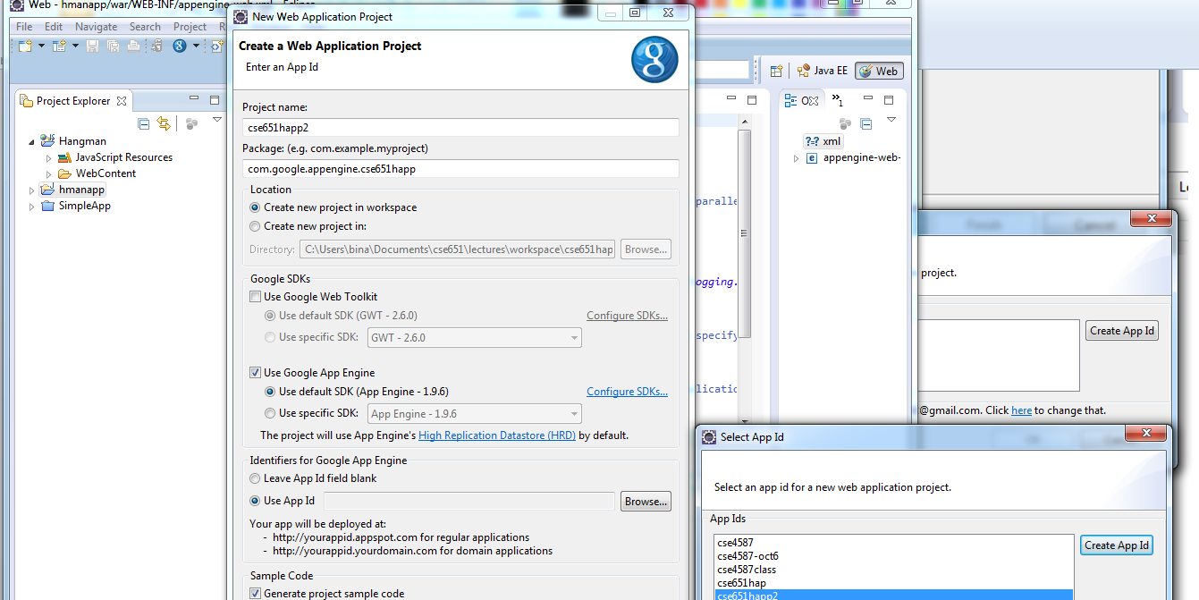

- On the Windows explorer of the newly created project, go to the .war. Copy and paste all the components of the application you created to .war folder: hangman.html, hangman.js, and the images folder.
- Edit the index.html to point to your .html file. In this case hangman.html.
- Right click on the newly create application, Google and deploy application on app engine. You will have to sign into the app engine.
- If everything goes fine, you will see the application being deployed and the web front for the application show up. Click the application and use it.
- Monitor the various aspects of the app by studying the Google app Admin console and status indicators. You will also be able to undeploy and delete the app from the console. Study all the features of the Google App Engine and also the tutorials.

