CSE651 Emerging Applications and Platforms Summer 2014
Anduino Hnadout#1
- Make Arduino IDE is installed and you an Arduino board and connector ready.
- Connect the Arduino board. When it completes installing the driver make sure you note down the com port it is configured/connected to. (E.g. COM20)
- Open the Arduino Ide and study the various command menus.
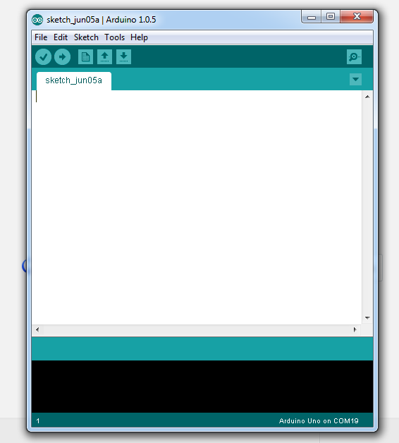

- The menu items are Verify (check code for errors), Upload (upload a program into the Arduino unit), New ( open a new blank program), Open (existing programs), Save (the current program).
- The Arduino IDE is written in a development language called Processing. ( We will learn about Processing later). A program written in this environment is called a “Sketch”. Processing is indeed written on top of Java as a Java library.
- Connect the Arduino board.
- Enter the following “sketch” with three parts: data definitions, setup() function and a loop() function.
/*
Blink
Turns on an LED on for one second, then off for one second, repeatedly.

This example code is in the public domain.
*/

// Pin 13 has an LED connected on most Arduino boards.
// give it a name:
//DATA AREA
int led = 13;

// the setup routine runs once when you press reset:
//SETUP
void setup() {
// initialize the digital pin as an output.
pinMode(led, OUTPUT);
}

// the loop routine runs over and over again forever:
//LOOP forever or until terminated by the user
void loop() {
digitalWrite(led, HIGH); // turn the LED on (HIGH is the voltage level)
delay(100); // wait for a second
digitalWrite(led, LOW); // turn the LED off by making the voltage LOW
delay(100); // wait for a second
}
- The data definition part defines the data needed by the application.
- The setup() function establishes the initial setup and configuration of the devices and other variables.
- Loop keeps looping the operation specified in the function.
- Lets write a simple blink and under the basic setup.

