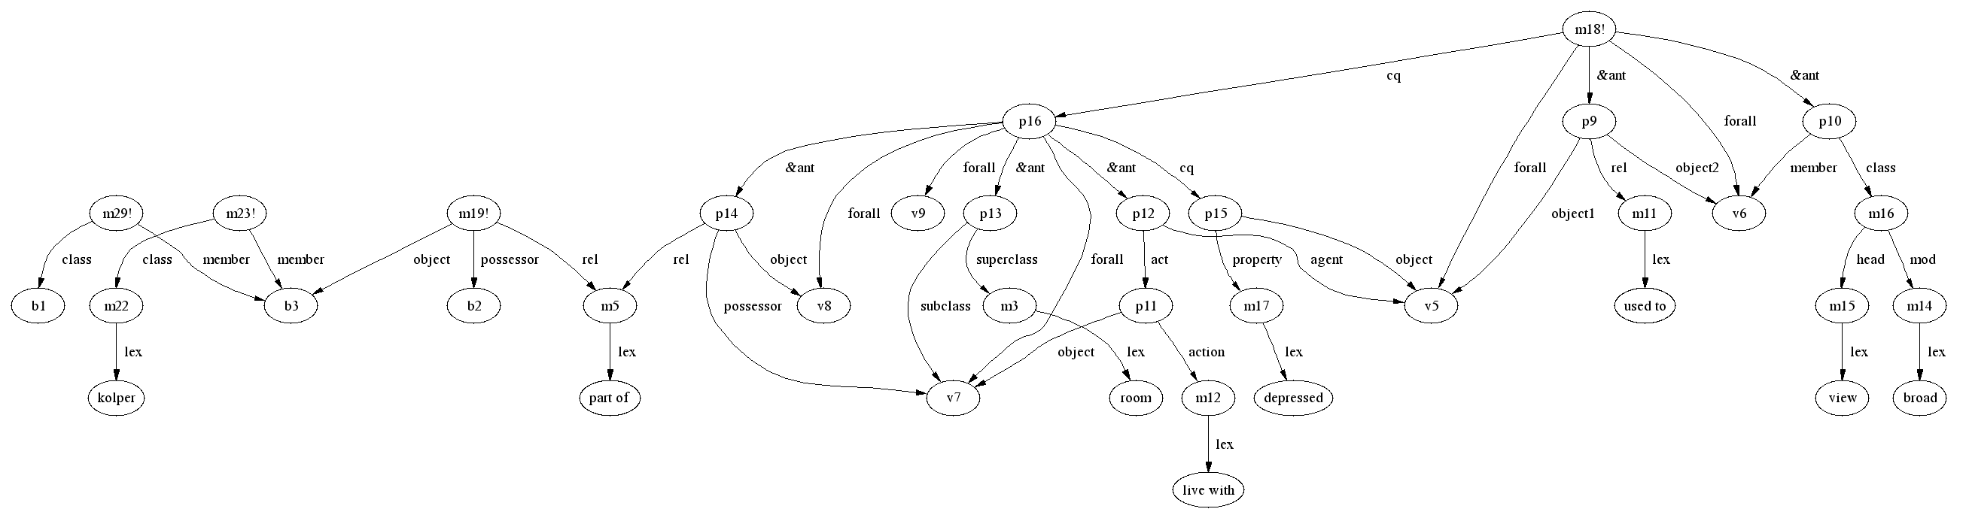

“If you used to V and V is broad view, then if you live with W, W is subclass of room, X is part of W then you are depressed”,
“Kolper is part of a room”,
“Kolper front a courtyard”,
“Courtyard is a place"

