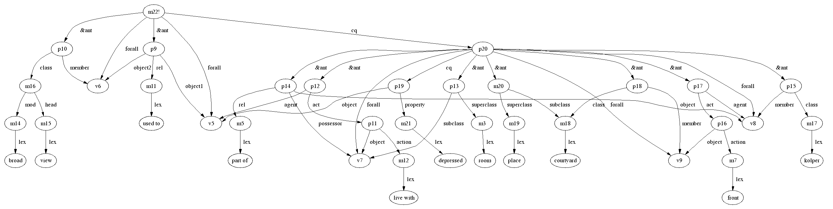
“If you used to V and V is broad view, then if you live with W, W is subclass of room, kolper is part of W, kolper front courtyard then you are depressed”

