Prerequisites: You must have SQL Server, SQL Server Management Studio, and Internet Information Services (IIS) installed.
To install IIS, go to Control Panel / Programs and Features, and select Turn Windows features on or off (on the left side of the menu), and select the following items in Internet Information Services, Web Management and World Wide Web Services, especially Application Development Features, and Internet Information Services Hostable Web Core
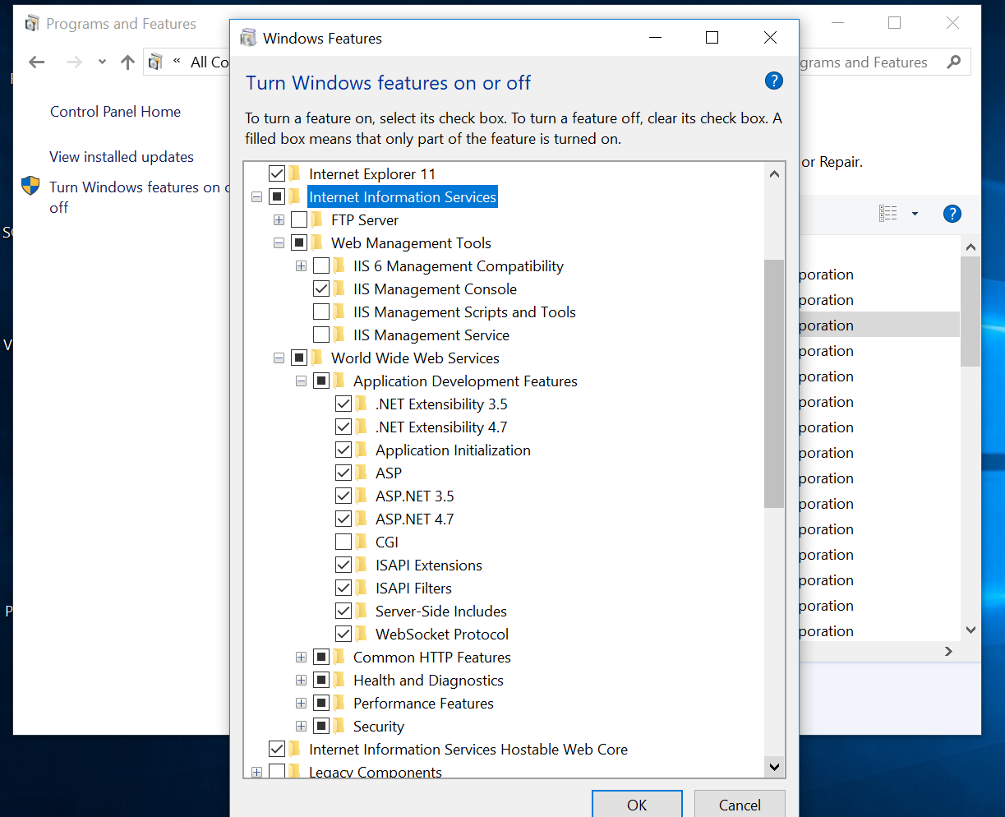

Publishing A Website
1. Start Visual Studio as Administrator, necessary to write to C:\inetpub\wwwroot
2. Right-click on Website Solution in Visual Studio, and select Publish
If a publishing profile is not establish, you must select PUBLISH TO A FILE SYSTEM, and then select a file location. Usually, it is C:\inetpub\wwwroot\website_name
3. In IIS Manager, select the new Website, right-click, and “Convert to Application”
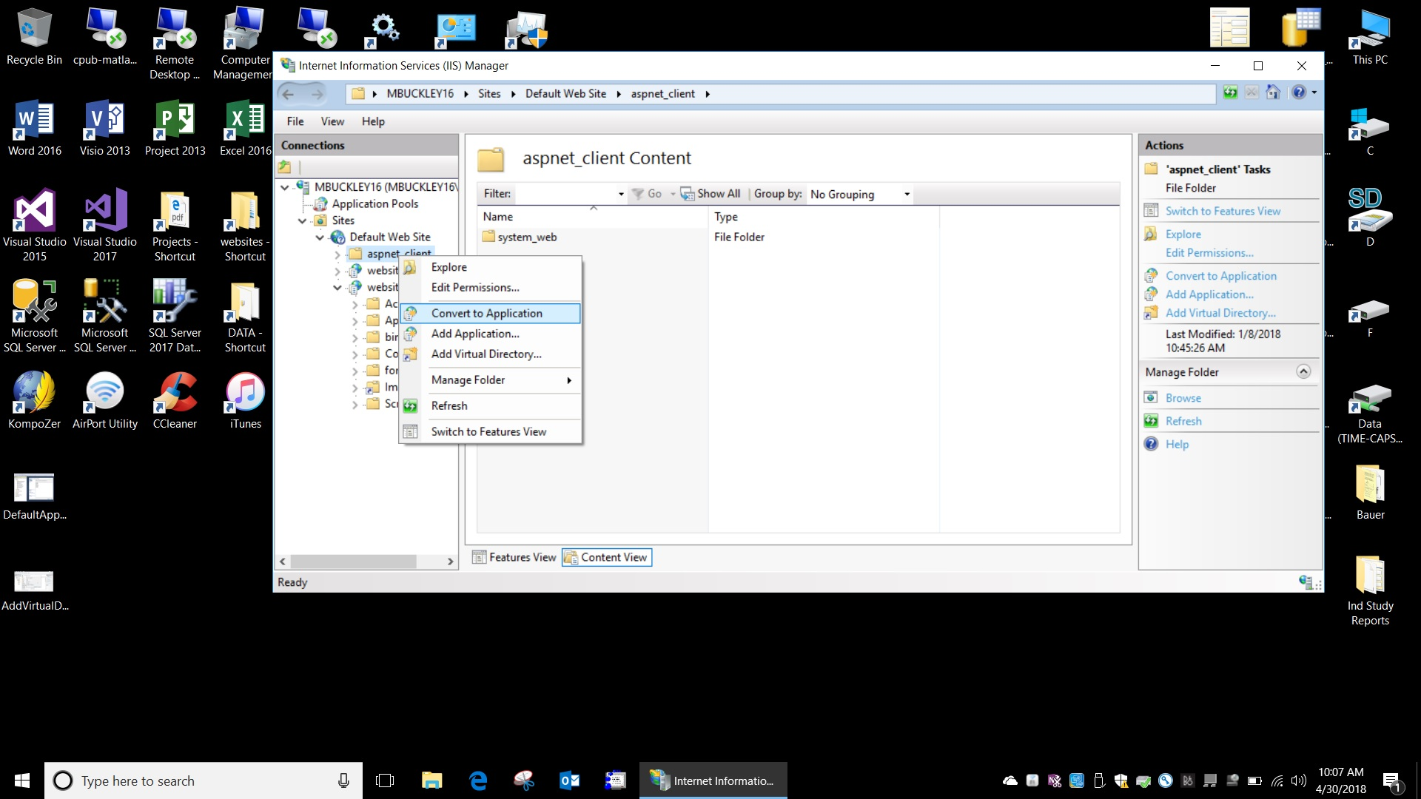

4. In IIS, create a virtual directory for that website, linking …wwwroot\Images to F:\Images
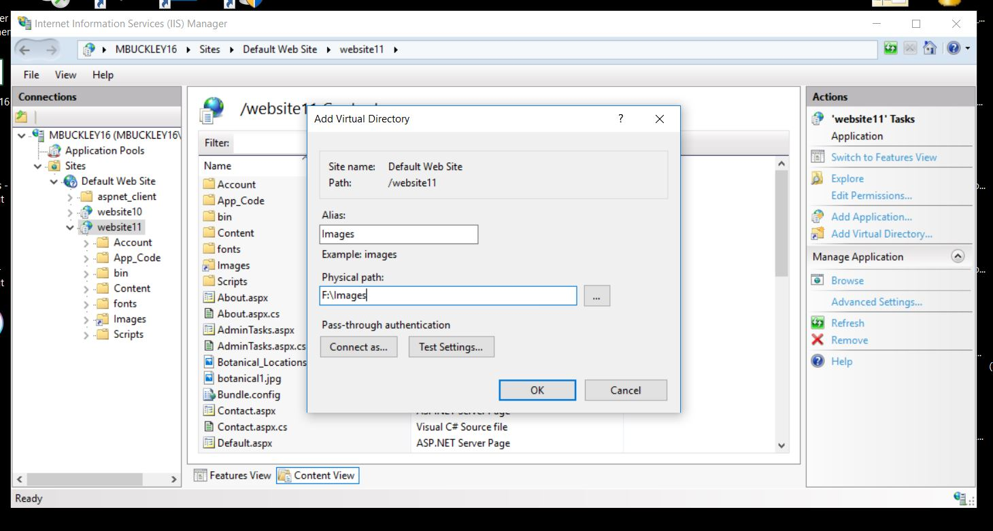

5. In SQL Server Management Studio, add IIS APPPOOL\DefaultAppPool to list of users in Security\Logins\(right click)New Logins:
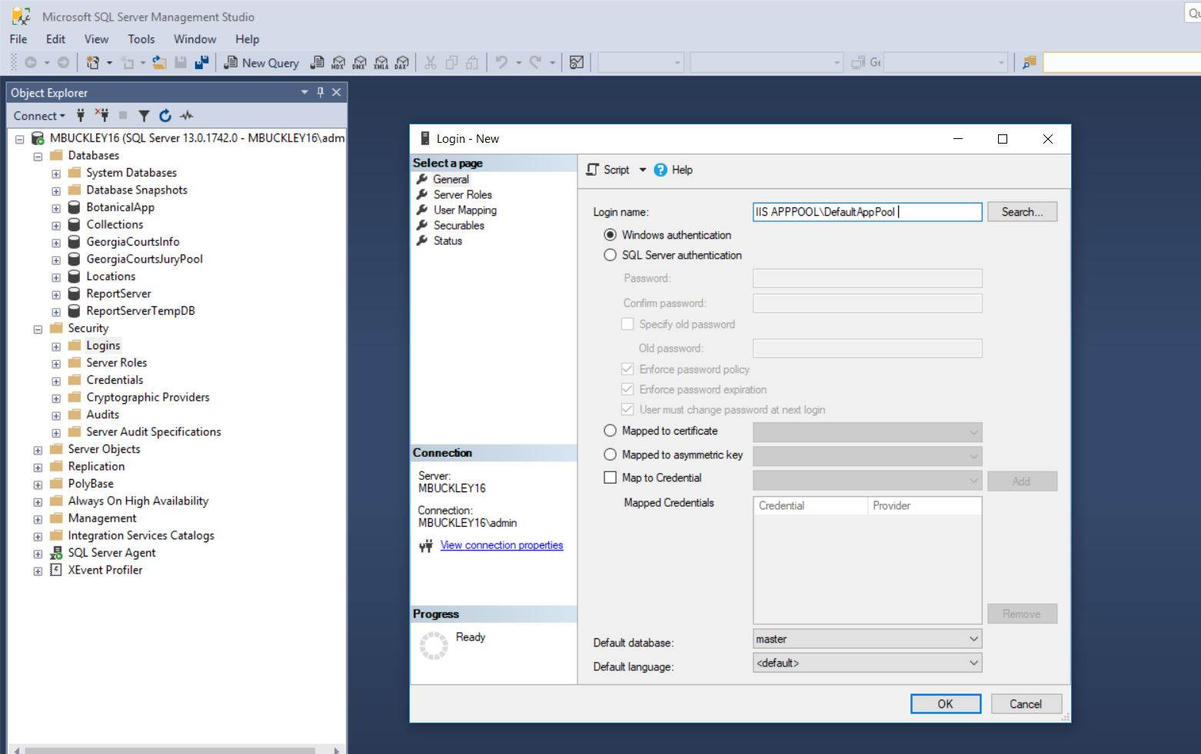
6. Under Security\Logins (right click on IIS APPPOOL\DefaultAppPool Properties) and grant Server Role = sysadmin.
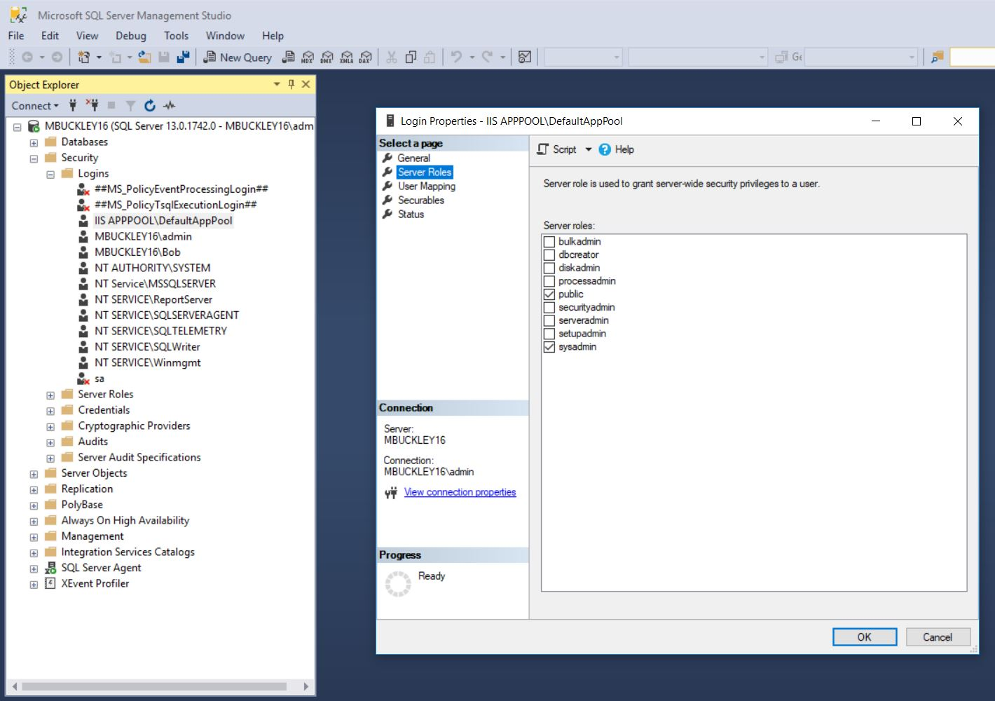

7. Make sure that default.aspx is the “Default Document” for Website11 in IIS Manager:
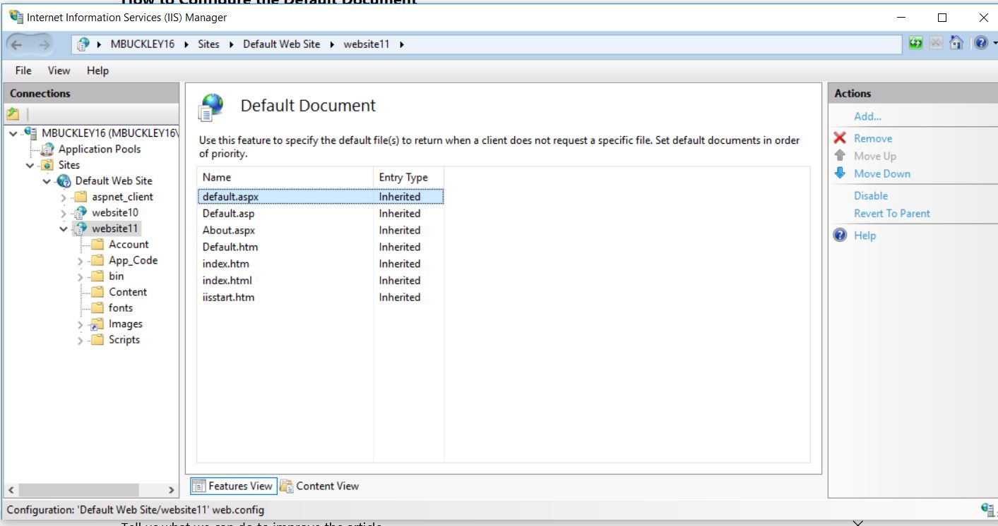

8. Reminder - In Control Panel / Programs and Features / (left side) Turn Windows Features On or Off
Enable these features under "Application Development Features"

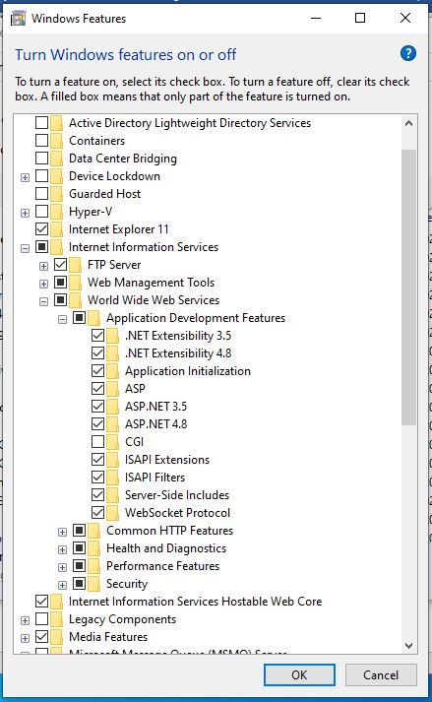

9. Browse to localhost\website11 to view website.

