Maximizing the Accuracy of the Retrieved Definition
of “Estuary” From Contextual Information
Matthew Sweeney
6 May 2002
CSE 663: Advanced Knowledge Representation

Abstract

The focus of the Contextual Vocabulary Acquisition project is to develop and refine a computational theory of how a system that understands natural language can understand a word that is unknown, incorrectly defined, or needs to have an additional meaning added to its definition through analyzing that word in context. The “context” includes the text surrounding the unknown word, grammatical clues, and background knowledge, but does not include external sources, such as a dictionary (Rapaport, Erhlich 2000: 347). My work consists of enhancing the current representation of “estuary” from previous work, contributing to further development of the noun definition algorithm, and eventually representing another passage to determine how well the current definition interacts with a new context. I have represented “estuary” in a practical way in relation to Karen Erhlich’s CVA noun definition algorithm.

1 Introduction

The focus of my work is to:
- Represent the meaning of “estuary” in SNePSUL code for implementation using the Contextual Vocabulary Acquisition (hereafter, CVA) algorithm
- Gain a solid understand of how the CVA algorithm works so that I could best represent the “estuary” passage in SNePS
- Develop a demonstration of the “estuary” passage working with the CVA algorithm
- Modify the original algorithm, if I deem my representation correct, so that it returns the correct information to define “estuary”

My work on this project will expose some of the problems of the current CVA algorithm and illustrates some methods of improving the algorithm. Further, my background knowledge is aimed toward a person with an average amount of knowledge about estuaries and bodies of water in general. The background knowledge base was intended to focus on things that a middle school age student would be able to understand or easily infer.

2 Semantics of the Network

A case frame is a pattern of arcs that connect nodes to another nodes. The pattern has a specific syntax and semantics, and is only value as it is understood by the reasoning system it is used with and whether that reasoning system has some built-in understand of what that pattern of nodes and arcs means.
The following is a list and explanation of the case frames that I utilized in my representation of “estuary.” Most of the case frames come from the case frame dictionary found online at the SneRG home page and at http://www.cse.buffalo.edu/sneps/Manuals/dictionary.ps or http://www.cse.buffalo.edu/sneps/Manuals/dictionary.pdf .

The following cases come from the case frame dictionary:

- Lex: p.5
- Member-Class: p.10
- Subclass – Superclass: p.13
- Object-Propername: p.8
- Object-Property: p.15
- Min-Max-Arg: p.23
- Agent – Act: p.20
- Action-Obj1-ObjN: p. 41

The following case frames used in the project come from the SNePS manual at http://www.cse.buffalo.edu/~jsantore/snepsman/:

&Ant-forall-cq: “And-entailment” (&ant, node 29)
Ant-forall-cq: “Or-entailement” (ant, node 31)
Skf-skarg: The Existential Quantifier – Skolem functions and constants (node 43).

The following case frames are based upon current case frames from the dictionary and are understood by Erhlich’s algorithm in her technical report (Erhlich 1995). The use of these case frames can be seen in Erhlich’s CVA algorithm itself ( see http://www.cse.buffalo.edu/~rapaport/676/F01/appendix.one.txt). These are all of the case frames that Erhlich’s algorithm recognizes. They may be referenced at Marc Broklawski’s case frame dictionary page for the noun definition algorithm at http://www.cse.buffalo.edu/~mkb3/case.frame.dictionary/case.frame.index.html:

- Agent-act
- Agent-act-object1 … objectN
- Agent-act-onto
- Member-class
- Object1-rel-Object2
  - Note that this case frame can be used generically for representing a relation between two objects, while at the same time it may be used to represent a relationship between some subordinate base node and some superordinate class.
- Mode-object
- Antonym-antonym
- Object-‘proper-name’
- Object-property
- Object-rel-possessor

Since my goal for this project was to align my representation as closely as possible with the case frames that Erhlich’s noun definition algorithm would gather information from, I did not attempt to implement any new case frames in the representation.

Also, I make extensive use of Skolem functions in my background knowledge and main passage representation, mainly to express part relationships between objects. For example, I can represent the concept, “there is some water of a river at the canyon,” using a Skolem function. I choose to represent things this way for 2 main reasons: (1) The Erhlich CVA algorithm does not address the issue of part-whole relationships, and (2) Using Skolem functions with the case frames that the algorithm retrieves gives you a return of most of the information that is represented in the semantic network.

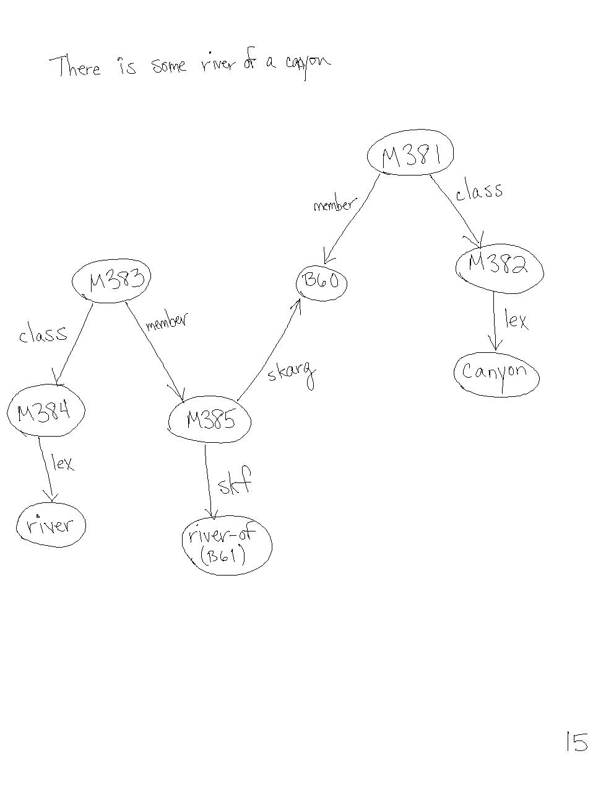

Figure 1: Node M385 represents “some river of the canyon.”
3 Representing “Estuary” in the CVA Algorithm’s Case Frames

Insofar as my goal for this project was to enhance the representation of “estuary” such that the CVA algorithm will extract and infer as much information as possible about “estuary” from my representation, I will focus on the enhancements I have made to the representation, instead of the best ways to implement the semantic network for the “most correct” representation. Note, however, that the entire representation is here for the sake of completeness. For an explanation of the original implementation of the estuary passage in its optimal and practical forms, see “Defining Estuary in the Context of Contextual Vocabulary Acquisition for a Semantic Network” (Sweeney 2001).

Revising my representation for Erhlich’s case frames in the CVA noun algorithm required rewriting some of the original passage, reworking some of the background knowledge (especially information about ‘bodies of water’), and writing new background rules to enable path and rule based inference such that the CVA algorithm would pick up the desired information that each sentence represents about “estuary.”

Main Passage Representation

I represented the main passage attempting to hold to the case frames that the noun algorithm checks for. The main passage reads:

An estuary is a coastal area where fresh water from rivers and streams mixes with salt water from oceans. Many bays, sounds, and lagoons are estuaries. Estuaries provide safe spawning grounds and nurseries and are critical for fish, birds, and other wildlife (“Striking a balance” 1997).

One major issue that forced me to reconsider my original representation was Erhlich’s concept of a “basic level category” and her use of that category for retrieving information within the semantic network for the noun definition. I found that her representation required determining what a “basic level category” was in the scheme of class representation must occur prior to and during the breakdown of the main passage.

The passage is broken down into four main clauses, and the SNePSUL code corresponds according. Initially, the code would not compile correctly when I represented Skolem functions built directly in a rule node, instead of building them beforehand, assigning them variable names, and then referring to those variable names in the rule node, as the code currently performs. By assigning the Skolem functions variable names, however, the rule becomes much more readable.

The way that information represented about estuary occurs in my passage forms a hierarchical structure – the first sentence is a definition of an estuary, the second sentence defines some examples of what estuaries are, the third sentence represents some information about an estuaries significance to other objects (especially in nature), and the last clause extends the relation to external objects.

The SNePSUL code precedes the graphical representation of the code. The graphical and SNePSUL representations of each clause follow:
Figure 2a: An estuary is a coastal area where fresh water from rivers and streams mixes with salt water from the ocean.

There is some salt water of the estuary that is a member of the class "salt water"

(describe
(add class (build lex "salt water")
member (build skf saltwater-of
skarg *estuary) = saltwater-of-estuary))

There is some fresh water of the estuary that is a member of the class "fresh water"

(describe
(add class (build lex "fresh water")
member (build skf freshwater-of
skarg *estuary) = freshwater-of-estuary))

There is some river of the estuary that is a member of the class "river"

(describe
(add class (build lex "river")
member (build skf river-of
skarg *estuary) = river-of-estuary))

There is some stream of the estuary that is a member of the class "stream"

(describe
(add class (build lex "stream")
member (build skf stream-of
skarg *estuary) = stream-of-estuary))

There is some ocean of the estuary that is a member of the class "ocean"

(describe
(add class (build lex "ocean")
member (build skf ocean-of
skarg *estuary) = ocean-of-estuary))

For all x that is a member of the class "estuary" then:
- x ISA coastal area
- there is some freshwater of the estuary that is "from" the river of the estuary that "mixes" with salt water that is "from" the ocean of the estuary and this "mixing" occurs at x
- there is some freshwater of the estuary that is "from" the stream of the estuary that "mixes" with salt water that is "from" the ocean of the estuary and this "mixing" occurs at x

(describe
(add forall $est
ant (build member *est
class (build lex "estuary"))
cq ((build object1 *est
rel "ISA"
object2 (build lex "coastal area"))
(build act (build lex "mix")
location *est
agent (build location *river-of-estuary
rel (build lex "from")
object *freshwater-of-estuary)
object (build location *ocean-of-estuary
rel (build lex "from")
object *saltwater-of-estuary))
(build act (build lex "mix")
location *est
agent (build location *stream-of-estuary
rel (build lex "from")
object *freshwater-of-estuary)
object (build location *ocean-of-estuary
rel (build lex "from")
object *saltwater-of-estuary)))))

There is some estuary:

(describe
(add member #est1
class (build lex "estuary")))
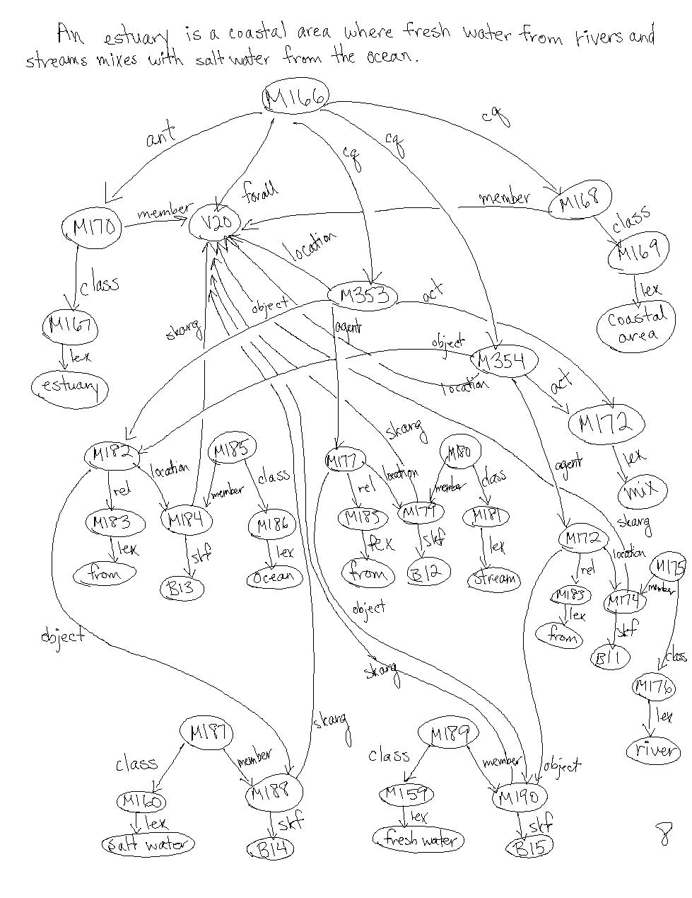
Figure 2a: An estuary is a coastal area where fresh water from rivers and streams mixes with salt water from the ocean.

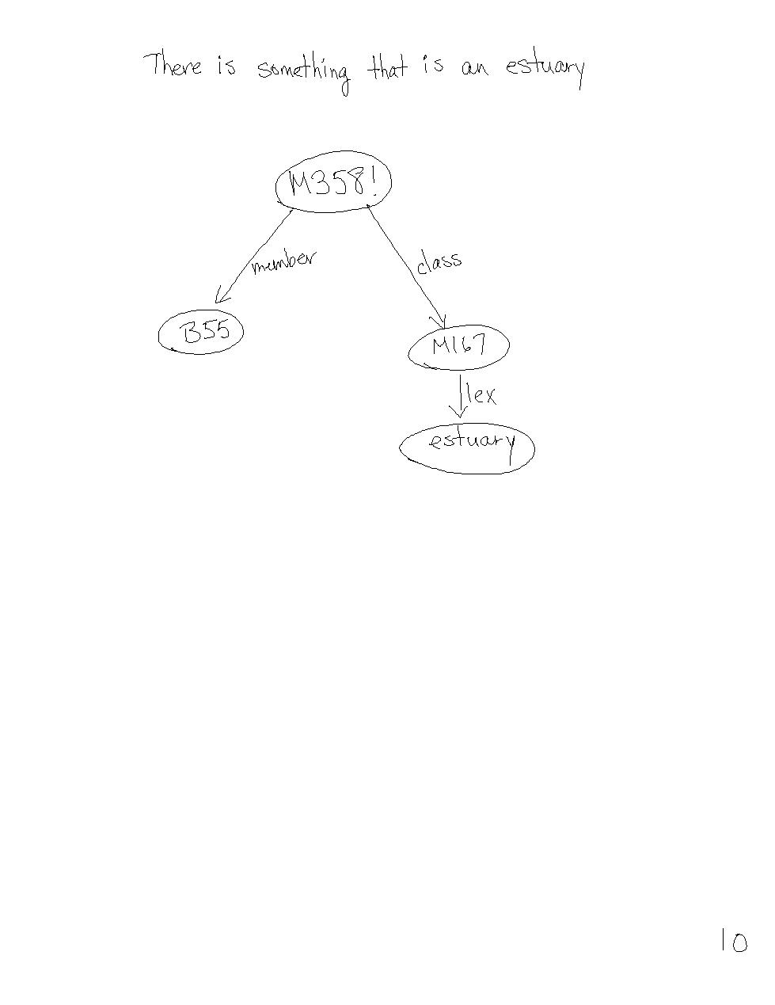
Figure 2a (part II): There is some estuary.

Figure 2b: Many bays, sounds, and lagoons are estuaries:

There is some x that is a member of the class "bay":

(describe
(add class (build lex "bay")
member #bay))

There is some x that is a member of the class "sound":

(describe
(add class (build lex "sound")
member #sound))

There is some x that is a member of the class "lagoon":

(describe
(add class (build lex "lagoon")
member #lagoon))

Bays are estuaries:

(describe
(add class (build lex "estuary")
member *bay))

Sounds are estuaries:

(describe
(add class (build lex "estuary")
member *sound))

Lagoons are estuaries:

(describe
(add class (build lex "estuary")
member *lagoon))

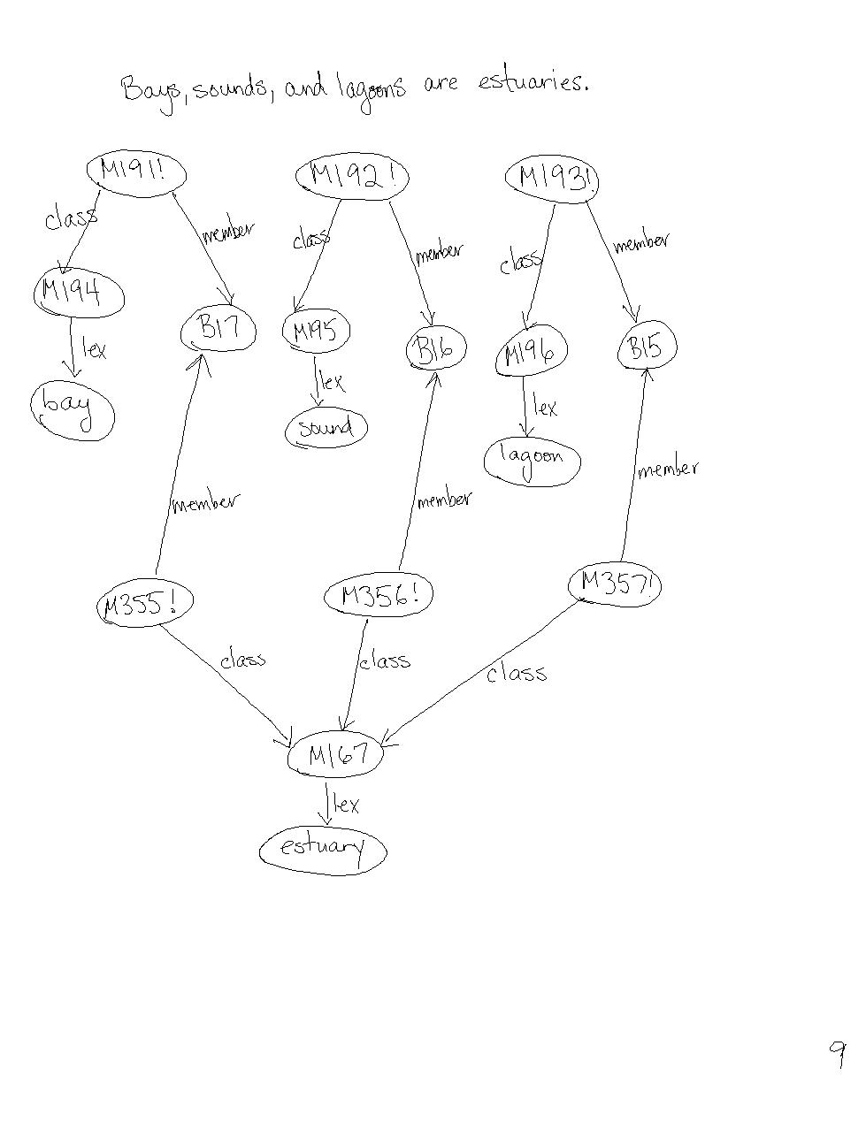
Figure 2b: (Many) Bays, sounds, and lagoons are estuaries.

Figure 2c: Estuaries are critical for fish, birds, and other wildlife:
The estuary(x) is in the relation "critical" to members of the classes of "fish", "birds" and "wildlife":

(describe
(add member #fish
class (build lex "fish")))

(describe
(add member #birds
class (build lex "birds")))

(describe
(add member #wildlife
class (build lex "wildlife")))

(describe
(add object1 *est1
rel (build lex "critical")
object2 (*fish *birds *wildlife)))
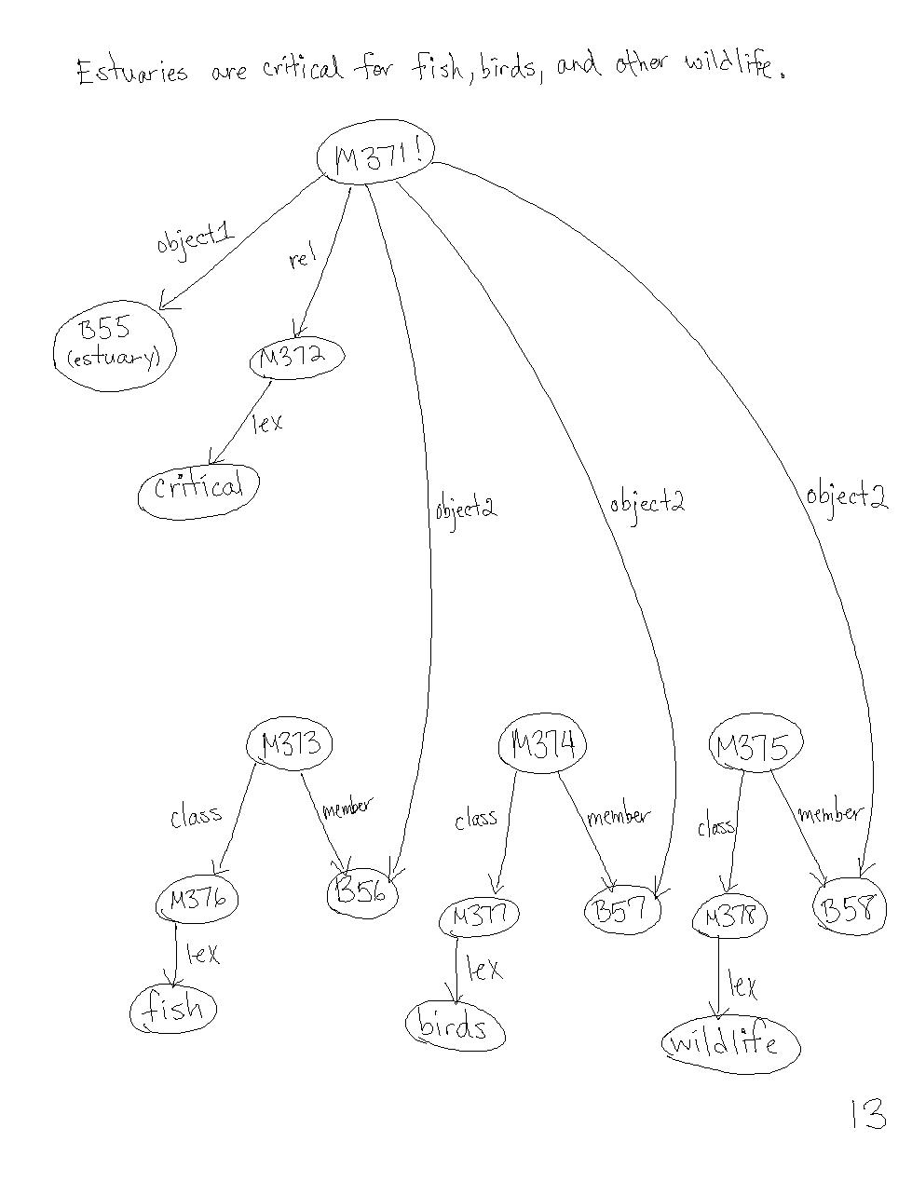
Figure 2c: Estuaries are critical for fish, birds, and other wildlife.

Figure 2d: Estuaries provide safe spawning grounds and nurseries:

For all estuary(x), spawning ground(y) and nursery(z), if x is a member of the class "estuary", y is a member of the class "spawning ground" and z is a member of the class "nursery" then y and z have the property of "safe" and x(the estuary) "provides" y and z:

(describe
(add forall ($est2 $spawn_grnd $nursery)
&ant ((build member *est2
class (build lex "estuary"))
(build member *spawn_grnd
class (build lex "spawning ground"))
(build member *nursery
class (build lex "nursery")))
cq ((build object *spawn_grnd
property (build lex "safe"))
(build object *nursery
property (build lex "safe"))
(build agent *est2
act (build lex "provide")
object *nursery)
(build agent *est2
act (build lex "provide")
object *spawn_grnd))))
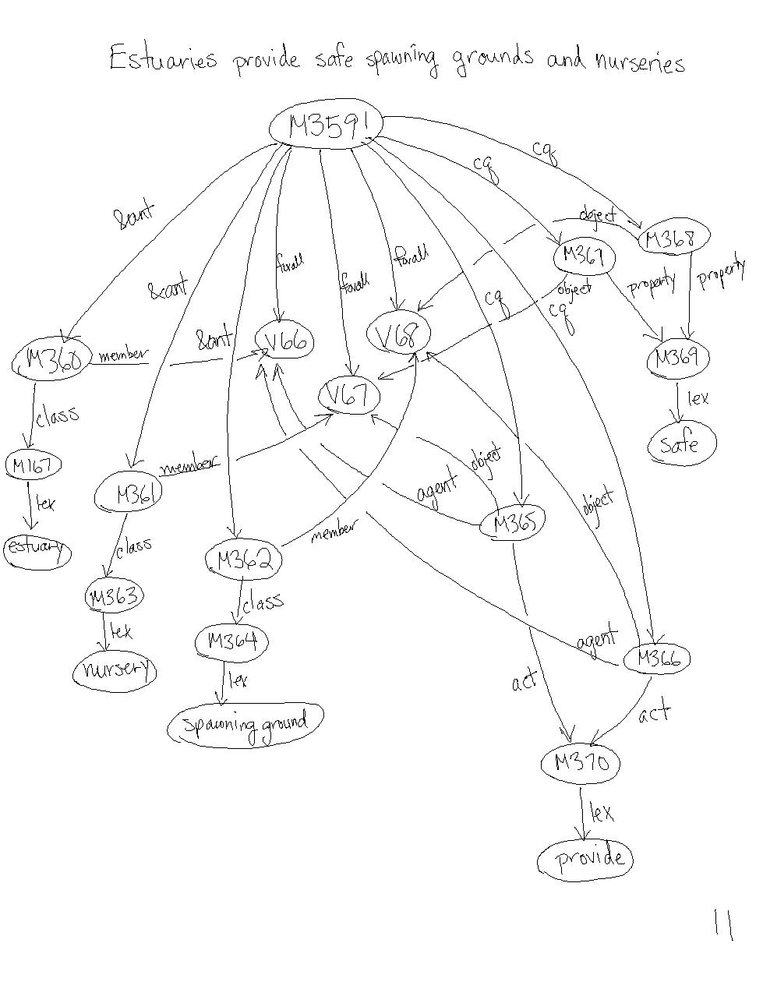
Figure 2d: Estuaries provides safe spawning grounds and nurseries.

Background Knowledge Representation

I had to modify my previous representation of the background knowledge for estuary for these main items:
  - existence of members of classes that have a universally quantified rule so that forward inference will work properly
  - Hierarchy (superclass-subclass) of “bodies of water” and “water” so that proper inferences were made about structural information for “estuary” and the actions (mixing) that are performed on liquids at an estuary
  - Rules so that structural information about an “estuary” is inferred (such as it containing a body of land and a body of water) and that relationships between bodies are water are built

Additionally, upon initially coding the SNePSUL representation of the background knowledge and main representation, some of the main informational iterms that were in the definition in the first sentence of the passage were not being caught by the CVA algorithm. Upon analyzing Erhlich’s base knowledge for her brachet and cat demos, I found that several rules might be helpful. Therefore, I attempted loading the entire cat demo and brachet background knowledge before loading my background or passage representation. Eventually, I was able to determine exactly which rules were benefiting the information being extracted from my representation and can now just load three additional rules. The following rule was especially helpful (as it picked up the “mixing”):

If a member of some class has a property, then it is possible for other members of that class to have that property:

(describe
(assert forall (*v14 *v15 *v17 $v18)
&ant ((build object *v17
property *v15)
(build member *v17
class *v14)
(build member *v18
class *v14))
cq (build mode (build lex "possibly")
object (build object *v18
property *v15))
kn_cat "life-rule.1"))

With this rule inserted as background knowledge, the act of mixing of liquids is picked up by the CVA algorithm, otherwise it is not, but other information is deduced in its place. Without that rule inserted, however, additional structure information is extracted and useful information is still gained about the acts that “estuary” can perform.

The SNePSUL and graphical representations of the background knowledge:

There is something that is the "land-of" the class of bodies of land:

(describe
(assert member (build skf "land-of"
skarg #cstarea) = landofcoast
class (build lex "body of land")))

There is something that is the "water-of" the class of bodies of water:

(describe
(assert member (build skf "water-of"
skarg *cstarea) = waterofcoast
class (build lex "body of water")))

If x is a coastal area, then x stands in the "contain" relation to some y and z that are the land of the coast and water of the coast, respectively, and x is where land and watch "touch”:

(describe
(assert forall $cstarea1
ant (build member *cstarea1
class (build lex "coastal area"))
cq ((build object1 *landofcoast
rel (build lex "touch")
object2 *waterofcoast)
(build object1 *cstarea1
object2 (*waterofcoast *landofcoast)
rel (build lex "contain")))))
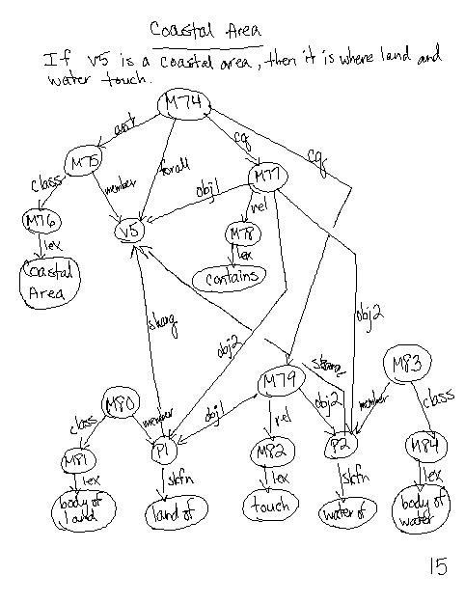
Figure 3: If there is some coastal area, then it is a place where land and water touch.

If x and y are liquids and they mix, then the act of mixing forms z, a new liquid:

(describe
(assert forall ($liq1 $liq2)
&ant ((build class (build lex "liquid")
member *liq1)
(build class (build lex "liquid")
member *liq2)
(build agent *liq1
act (build lex "mix")
object *liq2))
cq ((build member #newliq
class (build lex "liquid"))
(build agent ((build agent *liq1
act (build lex "mix")
object *liq2))
act (build lex "form")
object *newliq))))
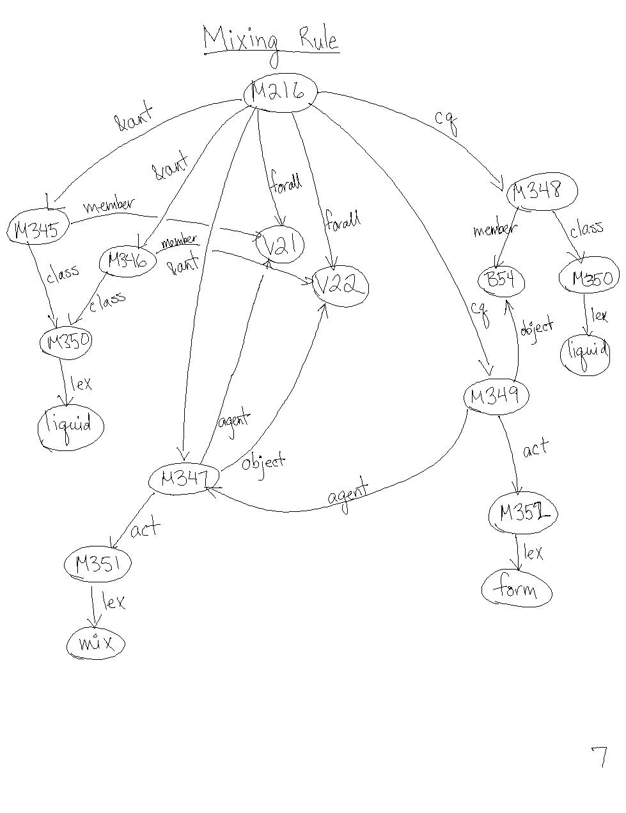
Figure 4: If 2 liquids mix, then a new liquid is formed by the action of mixing.

There is some member of the class "fish" that is a fish of the spawning ground:

(describe
(assert class (build lex "fish")
member (build skf "fish-of"
skarg #spawn_grnd) = fish-of-spawn-grnd))

There is some member of the class "eggs" that is the eggs of the spawning ground:

(describe
(assert class (build lex "eggs")
member (build skf "eggs-of"
skarg *fish-of-spawn-grnd) = eggs-of-spawn-grnd))

Rule (necessary condition) for what a spawning ground is:
If there is some member of the class of "spawning ground" then there are some fish of the spawning ground that lay eggs of the spawning ground.

(describe
(assert forall *spawn_grnd
ant (build class (build lex "spawning ground")
member *spawn_grnd)
cq (build agent *fish-of-spawn-grnd
act (build lex "lay")
in *spawn_grnd
object *eggs-of-spawn-grnd)))
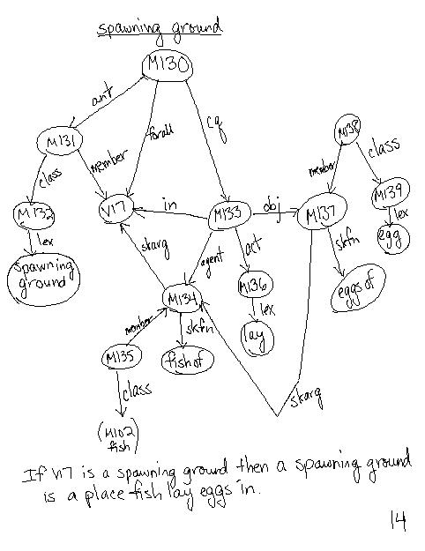
Figure 5: If there is some spawning ground, then a spawning ground is a place fish lay eggs in.

Knowledge base for fresh and salt water; rule for what salt water is:

"Salt water" is a member of class "water":

(describe
(assert class (build lex "water")
member (build lex "salt water")))

"Fresh water" is a member of the class "water.”:

(describe
(assert class (build lex "water")
member (build lex "fresh water")))

Water is a subclass of liquid:

(describe
(assert member (build lex "water")
class (build lex "liquid")))
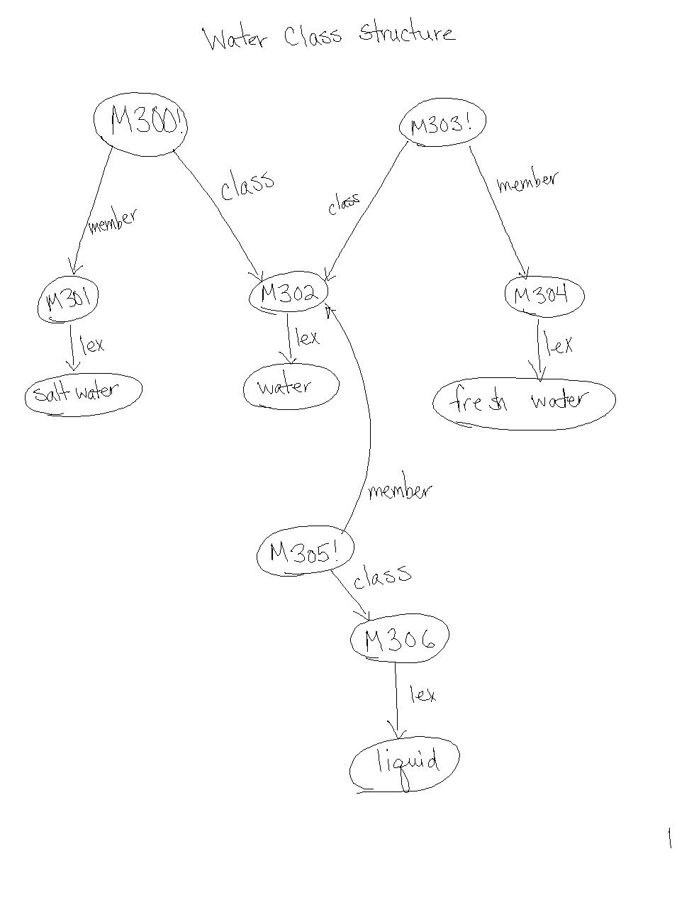
Figure 6: Salt water is water; fresh water is water; water is liquid

For all x, if x is a member of the class "salt water," then x "contains" salt:

(describe
(assert forall $sw
ant (build class (build lex "salt water")
member *sw)
cq (build object1 *sw
rel (build lex "contain")
object2 (build lex "salt"))))
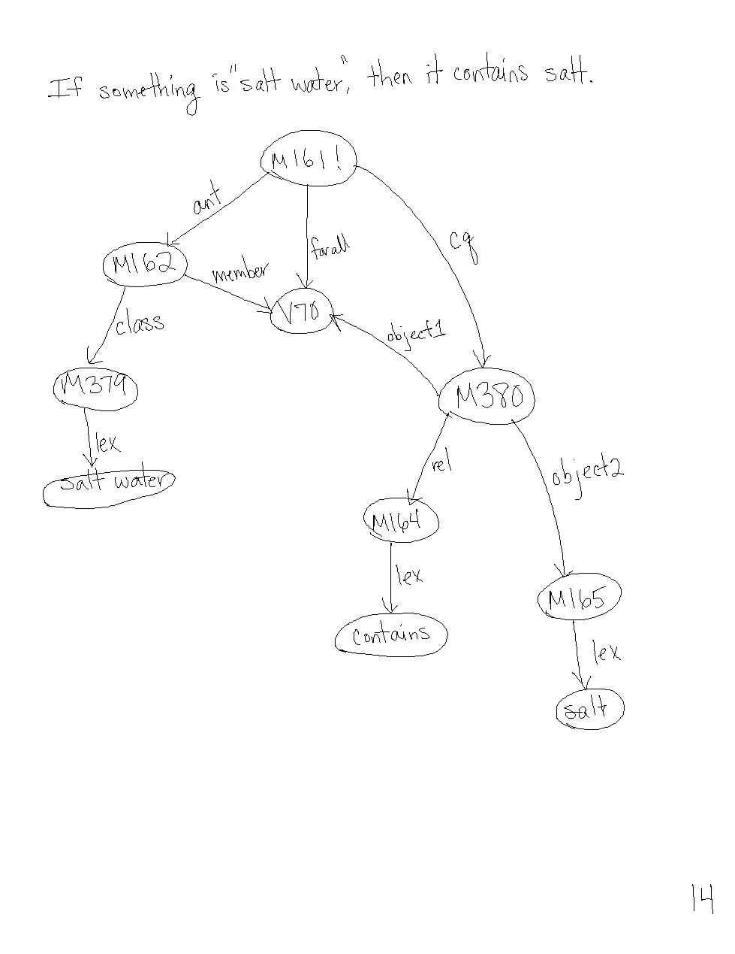
Figure 7: If there is some salt water, then it contains salt

Background for different bodies of water:

An ocean is a subclass of "bodies of water":

(describe
(assert superclass (build lex "body of water")
subclass (build lex "ocean")))

There is some ocean:

(describe
(assert class (build lex "ocean")
member #ocean))

The ocean is a "body of water":

(describe
(assert class (build lex "body of water")
member *ocean))

A gulf is a subclass of "oceans":

(describe
(assert superclass (build lex "ocean")
subclass (build lex "gulf")))

There is a gulf:

(describe
(assert class (build lex "gulf")
member #gulf))

The gulf is a "body of water":

(describe
(assert class (build lex "body of water")
member *gulf))

A bay is a subclass of "gulfs":

(describe
(assert superclass (build lex "gulf")
subclass (build lex "bay")))

There is a bay:

(describe
(assert class (build lex "bay")
member #bay))

The bay is a "body of water":

(describe
(assert class (build lex "body of water")
member *bay))

A Cove is a subclass of "bays":

(describe
(assert superclass (build lex "bay")
subclass (build lex "cove")))

A lagoon is a subclass of "bodies of water":

(describe
(assert superclass (build lex "body of water")
subclass (build lex "lagoon")))

There is a lagoon:

(describe
(assert member #lag
class (build lex "lagoon")))

The lagoon is a "body of water":

(describe
(assert class (build lex "body of water")
member *lag))

A gulf is a subclass of "sounds":

(describe
(assert superclass (build lex "sound")
subclass (build lex "gulf")))
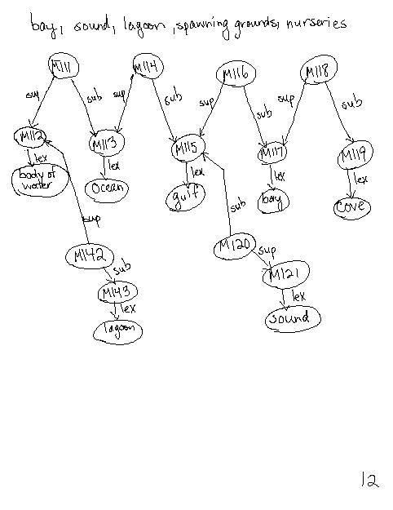
Figure 8: Superclass-subclass structure for different bodies of water
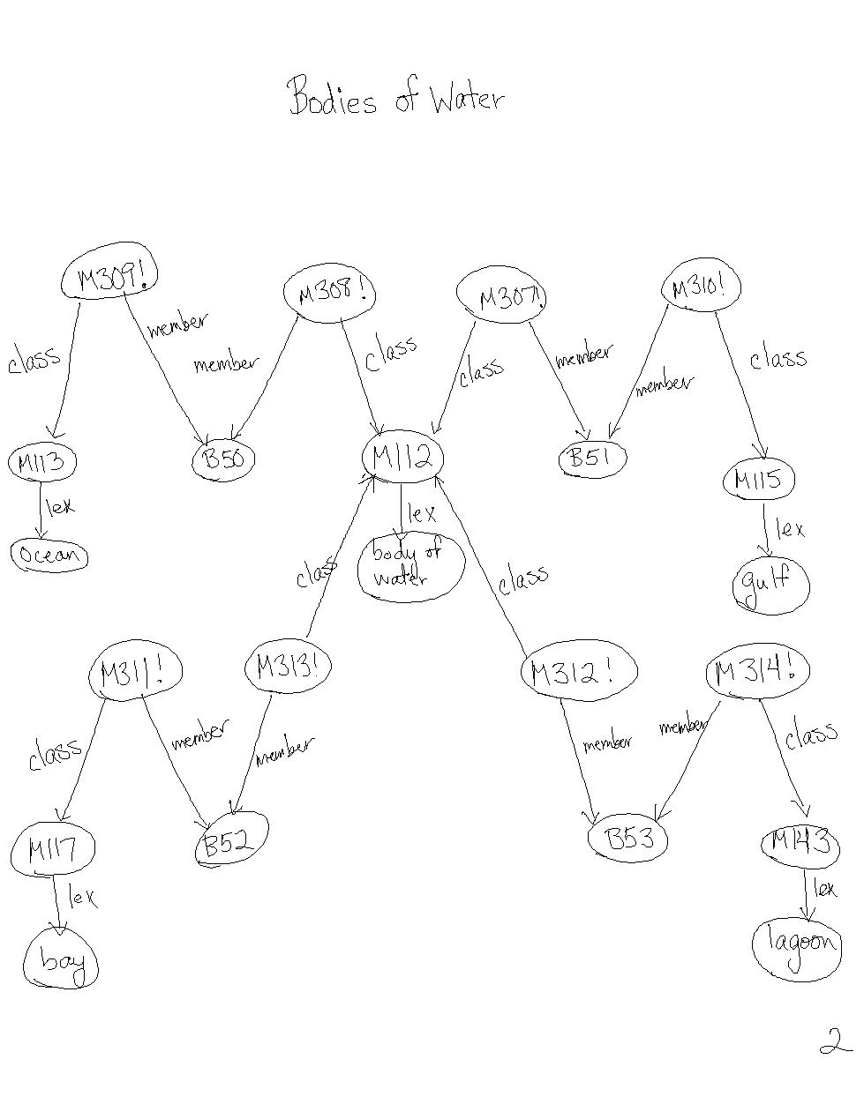
Figure 9: Oceans, bays, sounds, and lagoons are bodies of water

Rule (necessary condition) for what a lagoon is:

For all x, if x is a member of the class "lagoon", then a reef separates x from a "body of water" and there is some reef of the lagoon that is the member of the class reefs and there is some reef of the lagoon that either has the property of being coral or sand.:

(describe
(assert forall $lagoon
ant (build class (build lex "lagoon")
member *lagoon)
cq ((build object *lagoon
act (build lex "separate")
from (build lex "body of water")
agent (build skf "reef-of"
skarg *lagoon) = reef-of-lagoon)
(build member *reef-of-lagoon
class (build lex "reef"))
(build object *reef-of-lagoon)
property (build min 1 max 1
arg ((build object (build lex "reef")
property (build lex "coral"))
(build object (build lex "reef")
property (build lex "sand"))))))))
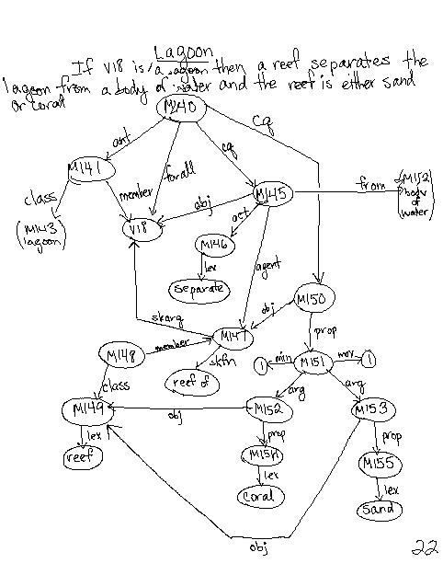
Figure 10: If something is a lagoon, then it is a body of water and it can be separated by either a sand or coral reef.

Class information for fish, birds, and other wildlife:

A fish is a subclass of "wildlife":

(describe
(assert superclass (build lex "wildlife")
subclass (build lex "fish")))

A bird is a subclass of "wildlife":
(describe
(assert superclass (build lex "wildlife")
subclass (build lex "birds")))
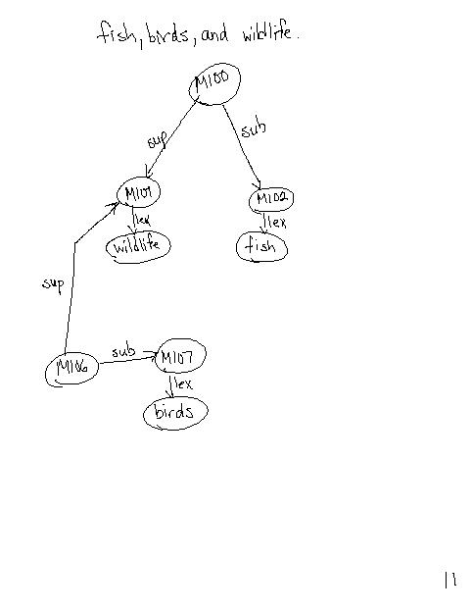
Figure 11: Birds and fish are subclasses of wildlife

Rule "if x is critical for y, then if something harmful(z) affects x, then z affects to y.":

(describe
(assert forall ($x $y)
ant (build object1 *x
rel (build lex "critical")
object2 *y)
cq (build forall $z
&ant ((build object *z
property (build lex "harmful"))
(build object1 *z
rel (build lex "affect")
object2 *x))
cq (build object1 *z
rel (build lex "affect")
object2 *y))))
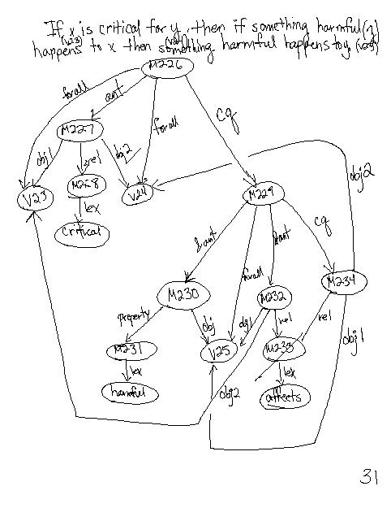
Figure 12: If x is critical for y, then if something harmful happens to x, then something harmful happens to y.

Rule "if something harmful(z) affects x, then z affects y." (sufficient condition):

(describe
(assert forall (*x *z)
&ant ((build object *z
property (build lex "harmful"))
(build object1 *z
rel (build lex "affect")
object2 *x))
cq (build forall *y
ant (build object1 *z
rel (build lex "affect")
object2 *y)
cq (build object1 *x
rel (build lex "critical")
object2 *y))))
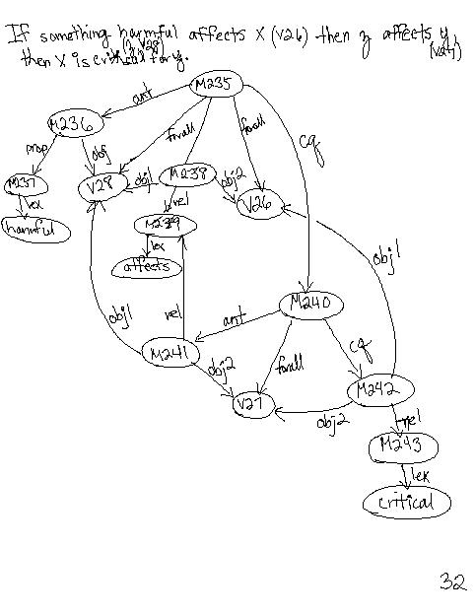
Figure 13: If something harmful (z) affects x, and then z affects y, then x is critical for y.

Rule "if a1 provides b1, then a1 possesses b1:
(describe
(assert forall ($a1 $b1 $class-of-b1)
&ant ((build agent *a1
act (build lex "provide")
object *b1)
(build member *b1
class (build lex *class-of-b1)))
cq (build object *b1
rel (build lex *class-of-b1)
possessor *a1)))
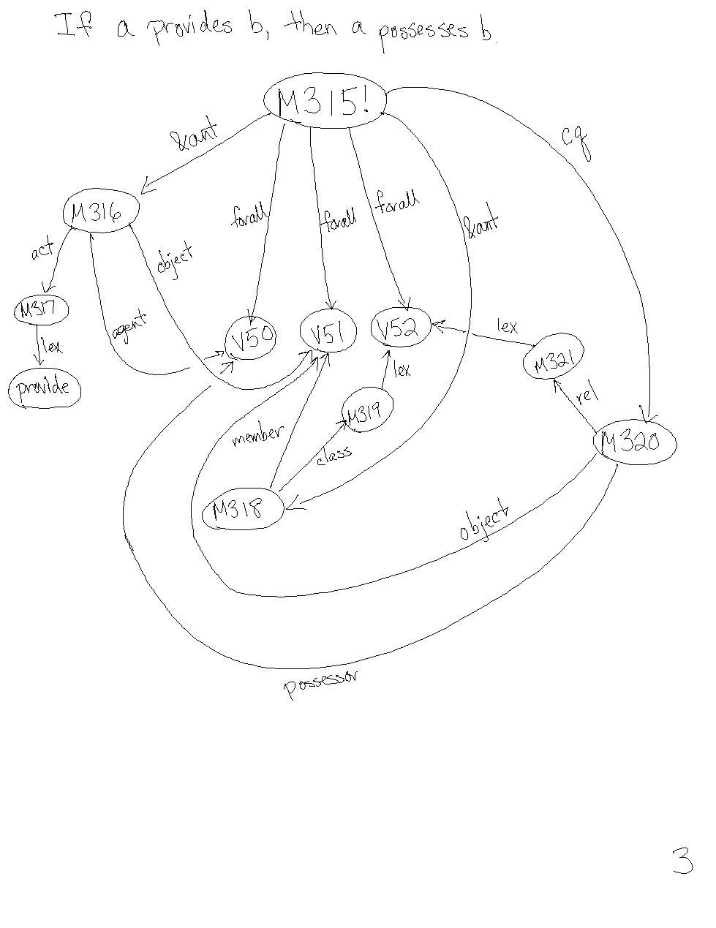
Figure 14: If a provides b, then a possesses b.

Rule "if a provides c for b, then a gets its b from c.":

(describe
(assert forall ($a $b $c)
ant (build agent *a
act (build lex "provide")
object (build object1 *c
rel (build lex "for")
object2 *b))
cq (build agent *b
act (build lex "get")
object (build object1 *c
rel (build lex "from")
object2 *a))))
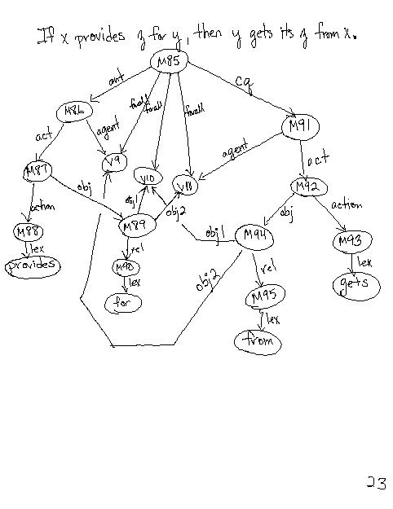
Figure 15: If x provides z for y, then y gets its z from x.

Rule "if b gets its c from a, then a provides c for b.":

(describe
(assert forall (*a *b *c)
ant (build agent *b
act (build lex "get")
object (build object1 *c
rel (build lex "from")
object2 *a))
cq (build agent *a
act (build lex "provide")
object (build object1 *c
rel (build lex "for")
object2 *b))))

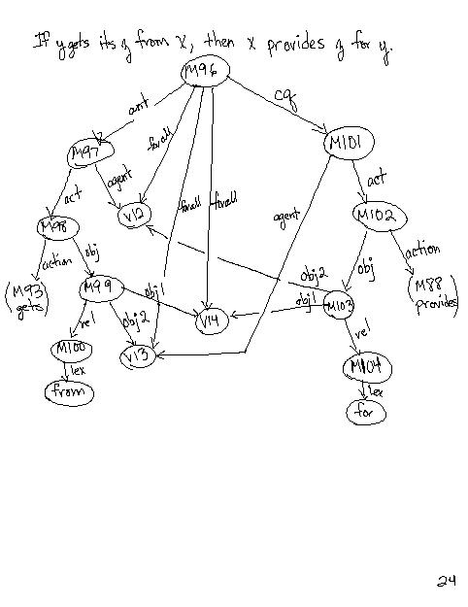
Figure 16: If y gets its z from x, then x provides z for y.

Rule that forall c and w, if c "contains" w, then c possesses w:

(describe
(assert forall ($c $w $class-of-w)
&ant ((build object1 *c
rel (build lex "contain")
object2 *w)
(build member *w
class (build lex *class-of-w)))
cq (build object *w
rel (build lex *class-of-w)
possessor *c)))
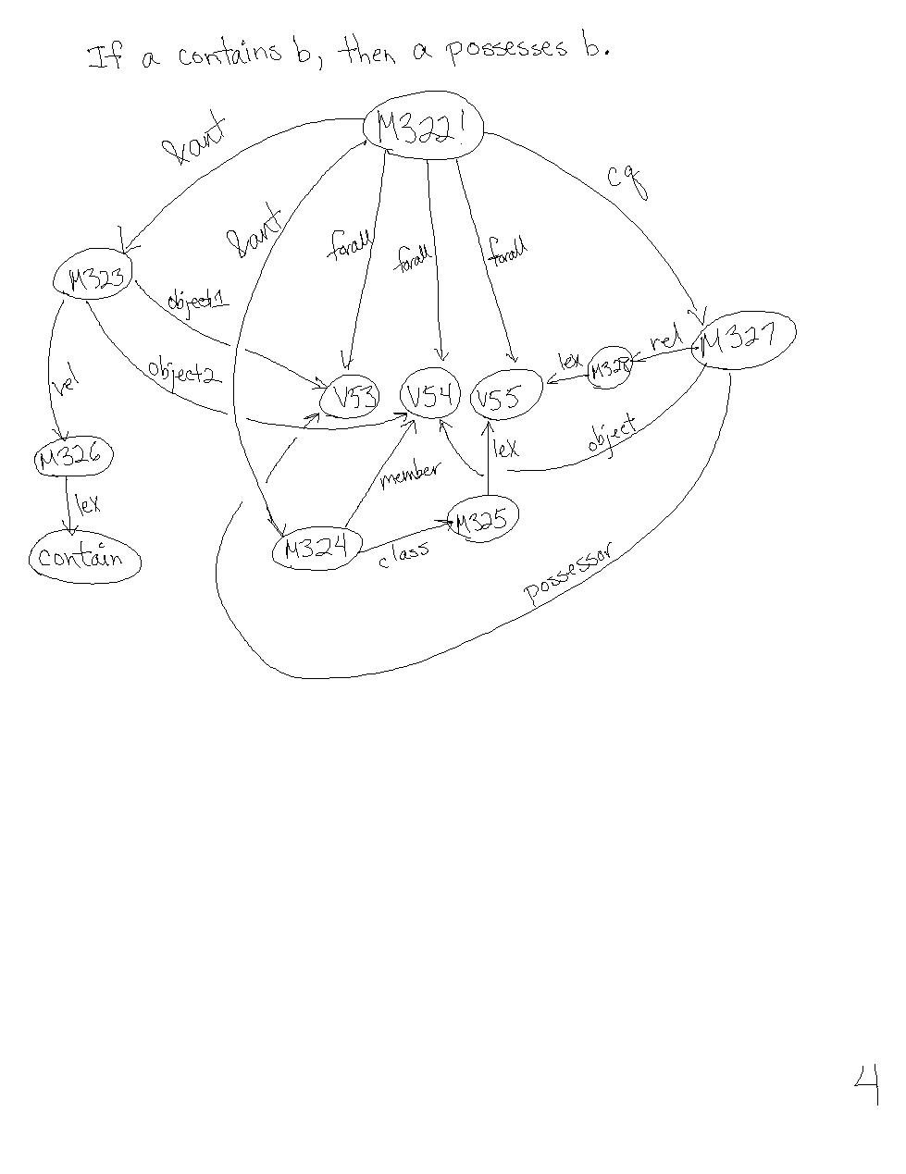
Figure 17: If a contains b, then a possesses b.

If 2 liquids are members of the class (body-of?) water mix at a certain location(loc), then that location is a member of the class body-of water:

(describe
(assert forall ($loc $ag $obj *liq1 *liq2)
&ant ((build member *liq1
class (build lex "body of water"))
(build member *liq2
class (build lex "body of water"))
(build act (build lex "mix")
location *loc
agent *ag
object *obj))
cq (build member *loc
class "body of water")))
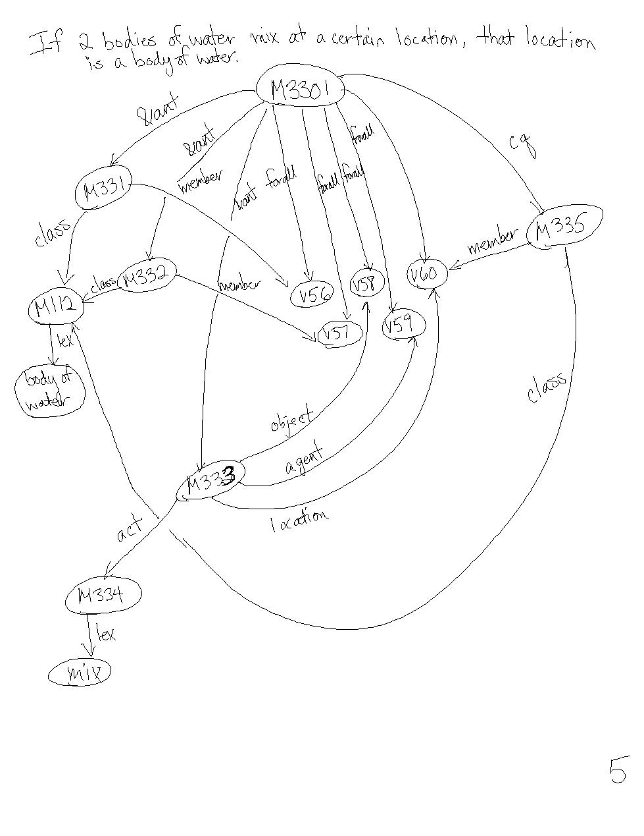
Figure 18: If 2 bodies of water mix at a certain location, that location is a body of water.

An even stronger rule of the above is:
If 2 liquids mix, aremembers of class water, and they mix at a certain location (loc) which "touches" land, then that location is a member of class "body of water":

(describe
(assert forall (*loc *ag *obj $obj2 *liq1 *liq2)
&ant ((build member *liq1
class (build lex "water"))
(build member *liq2
class (build lex "water"))
(build act (build lex "mix")
location *loc
agent *ag
object *obj)
(build object1 *loc
rel (build lex "touch")
object2 *obj2))
cq ((build member *loc
class (build lex "body of water")))))
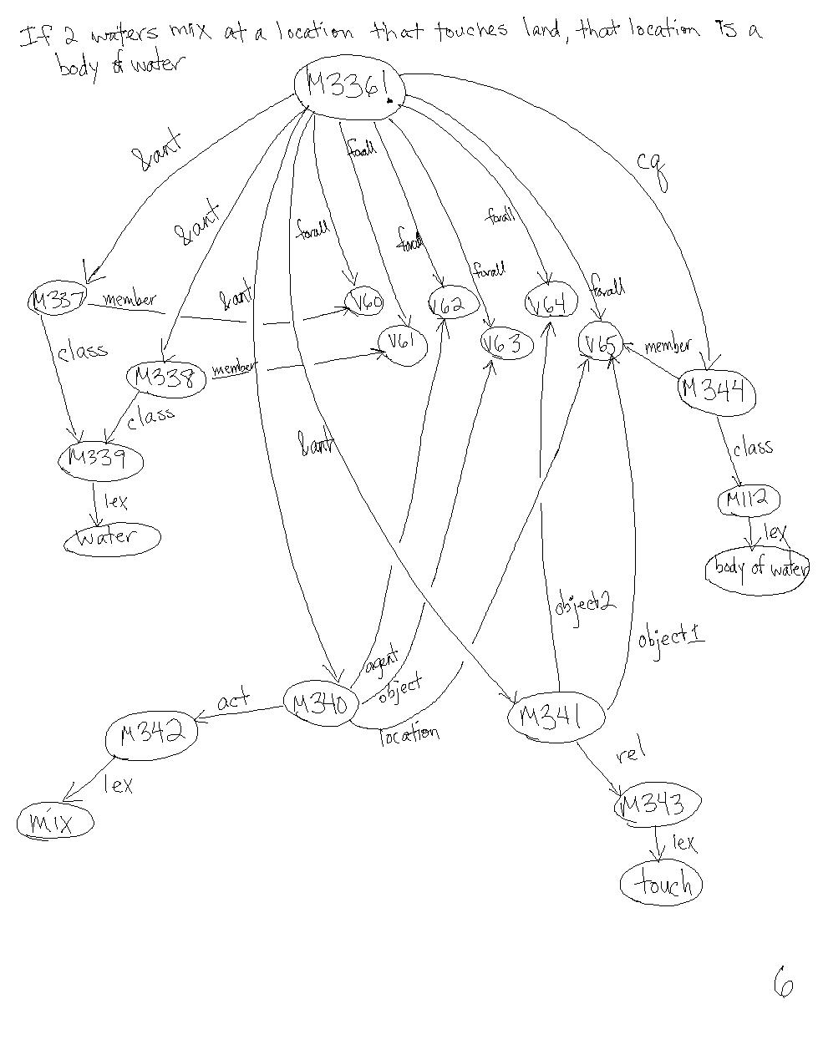
Figure 19: If 2 waters mix at a certain location that touches land, then that location is a body of water.

Extra background knowledge from Karen Erhlich’s brachet demo:

If something belongs to a subclass of a basic category, then it's a member of that category:
(describe
(assert forall ($v10 $v11 $v12)
&ant ((build object1 *v12
object2 (build lex "basic ctgy")
rel "ISA")
(build subclass *v11
superclass *v12)
(build object1 *v10
object2 *v11
rel "ISA"))
cq (build member *v10
class *v12)
kn_cat "intrinsic"))

If a member of some class has a property, then it is possible for other members of that class to have that property:
(describe
(assert forall (*v14 *v15 *v17 $v18)
&ant ((build object *v17
property *v15)
(build member *v17
class *v14)
(build member *v18
class *v14))
cq (build mode (build lex "possibly")
object (build object *v18
property *v15))
kn_cat "life-rule.1"))

(describe
(assert forall (*v14 *v15 *v17 *v18)
&ant ((build object1 *v17
object2 *v14
rel "ISA")
(build object *v17
property *v15)
(build object1 *v18
object2 *v14
rel "ISA"))
cq (build mode (build lex "possibly")
object (build object *v18
property *v15))
kn_cat "life-rule.1"))

4 Algorithm Results Comparison

There are two configurations for the estuary demo for defining the noun algorithm – one with the extra background knowledge from Erhlich’s background knowledge for brachet, the other without that information. Both of the implementations produce fairly different results, although there is information being hidden in the first implementation because of the limited values that are currently returned by the CVA algorithm.

Further, the standard method of forward and bi-directional inference for the SNePS system limits the values that can be returned, so that not too many things are inferred each time something is added to or deduced from the network. That is, if this functionality were not in place then Cassie would infer everything possible and build all arcs possible from the information in the system. Shapiro, Martins, and McKay discuss bi-directional inference in the SNePS system, presenting that “instead of doing a network pattern match to find additional rules, it uses rule instance AI immediately” (Shapiro, Martins, McKay 1982: 92). This kind of functionality, however, was inhibiting certain inferences in my system, so I found it useful to turn this “feature” off, and I received much better results because the rules concerning the structural information for “estuary” was being inferred properly.

- Running with extra Erhlich KB from brachet demo:

((UNIVERSAL DEF= (A ESTUARY IS A (coastal area))
STRUCTURE= (POSSIBLE STRUCTURAL FEATURES= (spawning ground nursery)) FUNCTION= NIL
ACTIONS= ((mix) (liquid estuary))
OWNERSHIP= NIL
POSSIBLE PROPERTIES= NIL))

- Running without extra background knowledge

((UNIVERSAL DEF= (A ESTUARY IS A (coastal area))
STRUCTURE= (POSSIBLE STRUCTURAL FEATURES= (spawning ground nursery body of water body of land))
FUNCTION= NIL
ACTIONS= ((provide) (spawning ground nursery))
OWNERSHIP= NIL
POSSIBLE PROPERTIES= NIL))

Both runs produce similar results, but the second run produces greater structural information, some of which should probably only be included in the “ACTIONS” category, while the act of mixing liquids should be included in that category as well. At the same time, knowing that there is a “body of land” and “body of water” at an estuary is correct and reflective of a proper definition.

5 Algorithm Enhancement

The enhancements I made to the noun algorithm consisted of two parts:
- New Universally quantified definition for the noun
The new “universal” definition returns both the necessary and sufficient conditions for the noun to be related directly to another class (noun is a x, or x is a noun). The following is a plain English explanation of the output that gets generated for the “univ_def” algorithm:

  - If only the second sufficient condition exists, that is returned
  - If only second sufficient condition and second necessary condition exist, they are returned
  - If only second sufficient condition and both necessary conditions exist, they are returned.
  - If only the first sufficient condition exists, that is returned
  - If only first sufficient condition and second necessary condition exist, they are returned
  - If only first sufficient condition and both necessary conditions exist, they are returned.
  - If both the second and first sufficient conditions exists, they are returned
  - If both sufficient conditions exist and the second necessary condition exists, then they are returned
  - If both sufficient conditions exist and the first necessary condition exists, they are returned
  - If all necessary and sufficient conditions exist, then they are all returned

This code modification was necessary to develop the definition saying “An estuary is a coastal area […].”

;----------------------------------------------------------------------------
; function: univ_def
; input: a noun to be defined
; output: a list of universally quantified defintions for the noun,
; which included necessary conditions of what the noun is
; (of the form, for all (noun), if there is some (noun),
; then noun is a "x", and the sufficient condition would
; cover the converse of that rule
;
; written: mss 04/02
;----------------------------------------------------------------------------
(defun univ_def (noun)
(setq nec1 #3! ((find (compose lex- class- cq- ! forall member- class lex) ~noun)))
(setq nec2 #3! ((find (compose lex- object2- cq- ! forall member- class lex) ~noun)))
(setq suff1 #3! ((find (compose lex- class- ant- ! forall member- class lex) ~noun)))
(setq suff2 #3! ((find (compose lex- object1- ant- ! forall member- class lex) ~noun)))
(if (null nec1)
(if (null nec2)
(if (null suff1)
(if (null suff2)
(list 'nil)
(list 'a
suff2
'is 'a noun))
(list 'both (append suff1 suff2) 'are 'a noun))
(if (null suff1)
(if (null suff2)
(list 'a noun 'is 'a
nec2)
(list 'a noun 'is 'a
nec2
'and 'a
suff2
'is 'a noun))
(list 'a noun 'is 'a
nec2
'and (append suff1 suff2) 'is 'a noun)))
(if (null suff1)
(if (null suff2)
(list 'a noun 'is 'a (append nec1 nec2))
(list 'a noun 'is 'a (append nec1 nec2)
'and 'a
suff2
'is 'a noun))
(list 'a noun 'is 'a (append nec1 nec2) 'and
(append suff1 suff2) 'is 'a noun))))

- Insertion of the new universal definition into the noun definition template

The new value in the definition template for “universal def” is the value that is returned from the universally quantified rule about the (noun).

;--------------------------------------------------------------------------
;
; function: report_basic
; input: noun to be defined
; output: a list of class inclusions for the noun, a universally
; quantified (necessary and sufficient conditions) rule
; of what the noun is, as well as any actions, functions,
; structure, certain relations, and synonyms
; calls: act_filter, acts, classes, class_filter, func, struct,
; syn_noun, indiv_rand_rels, univ_def
; written: kae ??/92
; modified: kae 03/94
; modified: mss 04/02
;--------------------------------------------------------------------------
(defun report_basic (noun)
(setq clsall (classes noun))
addition → (setq univdef (univ_def noun))
(setq cls (class_filter clsall nil noun))
(setq str (struct noun clsall))
(setq fun (func noun))
(setq ac (acts noun))
(setq prop (genprop noun))
(if (null prop)
(if (and (null str) (null fun))
(list cls
addition → 'universal 'def= univdef
'structure= 'nil
'function= 'nil
'actions= (act_filter ac nil noun)
'ownership= (indiv_rand_rels noun)
'possible 'properties= (indiv_rand_props noun)
'synonyms= (syn_noun noun str fun cls))
(list cls
addition → 'universal 'def= univdef
'structure= str
'function= fun
'actions= (act_filter ac nil noun)
'ownership= (indiv_rand_rels noun)
'synonyms= (syn_noun noun str fun cls)))
(if (and (null str) (null fun))
(list cls
addition → 'universal 'def= univdef
'structure= 'nil
'function= 'nil
'actions= (act_filter ac nil noun)
'ownership= (indiv_rand_rels noun)
'properties= prop
'synonyms= (syn_noun noun str fun cls))
(list cls
addition → 'universal 'def= univdef
'structure= str
'function= fun
'actions= (act_filter ac nil noun)
'ownership= (indiv_rand_rels noun)
'properties= prop
'synonyms= (syn_noun noun str fun cls)))))

The insertions that were made to the “report_basic” algorithm were made to all the other “reporting” functions, including “there_exists,” so that the value for the universally quantified definition (necessary and sufficient conditions) will always be included in any definition template.
6 Immediate Future Work

- Modify the CVA noun algorithm to return all the data that exists about acts, functionality, structure, etc., instead of stopping at the first value that is returned.
- Ensure compatibility with the (rapidly) upcoming SNePS 2.6 implementation.
- Make sure the new necessary and sufficient condition definition template works properly (test the sufficient conditions)

7 Future Work

- Represent some other passages for estuary
- Implement the algorithm in SNePS 3.0 (completely rewrite it) once it becomes available
- Develop an explanation facility so that Cassie can explain how she derives the meaning of the unknown word to a user.
- Write a parser and generator so that the natural language facilities of SNePS can be implemented in defining the meaning of some unknown word that is entered by the user.

Appendix A – SNePSUL code

I. Background Knowledge Base:

;;; This is the base set of assertions for the "estuary" passage
;;; for use with Karen Erlich's CVA algorithm
;;; Written by Matthew Sweeney, Spring 2002.

; There is something that is the "land-of" the class of bodies of land
(describe
(assert member (build skf "land-of"
skarg #cstarea) = landofcoast
class (build lex "body of land")))

; There is something that is the "water-of" the class of bodies of water
(describe
(assert member (build skf "water-of"
skarg *cstarea) = waterofcoast
class (build lex "body of water")))

; There is some estuary
(describe
(assert member #estuary
class (build lex "estuary")))

; There is some nursery
(describe
(assert member #nur
class (build lex "nursery")))

; There is some spawning ground
(describe
(assert member #spawn
class (build lex "spawning ground")))

; If x is a coastal area, then x stands in the "contain" relation
; to some y and z that are the land of the coast and water of the coast,
; respectively, and x is where land and watch "touch."
(describe
(assert forall $cstarea1
ant (build member *cstarea1
class (build lex "coastal area"))
cq ((build object1 *landofcoast
rel (build lex "touch")
object2 *waterofcoast)
(build object1 *cstarea1
object2 (*waterofcoast *landofcoast)
rel (build lex "contain")))))

; Same as above rule, except that it checks for object1-rel "ISA"-
; object2 relationships between the variable and the "coastal area"
(describe
(assert forall $cstarea2
ant (build object1 *cstarea2
rel "ISA"
object2 (build lex "coastal area"))
cq ((build object1 *landofcoast
rel (build lex "touch")
object2 *waterofcoast)
(build object1 *cstarea2
object2 (*waterofcoast *landofcoast)
rel (build lex "contain")))))

;;; If x and y are liquids and they mix,
;;; then the act of mixing forms a new liquid, z.
(describe
(assert forall ($liq1 $liq2)
&ant ((build class (build lex "liquid")
member *liq1)
(build class (build lex "liquid")
member *liq2)
(build agent *liq1
act (build lex "mix")
object *liq2))
cq ((build member #newliq
class (build lex "liquid"))
(build agent ((build agent *liq1
act (build lex "mix")
object *liq2))
act (build lex "form")
object *newliq))))

; There is some member of the class "fish" that is a fish of the
; spawning ground
(describe
(assert class (build lex "fish")
member (build skf "fish-of"
skarg #spawn_grnd) = fish-of-spawn-grnd))

; There is some member of the class "eggs" that is the eggs of
; the spawning ground
(describe
(assert class (build lex "eggs")
member (build skf "eggs-of"
skarg *fish-of-spawn-grnd) = eggs-of-spawn-grnd))

; Rule (necessary condition) for what a spawning ground is
; If there is some member of the class of "spawning ground" then
; there are some fish of the spawning ground that lay eggs of the
; spawning ground.
(describe
(assert forall *spawn_grnd
ant (build class (build lex "spawning ground")
member *spawn_grnd)
cq (build agent *fish-of-spawn-grnd
act (build lex "lay")
in *spawn_grnd
object *eggs-of-spawn-grnd)))

;;BK for fresh and salt water; rule for what salt water is
; "Salt water" is a member of class "water"
(describe
(assert class (build lex "water")
member (build lex "salt water")))

; "Fresh water" is a member of the class "water"
(describe
(assert class (build lex "water")
member (build lex "fresh water")))

;;; Water is a subclass of liquid
(describe
(assert member (build lex "water")
class (build lex "liquid")))

; For all x, if x is a member of the class "salt water,"
; then x "contains" salt
(describe
(assert forall $sw
ant (build class (build lex "salt water")
member *sw)
cq (build object1 *sw
rel (build lex "contain")
object2 (build lex "salt"))))

; Background for different bodies of water
; An ocean is a subclass of "bodies of water"
(describe
(assert superclass (build lex "body of water")
subclass (build lex "ocean")))

; There is some ocean
(describe
(assert class (build lex "ocean")
member #ocean))

; The ocean is a "body of water"
(describe
(assert class (build lex "body of water")
member *ocean))

; A gulf is a subclass of "oceans"
(describe
(assert superclass (build lex "ocean")
subclass (build lex "gulf")))

; There is a gulf
(describe
(assert class (build lex "gulf")
member #gulf))

; The gulf is a "body of water"
(describe
(assert class (build lex "body of water")
member *gulf))

; A bay is a subclass of "gulfs"
(describe
(assert superclass (build lex "gulf")
subclass (build lex "bay")))

; There is a bay
(describe
(assert class (build lex "bay")
member #bay))

; The bay is a "body of water"
(describe
(assert class (build lex "body of water")
member *bay))

; A Cove is a subclass of "bays"
(describe
(assert superclass (build lex "bay")
subclass (build lex "cove")))

; A lagoon is a subclass of "bodies of water"
(describe
(assert superclass (build lex "body of water")
subclass (build lex "lagoon")))

; There is a lagoon
(describe
(assert member #lag
class (build lex "lagoon")))

; The lagoon is a "body of water"
(describe
(assert class (build lex "body of water")
member *lag))

; A gulf is a subclass of "sounds"
(describe
(assert superclass (build lex "sound")
subclass (build lex "gulf")))

; Rule (necessary condition) for what a lagoon is
; For all x, if x is a member of the class "lagoon", then a reef
; separates x from a "body of water"
; and there is some reef of the lagoon that is the member of the
; class reefs and there is some reef of the lagoon that either has
; the property of being coral or sand.
(describe
(assert forall $lagoon
ant (build class (build lex "lagoon")
member *lagoon)
cq ((build object *lagoon
act (build lex "separate")
from (build lex "body of water")
agent (build skf "reef-of"
skarg *lagoon) = reef-of-lagoon)
(build member *reef-of-lagoon
class (build lex "reef"))
(build object *reef-of-lagoon)
property (build min 1 max 1
arg ((build object (build lex "reef")
property (build lex "coral"))
(build object (build lex "reef")
property (build lex "sand"))))))))

; Class information for fish, birds, and other wildlife
; A fish is a subclass of "wildlife"
(describe
(assert superclass (build lex "wildlife")
subclass (build lex "fish")))

; A bird is a subclass of "wildlife"
(describe
(assert superclass (build lex "wildlife")
subclass (build lex "birds")))

;Rule "if x is critical for y, then if something harmful(z) affects x, then z affects to y."
(describe
(assert forall ($x $y)
ant (build object1 *x
rel (build lex "critical")
object2 *y)
cq (build forall $z
&ant ((build object *z
property (build lex "harmful"))
(build object1 *z
rel (build lex "affect")
object2 *x))
cq (build object1 *z
rel (build lex "affect")
object2 *y))))

;Rule "if something harmful(z) affects x, then z affects y." (sufficient condition)
(describe
(assert forall (*x *z)
&ant ((build object *z
property (build lex "harmful"))
(build object1 *z
rel (build lex "affect")
object2 *x))
cq (build forall *y
ant (build object1 *z
rel (build lex "affect")
object2 *y)
cq (build object1 *x
rel (build lex "critical")
object2 *y))))

;;;Rule "if a1 provides b1, then a1 possesses b1
(describe
(assert forall ($a1 $b1 $class-of-b1)
&ant ((build agent *a1
act (build lex "provide")
object *b1)
(build member *b1
class (build lex *class-of-b1)))
cq (build object *b1
rel (build lex *class-of-b1)
possessor *a1)))

; Same as above rule, but uses obj1-rel "ISA"-obj2 case
; instead of member-class case frame
(describe
(assert forall (*a1 *b1 *class-of-b1)
&ant ((build agent *a1
act (build lex "provide")
object *b1)
(build object1 *b1
rel ISA
object2 (build lex *class-of-b1)))
cq (build object *b1
rel (build lex *class-of-b1)
possessor *a1)))

;Rule "if a provides c for b, then a gets its b from c."
(describe
(assert forall ($a $b $c)
ant (build agent *a
act (build lex "provide")
object (build object1 *c
rel (build lex "for")
object2 *b))
cq (build agent *b
act (build lex "get")
object (build object1 *c
rel (build lex "from")
object2 *a))))

;Rule "if b gets its c from a, then a provides c for b."
(describe
(assert forall (*a *b *c)
ant (build agent *b
act (build lex "get")
object (build object1 *c
rel (build lex "from")
object2 *a))
cq (build agent *a
act (build lex "provide")
object (build object1 *c
rel (build lex "for")
object2 *b))))

;;; All of the following rules were added after 04/08/2002
;;; Rule that forall c and w, if c "contains" w, then
;;; c possesses w

(describe
(assert forall ($c $w $class-of-w)
&ant ((build object1 *c
rel (build lex "contain")
object2 *w)
(build member *w
class (build lex *class-of-w)))
cq (build object *w
rel (build lex *class-of-w)
possessor *c)))

; Same as above rule, except using obj1-rel ISA-obj2 case
; instead of member-class
(describe
(assert forall (*c *w *class-of-w)
&ant ((build object1 *c
rel (build lex "contain")
object2 *w)
(build object1 *w
rel ISA
object2 (build lex *class-of-w)))
cq (build object *w
rel (build lex *class-of-w)
possessor *c)))

;;; If 2 liquids are member of the class (body-of?) water mix
;;; at a certain location(loc), then that location is a member
;;; of the class body-of water

(describe
(assert forall ($loc $ag $obj *liq1 *liq2)
&ant ((build member *liq1
class (build lex "body of water"))
(build member *liq2
class (build lex "body of water"))
(build act (build lex "mix")
location *loc
agent *ag
object *obj))
cq (build member *loc
class "body of water")))

;;; An even stronger rule of the above is: If 2 liquids mix, are
;;; members of class water, and they mix at a certain location (loc)
;;; which "touches" land, then that location is a member of class
;;; "body of water"

(describe
(assert forall (*loc *ag *obj $obj2 *liq1 *liq2)
&ant ((build member *liq1
class (build lex "water"))
(build member *liq2
class (build lex "water"))
(build act (build lex "mix")
location *loc
agent *ag
object *obj)
(build object1 *loc
rel (build lex "touch")
object2 *obj2))
cq ((build member *loc
class (build lex "body of water")))))

background from brachet demo:

;;; If something belongs to a subclass of a basic category, then it's a member
;;; of that category

(describe
(assert forall ($v10 $v11 $v12)
&ant ((build object1 *v12
object2 (build lex "basic ctgy")
rel "ISA")
(build subclass *v11
superclass *v12)
(build object1 *v10
object2 *v11
rel "ISA"))
cq (build member *v10
class *v12)
kn_cat "intrinsic"))

;;; If a member of some class has a property, then it is possible for other
;;; members of that class to have that property

(describe
(assert forall (*v14 *v15 *v17 $v18)
&ant ((build object *v17
property *v15)
(build member *v17
class *v14)
(build member *v18
class *v14))
cq (build mode (build lex "possibly")
object (build object *v18
property *v15))
kn_cat "life-rule.1"))

(describe
(assert forall (*v14 *v15 *v17 *v18)
&ant ((build object1 *v17
object2 *v14
rel "ISA")
(build object *v17
property *v15)
(build object1 *v18
object2 *v14
rel "ISA"))
cq (build mode (build lex "possibly")
object (build object *v18
property *v15))
kn_cat "life-rule.1"))

II. Demonstration File (Main passage representation:

;;; SNePSUL code for the representation of the first paragraph of
;;; the estuary passage.
;;;

;;; turn off singular path inference
^(in-package snip)

;;; redefine function to return nil
;;; so that forward inference will not be limited
^(defun broadcast-one-report (rep)
(let (anysent)
(do.chset (ch *OUTGOING-CHANNELS* anysent)
(when (isopen.ch ch)
(setq anysent (or (try-to-send-report rep ch) anysent)))))
nil)

;;; return to sneps package
^(in-package sneps)

;;; Reset the network
(resetnet t)

;;; Don't trace infer
^(setq snip:*infertrace* nil)

;;; Load all valid relations
(intext "/home/engdue/sweeney4/CVA/rels/estuary.rels")

;;; Compose paths
(intext "/home/engdue/sweeney4/CVA/paths/paths")

;;; Load Ehrlich Algorithm
^(load "/home/engdue/sweeney4/CVA/src/fast.code")

;;; Load the brachet passage background knowledge
;;;(intext "/home/engdue/sweeney4/CVA/kbs/brachet.base")

;;; Rules without loading whole brachet passage and cat demo
;(intext "/home/engdue/sweeney4/CVA/newrules.base")

;;; Load the estuary passage background knowledge
(intext "/home/engdue/sweeney4/CVA/estuary.base")

;Figure 2a: An estuary is a coastal area where fresh water from rivers
;and streams mixes with salt water from the ocean.
;
; There is some salt water of the estuary that is a member of the class
; "salt water"
(describe
(add class (build lex "salt water")
member (build skf saltwater-of
skarg *estuary) = saltwater-of-estuary))

; There is some fresh water of the estuary that is a member of the class
; "fresh water"
(describe
(add class (build lex "fresh water")
member (build skf freshwater-of
skarg *estuary) = freshwater-of-estuary))

; There is some river of the estuary that is a member of the class "river"
(describe
(add class (build lex "river")
member (build skf river-of
skarg *estuary) = river-of-estuary))

; Ther is some stream of the estuary that is a member of the class "stream"
(describe
(add class (build lex "stream")
member (build skf stream-of
skarg *estuary) = stream-of-estuary))

; There is some ocean of the estuary that is a member of the class "ocean"
(describe
(add class (build lex "ocean")
member (build skf ocean-of
skarg *estuary) = ocean-of-estuary))

; For all x that is a member of the class "estuary" then:
; - x ISA coastal area
; - there is some freshwater of the estuary that is "from"
; the river of the estuary that "mixes" with salt water
; that is "from" the ocean of the estuary and this "mixing"
; occurs at x
; - there is some freshwater of the estuary that is "from"
; the stream of the estuary that "mixes" with salt water
; that is "from" the ocean of the estuary and this "mixing"
; occurs at x

(describe
(add forall $est
ant (build member *est
class (build lex "estuary"))
cq ((build object1 *est
rel "ISA"
object2 (build lex "coastal area"))
(build act (build lex "mix")
location *est
agent (build location *river-of-estuary
rel (build lex "from")
object *freshwater-of-estuary)
object (build location *ocean-of-estuary
rel (build lex "from")
object *saltwater-of-estuary))
(build act (build lex "mix")
location *est
agent (build location *stream-of-estuary
rel (build lex "from")
object *freshwater-of-estuary)
object (build location *ocean-of-estuary
rel (build lex "from")
object *saltwater-of-estuary)))))

; There is some estuary
(describe
(add member #est1
class (build lex "estuary")))

; What is the definition is estuary?
^(defn_noun 'estuary)

; Figure 2b: Many bays, sounds, and lagoons are estuaries
; There is some x that is a member of the class "bay"
(describe
(add class (build lex "bay")
member #bay))

; There is some x that is a member of the class "sound"
(describe
(add class (build lex "sound")
member #sound))

; There is some x that is a member of the class "lagoon"
(describe
(add class (build lex "lagoon")
member #lagoon))

; Commented out while it is determined whether to use "ISA"
; relations, "sub-sup", or "member-class"
(describe
(add class (build lex "estuary")
member *bay))

(describe
(add class (build lex "estuary")
member *sound))

(describe
(add class (build lex "estuary")
member *lagoon))

; What is the definition of esutary?
^(defn_noun 'estuary)

; Figure 2c: Estuaries are critical for fish, birds, and other wildlife.
; The estuary(x) is in the relation "critical" to members of the classes
; of "fish", "birds" and "wildlife"

(describe
(add member #fish
class (build lex "fish")))

(describe
(add member #birds
class (build lex "birds")))

(describe
(add member #wildlife
class (build lex "wildlife")))

(describe
(add object1 *est1
rel (build lex "critical")
object2 (*fish *birds *wildlife)))

; What is the definition of estuary?
^(defn_noun 'estuary)

; Figure 2d: Estuaries provide safe spawning grounds and nurseries.
; For all estuary(x), spawning ground(y) and nursery(z), if x is a
; member of the class "estuary", y is a member of the class "spawning ground"
; and z is a member of the class "nursery" then y and z have the property of
; "safe" and x(the estuary) "provides" y and z.
(describe
(add forall ($est2 $spawn_grnd $nursery)
&ant ((build member *est2
class (build lex "estuary"))
(build member *spawn_grnd
class (build lex "spawning ground"))
(build member *nursery
class (build lex "nursery")))
cq ((build object *spawn_grnd
property (build lex "safe"))
(build object *nursery
property (build lex "safe"))
(build agent *est2
act (build lex "provide")
object *nursery)
(build agent *est2
act (build lex "provide")
object *spawn_grnd))))

;;; What is the definition of "estuary"?
^(defn_noun 'estuary)

Appendix B – noun definition algorithm code

;--------------------------------------------------------------------------
;
; function: report_basic
; input: noun to be defined
; output: a list of class inclusions for the noun, a universally
; quantified (necessary and sufficient conditions) rule
; of what the noun is, as well as any actions, functions,
; structure, certain relations, and synonyms
; calls: act_filter, acts, classes, class_filter, func, struct,
; syn_noun, indiv_rand_rels, univ_def
; written: kae ??/92
; modified: kae 03/94
; modified: mss 04/02
;--------------------------------------------------------------------------
(defun report_basic (noun)
(setq clsall (classes noun))
(setq univdef (univ_def noun))
(setq cls (class_filter clsall nil noun))
(setq str (struct noun clsall))
(setq fun (func noun))
(setq ac (acts noun))
(setq prop (genprop noun))
(if (null prop)
(if (and (null str) (null fun))
(list cls
'universal 'def= univdef
'structure= 'nil
'function= 'nil
'actions= (act_filter ac nil noun)
'ownership= (indiv_rand_rels noun)
'possible 'properties= (indiv_rand_props noun)
'synonyms= (syn_noun noun str fun cls))
(list cls
'universal 'def= univdef
'structure= str
'function= fun
'actions= (act_filter ac nil noun)
'ownership= (indiv_rand_rels noun)
'synonyms= (syn_noun noun str fun cls)))
(if (and (null str) (null fun))
(list cls
'universal 'def= univdef
'structure= 'nil
'function= 'nil
'actions= (act_filter ac nil noun)
'ownership= (indiv_rand_rels noun)
'properties= prop
'synonyms= (syn_noun noun str fun cls))
(list cls
'universal 'def= univdef
'structure= str
'function= fun
'actions= (act_filter ac nil noun)
'ownership= (indiv_rand_rels noun)
'properties= prop
'synonyms= (syn_noun noun str fun cls)))))

;------------------------------------------------------------------------------
;
; function: report_subbasic
; input: a noun to be defined, the basic level ctgy to which it belongs
; output: a list containing the basic level catgy to which <noun> belongs
; (no other class inclusions) and the actions (if animate),
; functions, structures of <noun>, and a universally (necessary
; and sufficient conditions) quantified definition of what the
; noun is
; calls: act_filter, acts, func, struct, and syn_noun, univ_def
;
; modified: mss 04/02
;------------------------------------------------------------------------------
(defun report_subbasic (noun clas)
(setq univdef (univ_def noun))
(setq str (struct noun clas))
(setq fn (func noun))
(setq prop (genprop noun))
(setq cls (append (list 'x 'y) (list clas))) ;kludge for syn_noun, which
;works with the caddr of a
;class list.
(if (null prop)
(if #3! ((deduce subclass (build lex ~noun) superclass (build lex "animal")))
(list 'a noun 'is 'a 'kind 'of clas
'universal 'def= univdef
'actions= (act_filter (acts noun) nil noun)
'function= fn
'structure= str
'ownership= (indiv_rand_rels noun)
'synonyms= (syn_noun noun str fn cls))
(list 'a noun 'is 'a 'kind 'of clas
'universal 'def= univdef
'function= fn
'structure= str
'ownership= (indiv_rand_rels noun)
'synonyms= (syn_noun noun str fn cls)))
(if #3! ((deduce subclass (build lex ~noun) superclass (build lex "animal")))
(list 'a noun 'is 'a 'kind 'of clas
'universal 'def= univdef
'actions= (act_filter (acts noun) nil noun)
'function= fn
'structure= str
'ownership= (indiv_rand_rels noun)
'properties= prop
'synonyms= (syn_noun noun str fn cls))
(list 'a noun 'is 'a 'kind 'of clas
'universal 'def= univdef
'function= fn
'structure= str
'ownership= (indiv_rand_rels noun)
'properties= prop
'synonyms= (syn_noun noun str fn cls)))))

;--------------------------------------------------------------------------
;
; function: report_super
; input: noun to be defined
; output: a list of class inclusions for the noun, a universally
; quantified definition (necessary and sufficient
; conditions) of what the noun is, as well as any
; actions, functions, structure, certain relations,
; and synonyms.
; calls: act_filter, acts, classes, class_filter, func, struct,
; syn_noun, indiv_rand_rels, ag-act-fn, univ_def
; written: kae 05/94
; modified: mkb 04/2002
; modified: mss 04/02
;--------------------------------------------------------------------------
(defun report_super (noun)
(setq clsall (classes noun))
(setq univdef (univ_def noun))
(setq str (struct noun clsall))
(setq ac (acts noun))
(setq fun (func noun))
(setq cls (class_filter clsall nil noun))
(setq synn (syn_noun noun str fun cls))
(setq prop (genprop noun))
(if (and (null str) (null fun))
(cond ((and (null ac) (null synn))
(setq agent-act (ag-act-fn noun))
(if (not (null agent-act))
agent-act)
(list cls
'universal 'def= univdef
'structure= 'nil
'function= 'nil
'actions= 'nil
'ownership= (indiv_rand_rels noun)
'possible 'properties= (indiv_rand_props noun)
'synonyms= 'nil))
(t (list cls
'universal 'def= univdef
'structure= 'nil
'function= 'nil
'actions= (act_filter ac nil noun)
'ownership= (indiv_rand_rels noun)
'possible 'properties= (indiv_rand_props noun)
'synonyms= synn)))
(if (null prop)
(list cls
'universal 'def= univdef
'structure= str
'function= fun
'actions= (act_filter ac nil noun)
'ownership= (indiv_rand_rels noun)
'synonyms= synn)
(list cls
'universal 'def= univdef
'structure= str
'function= fun
'actions= (act_filter ac nil noun)
'ownership= (indiv_rand_rels noun)
'properties= prop
'synonyms= synn))))
;--------------------------------------------------------------------------
;
; function: report_abstr
; input: noun to be defined
; output: a list of class inclusions for the noun, a universally
; quantified definition (neccessary and sufficient
; conditions) of the noun, as well as any
; actions, functions, and synonyms.
; calls: act_filter, acts, classes, class_filter, func,
; syn_noun, ag-act-fn
; written: kae 06/94
; modified: mss 04/02
;--------------------------------------------------------------------------
(defun report_abstr (noun)
(setq clsall (classes noun))
(setq univdef (univ_def noun))
(setq ac (acts noun))
(setq fun (func noun))
(setq cls (class_filter clsall nil noun))
(setq synn (syn_noun noun nil fun cls))
(setq prop (genprop noun))
(if (and (null cls) (null fun))
(cond ((and (null ac) (null synn))
(setq agent-act (ag-act-fn noun))
(if (not (null agent-act))
agent-act)
(list 'universal 'def= univdef
'function= 'nil
'actions= 'nil
'possible 'properties= (indiv_rand_props noun)
'synonyms= 'nil))
(t (list 'universal 'def= univdef
'function= 'nil
'actions= (act_filter ac nil noun)
'possible 'properties= (indiv_rand_props noun)
'synonyms= synn)))
(if (null prop)
(list cls
'universal 'def= univdef
'function= fun
'actions= (act_filter ac nil noun)
'synonyms= synn)
(list cls
'universal 'def= univdef
'function= fun
'actions= (act_filter ac nil noun)
'properties= prop
'synonyms= synn))))

;------------------------------------------------------------------------------
;
; function: there_exists
; input: a noun to be defined
; output: a list of individuals of type <noun> together with any
; possessions, functions, actions, relations, or other
; properties attributed to those individuals, along with
; a universally quantified definition (necessar and
; sufficient conditions) of what the noun is. If individuals
; exist, and have such properties, but aren't named, list
; the properties anyway.
; modified: mkb 2002
; modified: mss 04/02
;-------------------------------------------------------------------------------
(defun there_exists (noun)
(setq agent-act (ag-act-fn noun))
(setq str (struct noun nil))
(setq ac (acts noun))
(setq fun (func noun))
(setq univ_val (univ_def noun))
(cond ((setq thex1 #3! ((find (compose lex- proper-name- ! object object1- ! object2 lex)
~noun)))
(if (and (null str) (null fun))
(if (and (null ac) agent-act)
(append agent-act (list 'a noun 'is 'something
thex1
'is.
'structure= 'nil
'function= 'nil
'actions= 'nil
'ownership= (indiv_rand_rels noun)
'possible 'properties= (indiv_rand_props noun)))
(list 'a noun 'is 'something
thex1
'is.
'structure= 'nil
'function= 'nil
'actions= ac
'ownership= (indiv_rand_rels noun)
'possible 'properties= (indiv_rand_props noun)))
(list 'a noun 'is 'something
thex1
'is.
'structure= str
'function= fun
'actions= ac
'ownership= (indiv_rand_rels noun))))
((setq thex2 #3! ((find (compose lex- proper-name- ! object member- ! class lex)
~noun)))
(if (and (null str) (null fun))
(if (and (null ac) agent-act)
(append agent-act (list 'a noun 'is 'something
thex2
'is.
'structure= 'nil
'function= 'nil
'actions= 'nil
'ownership= (indiv_rand_rels noun)
'possible 'properties= (indiv_rand_props noun)))
(list 'a noun 'is 'something
thex2
'is.
'structure= 'nil
'function= 'nil
'actions= ac
'ownership= (indiv_rand_rels noun)
'possible 'properties= (indiv_rand_props noun)))
(list 'a noun 'is 'something
thex2
'is.
'structure= str
'function= fun
'actions= ac
'ownership= (indiv_rand_rels noun))))
(#3! ((find (compose lex- object2- cq- ! forall member- class lex) ~noun))
(list 'universal 'def= univ_val
'structure= str
'function= fun
'actions= ac
'ownership= (indiv_rand_rels noun)
'possible 'properties= (indiv_rand_props noun)))
(#3! ((find (compose lex- class- cq- ! forall member- class lex) ~noun))
(list 'universal 'def= univ_val
'structure= str
'function= fun
'actions= ac
'ownership= (indiv_rand_rels noun)
'possible 'properties= (indiv_rand_props noun)))
(#3! ((find (compose object1- ! object2 lex) ~noun))
(if (and (null str) (null fun) agent-act)
(append agent-act (list 'structure= 'nil
'function= 'nil
'actions= ac
'ownership= (indiv_rand_rels noun)
'possible 'properties= (indiv_rand_props noun)))
(list 'structure= str
'function= fun
'actions= ac
'ownership= (indiv_rand_rels noun)
'possible 'properties= (indiv_rand_props noun))))
(#3! ((find (compose member- ! class lex) ~noun))
(if (and (null str) (null fun) agent-act)
(append agent-act (list 'structure= 'nil
'function= 'nil
'actions= ac
'ownership= (indiv_rand_rels noun)
'possible 'properties= (indiv_rand_props noun)))
(list 'structure= str
'function= fun
'actions= ac
'ownership= (indiv_rand_rels noun)
'possible 'properties= (indiv_rand_props noun)))) ))

;------------------------------------------------------------------------------
; function: univ_def
; input: a noun to be defined
; output: a list of universally quantified defintions for the noun,
; which included necessary conditions of what the noun is
; (of the form, for all (noun), if there is some (noun),
; then noun is a "x", and the sufficient condition would
; cover the converse of that rule
;
; written: mss 04/02
;------------------------------------------------------------------------------
(defun univ_def (noun)
(setq nec1 #3! ((find (compose lex- class- cq- ! forall member- class lex) ~noun)))
(setq nec2 #3! ((find (compose lex- object2- cq- ! forall member- class lex) ~noun)))
(setq suff1 #3! ((find (compose lex- class- ant- ! forall member- class lex) ~noun)))
(setq suff2 #3! ((find (compose lex- object1- ant- ! forall member- class lex) ~noun)))
(if (null nec1)
(if (null nec2)
(if (null suff1)
(if (null suff2)
(list 'nil)
(list 'a
suff2
'is 'a noun))
(list 'both (append suff1 suff2) 'are 'a noun))
(if (null suff1)
(if (null suff2)
(list 'a noun 'is 'a
nec2)
(list 'a noun 'is 'a
nec2
'and 'a
suff2
'is 'a noun))
(list 'a noun 'is 'a
nec2
'and (append suff1 suff2) 'is 'a noun)))
(if (null suff1)
(if (null suff2)
(list 'a noun 'is 'a (append nec1 nec2))
(list 'a noun 'is 'a (append nec1 nec2)
'and 'a
suff2
'is 'a noun))
(list 'a noun 'is 'a (append nec1 nec2) 'and
(append suff1 suff2) 'is 'a noun))))

Appendix C – Full Sample Runs of the “Estuary” demo

Demo1 – with the knowledge base rules extracted from Erhlich’s brachet background knowledge:

* (demo "estuary.demo")

File /home/engdue/sweeney4/CVA/clean/estuary.demo is now the source of input.

CPU time : 0.00

* ;;; SNePSUL code for the representation of the first paragraph of
;;; the estuary passage.
;;;

;;; turn off singular path inference
^(
--> in-package snip)
#<The SNIP package>

CPU time : 0.00

*
;;; redefine function to return nil
;;; so that forward inference will not be limited
^(
--> defun broadcast-one-report (rep)
(let (anysent)
(do.chset (ch *OUTGOING-CHANNELS* anysent)
(when (isopen.ch ch)
(setq anysent (or (try-to-send-report rep ch) anysent)))))
nil)
BROADCAST-ONE-REPORT

CPU time : 0.00

*
;;; return to sneps package
^(
--> in-package sneps)
#<The SNEPS package>

CPU time : 0.00

*
;;; Reset the network
(resetnet t)

Net reset

CPU time : 0.01

*
;;; Don't trace infer
^(
--> setq snip:*infertrace* nil)
NIL

CPU time : 0.00

*
;;; Load all valid relations
(intext "/home/engdue/sweeney4/CVA/rels/estuary.rels")
File /home/engdue/sweeney4/CVA/rels/estuary.rels is now the source of input.

CPU time : 0.00

*
ACT is already defined.

ACTION is already defined.

EFFECT is already defined.

OBJECT1 is already defined.

OBJECT2 is already defined.

(A1 A2 A3 A4 ACT ACTION AFTER AGENT ANTONYM ASSOCIATED BEFORE CAUSE CLASS
DIRECTION EFFECT EQUIV ETIME FROM IN INDOBJ INSTR INTO LEX LOCATION KN_CAT
MANNER MEMBER MEMBERS MODE OBJECT OBJECTS OBJECT1 OBJECTS1 OBJECT2 ON ONTO
PART PLACE POSSESSOR PROPER-NAME PROPERTY PURPOSE REL SKARG SKF STIME
SUBCLASS SUPERCLASS SYNONYM TIME TO WHOLE)

CPU time : 0.07

*

End of file /home/engdue/sweeney4/CVA/rels/estuary.rels

CPU time : 0.07

*
;;; Compose paths
(intext "/home/engdue/sweeney4/CVA/paths/paths")
File /home/engdue/sweeney4/CVA/paths/paths is now the source of input.

CPU time : 0.00

*
BEFORE implied by the path (COMPOSE BEFORE (KSTAR (COMPOSE AFTER- ! BEFORE)))
BEFORE- implied by the path (COMPOSE (KSTAR (COMPOSE BEFORE- ! AFTER)) BEFORE-)

CPU time : 0.00

*
AFTER implied by the path (COMPOSE AFTER (KSTAR (COMPOSE BEFORE- ! AFTER)))
AFTER- implied by the path (COMPOSE (KSTAR (COMPOSE AFTER- ! BEFORE)) AFTER-)

CPU time : 0.00

*
SUB1 implied by the path (COMPOSE OBJECT1- SUPERCLASS- ! SUBCLASS SUPERCLASS-
! SUBCLASS)
SUB1- implied by the path (COMPOSE SUBCLASS- ! SUPERCLASS SUBCLASS- !
SUPERCLASS OBJECT1)

CPU time : 0.00

*
SUPER1 implied by the path (COMPOSE SUPERCLASS SUBCLASS- ! SUPERCLASS OBJECT1-
! OBJECT2)
SUPER1- implied by the path (COMPOSE OBJECT2- ! OBJECT1 SUPERCLASS- ! SUBCLASS
SUPERCLASS-)

CPU time : 0.01

*
SUPERCLASS implied by the path (OR SUPERCLASS SUPER1)
SUPERCLASS- implied by the path (OR SUPERCLASS- SUPER1-)

CPU time : 0.00

*

End of file /home/engdue/sweeney4/CVA/paths/paths

CPU time : 0.01

*
;;; Load Ehrlich Algorithm
^(
--> load "/home/engdue/sweeney4/CVA/src/fast.code")
; Loading /home/engdue/sweeney4/CVA/src/fast.code
T

CPU time : 0.56

*
;;; Load the brachet passage background knowledge
;;;(intext "/home/engdue/sweeney4/CVA/kbs/brachet.base")

;;; Rules without loading whole brachet passage and cat demo
(intext "/home/engdue/sweeney4/CVA/newrules.base")
File /home/engdue/sweeney4/CVA/newrules.base is now the source of input.

CPU time : 0.00

*
(M2! (FORALL V3 V2 V1)
(&ANT (P3 (OBJECT1 V1) (OBJECT2 V2) (REL ISA))
(P2 (SUBCLASS V2) (SUPERCLASS V3))
(P1 (OBJECT1 V3) (OBJECT2 (M1 (LEX basic ctgy))) (REL ISA)))
(CQ (P4 (CLASS V3) (MEMBER V1))) (KN_CAT intrinsic))

(M2!)

CPU time : 0.01

*
(M4! (FORALL V4) (&ANT (P5 (MEMBER V4)))
(CQ (P7 (MODE (M3 (LEX possibly))) (OBJECT (P6 (OBJECT V4)))))
(KN_CAT life-rule.1))

(M4!)

CPU time : 0.01

*
(M6! (FORALL V4) (&ANT (P8 (OBJECT1 V4) (REL ISA)) (M5 (REL ISA)))
(CQ (P7 (MODE (M3 (LEX possibly))) (OBJECT (P6 (OBJECT V4)))))
(KN_CAT life-rule.1))

(M6!)

CPU time : 0.00

*

End of file /home/engdue/sweeney4/CVA/newrules.base

CPU time : 0.02

*
;;; Load the estuary passage background knowledge
(intext "/home/engdue/sweeney4/CVA/estuary.base")
File /home/engdue/sweeney4/CVA/estuary.base is now the source of input.

CPU time : 0.00

*
(M9! (CLASS (M8 (LEX body of land))) (MEMBER (M7 (SKARG B1) (SKF land-of))))

(M9!)

CPU time : 0.00

*
(M12! (CLASS (M11 (LEX body of water)))
(MEMBER (M10 (SKARG B1) (SKF water-of))))

(M12!)

CPU time : 0.00

*
(M14! (CLASS (M13 (LEX estuary))) (MEMBER B2))

(M14!)

CPU time : 0.00

*
(M16! (CLASS (M15 (LEX nursery))) (MEMBER B3))

(M16!)

CPU time : 0.00

*
(M18! (CLASS (M17 (LEX spawning ground))) (MEMBER B4))

(M18!)

CPU time : 0.01

*
(M23! (FORALL V5) (ANT (P9 (CLASS (M19 (LEX coastal area))) (MEMBER V5)))
(CQ
(P10 (OBJECT1 V5)
(OBJECT2 (M10 (SKARG B1) (SKF water-of)) (M7 (SKARG B1) (SKF land-of)))
(REL (M22 (LEX contain))))
(M21 (OBJECT1 (M7)) (OBJECT2 (M10)) (REL (M20 (LEX touch))))))

(M23!)

CPU time : 0.00

*
(M24! (FORALL V6)
(ANT (P11 (OBJECT1 V6) (OBJECT2 (M19 (LEX coastal area))) (REL ISA)))
(CQ
(P12 (OBJECT1 V6)
(OBJECT2 (M10 (SKARG B1) (SKF water-of)) (M7 (SKARG B1) (SKF land-of)))
(REL (M22 (LEX contain))))
(M21 (OBJECT1 (M7)) (OBJECT2 (M10)) (REL (M20 (LEX touch))))))

(M24!)

CPU time : 0.00

*
(M29! (FORALL V8 V7)
(&ANT (P15 (ACT (M26 (LEX mix))) (AGENT V7) (OBJECT V8))
(P14 (CLASS (M25 (LEX liquid))) (MEMBER V8))
(P13 (CLASS (M25)) (MEMBER V7)))
(CQ (P16 (ACT (M28 (LEX form))) (AGENT (P15)) (OBJECT B5))
(M27 (CLASS (M25)) (MEMBER B5))))

(M29!)

CPU time : 0.01

*
(M32! (CLASS (M30 (LEX fish))) (MEMBER (M31 (SKARG B6) (SKF fish-of))))

(M32!)

CPU time : 0.01

*
(M35! (CLASS (M33 (LEX eggs)))
(MEMBER (M34 (SKARG (M31 (SKARG B6) (SKF fish-of))) (SKF eggs-of))))

(M35!)

CPU time : 0.00

*
(M39! (FORALL B6) (ANT (M36 (CLASS (M17 (LEX spawning ground))) (MEMBER B6)))
(CQ
(M38 (ACT (M37 (LEX lay))) (AGENT (M31 (SKARG B6) (SKF fish-of))) (IN B6)
(OBJECT (M34 (SKARG (M31)) (SKF eggs-of))))))

(M39!)

CPU time : 0.01

*
(M42! (CLASS (M40 (LEX water))) (MEMBER (M41 (LEX salt water))))

(M42!)

CPU time : 0.00

*
(M44! (CLASS (M40 (LEX water))) (MEMBER (M43 (LEX fresh water))))

(M44!)

CPU time : 0.00

*
(M45! (CLASS (M25 (LEX liquid))) (MEMBER (M40 (LEX water))))

(M45!)

CPU time : 0.00

*
(M47! (FORALL V9) (ANT (P17 (CLASS (M41 (LEX salt water))) (MEMBER V9)))
(CQ (P18 (OBJECT1 V9) (OBJECT2 (M46 (LEX salt))) (REL (M22 (LEX contain))))))

(M47!)

CPU time : 0.00

*
(M49! (SUBCLASS (M48 (LEX ocean))) (SUPERCLASS (M11 (LEX body of water))))

(M49!)

CPU time : 0.01

*
(M50! (CLASS (M48 (LEX ocean))) (MEMBER B7))

(M50!)

CPU time : 0.00

*
(M51! (CLASS (M11 (LEX body of water))) (MEMBER B7))

(M51!)

CPU time : 0.00

*
(M53! (SUBCLASS (M52 (LEX gulf))) (SUPERCLASS (M48 (LEX ocean))))

(M53!)

CPU time : 0.00

*
(M54! (CLASS (M52 (LEX gulf))) (MEMBER B8))

(M54!)

CPU time : 0.00

*
(M55! (CLASS (M11 (LEX body of water))) (MEMBER B8))

(M55!)

CPU time : 0.00

*
(M57! (SUBCLASS (M56 (LEX bay))) (SUPERCLASS (M52 (LEX gulf))))

(M57!)

CPU time : 0.00

*
(M58! (CLASS (M56 (LEX bay))) (MEMBER B9))

(M58!)

CPU time : 0.01

*
(M59! (CLASS (M11 (LEX body of water))) (MEMBER B9))

(M59!)

CPU time : 0.00

*
(M61! (SUBCLASS (M60 (LEX cove))) (SUPERCLASS (M56 (LEX bay))))

(M61!)

CPU time : 0.06

*
(M63! (SUBCLASS (M62 (LEX lagoon))) (SUPERCLASS (M11 (LEX body of water))))

(M63!)

CPU time : 0.00

*
(M64! (CLASS (M62 (LEX lagoon))) (MEMBER B10))

(M64!)

CPU time : 0.00

*
(M65! (CLASS (M11 (LEX body of water))) (MEMBER B10))

(M65!)

CPU time : 0.01

*
(M67! (SUBCLASS (M52 (LEX gulf))) (SUPERCLASS (M66 (LEX sound))))

(M67!)

CPU time : 0.00

*
(M75! (FORALL V10) (ANT (P19 (CLASS (M62 (LEX lagoon))) (MEMBER V10)))
(CQ
(M74 (MIN 1) (MAX 1)
(ARG (M73 (OBJECT (M69 (LEX reef))) (PROPERTY (M72 (LEX sand))))
(M71 (OBJECT (M69)) (PROPERTY (M70 (LEX coral))))))
PROPERTY (P23 (OBJECT (P20 (SKARG V10) (SKF reef-of))))
(P22 (CLASS (M69)) (MEMBER (P20)))
(P21 (ACT (M68 (LEX separate))) (AGENT (P20))
(FROM (M11 (LEX body of water))) (OBJECT V10))))

(M75!)

CPU time : 0.01

*
Warning: ignoring extra right parenthesis

(M77! (SUBCLASS (M30 (LEX fish))) (SUPERCLASS (M76 (LEX wildlife))))

(M77!)

CPU time : 0.00

*
(M79! (SUBCLASS (M78 (LEX birds))) (SUPERCLASS (M76 (LEX wildlife))))

(M79!)

CPU time : 0.01

*
(M83! (FORALL V12 V11)
(ANT (P24 (OBJECT1 V11) (OBJECT2 V12) (REL (M80 (LEX critical)))))
(CQ
(P28 (FORALL V13)
(&ANT (P26 (OBJECT1 V13) (OBJECT2 V11) (REL (M82 (LEX affect))))
(P25 (OBJECT V13) (PROPERTY (M81 (LEX harmful)))))
(CQ (P27 (OBJECT1 V13) (OBJECT2 V12) (REL (M82)))))))

(M83!)

CPU time : 0.01

*
(M84! (FORALL V13 V11)
(&ANT (P26 (OBJECT1 V13) (OBJECT2 V11) (REL (M82 (LEX affect))))
(P25 (OBJECT V13) (PROPERTY (M81 (LEX harmful)))))
(CQ
(P29 (FORALL V12) (ANT (P27 (OBJECT1 V13) (OBJECT2 V12) (REL (M82))))
(CQ (P24 (OBJECT1 V11) (OBJECT2 V12) (REL (M80 (LEX critical))))))))

(M84!)

CPU time : 0.00

*
(M86! (FORALL V16 V15 V14)
(&ANT (P32 (CLASS (P31 (LEX V16))) (MEMBER V15))
(P30 (ACT (M85 (LEX provide))) (AGENT V14) (OBJECT V15)))
(CQ (P33 (OBJECT V15) (POSSESSOR V14) (REL (P31)))))

(M86!)

CPU time : 0.01

*
(M87! (FORALL V16 V15 V14)
(&ANT (P34 (OBJECT1 V15) (OBJECT2 (P31 (LEX V16))) (REL ISA))
(P30 (ACT (M85 (LEX provide))) (AGENT V14) (OBJECT V15)))
(CQ (P33 (OBJECT V15) (POSSESSOR V14) (REL (P31)))))

(M87!)

CPU time : 0.00

*
(M91! (FORALL V19 V18 V17)
(ANT
(P36 (ACT (M85 (LEX provide))) (AGENT V17)
(OBJECT (P35 (OBJECT1 V19) (OBJECT2 V18) (REL (M88 (LEX for)))))))
(CQ
(P38 (ACT (M89 (LEX get))) (AGENT V18)
(OBJECT (P37 (OBJECT1 V19) (OBJECT2 V17) (REL (M90 (LEX from))))))))

(M91!)

CPU time : 0.00

*
(M92! (FORALL V19 V18 V17)
(ANT
(P38 (ACT (M89 (LEX get))) (AGENT V18)
(OBJECT (P37 (OBJECT1 V19) (OBJECT2 V17) (REL (M90 (LEX from)))))))
(CQ
(P36 (ACT (M85 (LEX provide))) (AGENT V17)
(OBJECT (P35 (OBJECT1 V19) (OBJECT2 V18) (REL (M88 (LEX for))))))))

(M92!)

CPU time : 0.00

*
(M93! (FORALL V22 V21 V20)
(&ANT (P41 (CLASS (P40 (LEX V22))) (MEMBER V21))
(P39 (OBJECT1 V20) (OBJECT2 V21) (REL (M22 (LEX contain)))))
(CQ (P42 (OBJECT V21) (POSSESSOR V20) (REL (P40)))))

(M93!)

CPU time : 0.01

*
(M94! (FORALL V22 V21 V20)
(&ANT (P43 (OBJECT1 V21) (OBJECT2 (P40 (LEX V22))) (REL ISA))
(P39 (OBJECT1 V20) (OBJECT2 V21) (REL (M22 (LEX contain)))))
(CQ (P42 (OBJECT V21) (POSSESSOR V20) (REL (P40)))))

(M94!)

CPU time : 0.01

*
(M95! (FORALL V25 V24 V23 V8 V7)
(&ANT (P46 (ACT (M26 (LEX mix))) (AGENT V24) (LOCATION V23) (OBJECT V25))
(P45 (CLASS (M11 (LEX body of water))) (MEMBER V8))
(P44 (CLASS (M11)) (MEMBER V7)))
(CQ (P47 (CLASS body of water) (MEMBER V23))))

(M95!)

CPU time : 0.01

*
(M96! (FORALL V26 V25 V24 V23 V8 V7)
(&ANT (P50 (OBJECT1 V23) (OBJECT2 V26) (REL (M20 (LEX touch))))
(P49 (CLASS (M40 (LEX water))) (MEMBER V8)) (P48 (CLASS (M40)) (MEMBER V7))
(P46 (ACT (M26 (LEX mix))) (AGENT V24) (LOCATION V23) (OBJECT V25)))
(CQ (P51 (CLASS (M11 (LEX body of water))) (MEMBER V23))))

(M96!)

CPU time : 0.01

*

End of file /home/engdue/sweeney4/CVA/estuary.base

CPU time : 0.28

*
;Figure 2a: An estuary is a coastal area where fresh water from rivers
;and streams mixes with salt water from the ocean.
;
; There is some salt water of the estuary that is a member of the class
; "salt water"
(describe
(add class (build lex "salt water")
member (build skf saltwater-of
skarg *estuary) = saltwater-of-estuary))

(M103! (OBJECT (M100 (OBJECT (M97 (SKARG B2) (SKF SALTWATER-OF))))))
(M102! (OBJECT1 (M97)) (OBJECT2 (M46 (LEX salt))) (REL (M22 (LEX contain))))
(M101! (MODE (M3 (LEX possibly))) (OBJECT (M100)))
(M99! (MEMBER (M97)))
(M98! (CLASS (M41 (LEX salt water))) (MEMBER (M97)))
(M79! (SUBCLASS (M78 (LEX birds))) (SUPERCLASS (M76 (LEX wildlife))))
(M77! (SUBCLASS (M30 (LEX fish))) (SUPERCLASS (M76)))
(M67! (SUBCLASS (M52 (LEX gulf))) (SUPERCLASS (M66 (LEX sound))))
(M63! (SUBCLASS (M62 (LEX lagoon))) (SUPERCLASS (M11 (LEX body of water))))
(M61! (SUBCLASS (M60 (LEX cove))) (SUPERCLASS (M56 (LEX bay))))
(M57! (SUBCLASS (M56)) (SUPERCLASS (M52)))
(M53! (SUBCLASS (M52)) (SUPERCLASS (M48 (LEX ocean))))
(M49! (SUBCLASS (M48)) (SUPERCLASS (M11)))
(M44! (CLASS (M40 (LEX water))) (MEMBER (M43 (LEX fresh water))))
(M42! (CLASS (M40)) (MEMBER (M41)))

(M103! M102! M101! M99! M98! M79! M77! M67! M63! M61! M57! M53! M49! M44! M42!)

CPU time : 0.95

*
; There is some fresh water of the estuary that is a member of the class
; "fresh water"
(describe
(add class (build lex "fresh water")
member (build skf freshwater-of
skarg *estuary) = freshwater-of-estuary))

(M124! (OBJECT (M122 (OBJECT (M119 (SKARG B2) (SKF FRESHWATER-OF))))))
(M123! (MODE (M3 (LEX possibly))) (OBJECT (M122)))
(M121! (MEMBER (M119)))
(M120! (CLASS (M43 (LEX fresh water))) (MEMBER (M119)))

(M124! M123! M121! M120!)

CPU time : 0.11

*
; There is some river of the estuary that is a member of the class "river"
(describe
(add class (build lex "river")
member (build skf river-of
skarg *estuary) = river-of-estuary))

(M131! (OBJECT (M129 (OBJECT (M126 (SKARG B2) (SKF RIVER-OF))))))
(M130! (MODE (M3 (LEX possibly))) (OBJECT (M129)))
(M128! (MEMBER (M126)))
(M127! (CLASS (M125 (LEX river))) (MEMBER (M126)))

(M131! M130! M128! M127!)

CPU time : 0.14

*
; Ther is some stream of the estuary that is a member of the class "stream"
(describe
(add class (build lex "stream")
member (build skf stream-of
skarg *estuary) = stream-of-estuary))

(M138! (OBJECT (M136 (OBJECT (M133 (SKARG B2) (SKF STREAM-OF))))))
(M137! (MODE (M3 (LEX possibly))) (OBJECT (M136)))
(M135! (MEMBER (M133)))
(M134! (CLASS (M132 (LEX stream))) (MEMBER (M133)))

(M138! M137! M135! M134!)

CPU time : 0.16

*
; There is some ocean of the estuary that is a member of the class "ocean"
(describe
(add class (build lex "ocean")
member (build skf ocean-of
skarg *estuary) = ocean-of-estuary))

(M144! (OBJECT (M142 (OBJECT (M139 (SKARG B2) (SKF OCEAN-OF))))))
(M143! (MODE (M3 (LEX possibly))) (OBJECT (M142)))
(M141! (MEMBER (M139)))
(M140! (CLASS (M48 (LEX ocean))) (MEMBER (M139)))

(M144! M143! M141! M140!)

CPU time : 0.15

*
; For all x that is a member of the class "estuary" then:
; - x ISA coastal area
; - there is some freshwater of the estuary that is "from"
; the river of the estuary that "mixes" with salt water
; that is "from" the ocean of the estuary and this "mixing"
; occurs at x
; - there is some freshwater of the estuary that is "from"
; the stream of the estuary that "mixes" with salt water
; that is "from" the ocean of the estuary and this "mixing"
; occurs at x

(describe
(add forall $est
ant (build member *est
class (build lex "estuary"))
cq ((build object1 *est
rel "ISA"
object2 (build lex "coastal area"))
(build act (build lex "mix")
location *est
agent (build location *river-of-estuary
rel (build lex "from")
object *freshwater-of-estuary)
object (build location *ocean-of-estuary
rel (build lex "from")
object *saltwater-of-estuary))
(build act (build lex "mix")
location *est
agent (build location *stream-of-estuary
rel (build lex "from")
object *freshwater-of-estuary)
object (build location *ocean-of-estuary
rel (build lex "from")
object *saltwater-of-estuary)))))

(M164! (MEMBER B2))
(M163! (CLASS body of water) (MEMBER B2))
(M158! (OBJECT (M156 (OBJECT B2))))
(M157! (MODE (M3 (LEX possibly))) (OBJECT (M156)))
(M155! (OBJECT1 B2) (REL ISA))
(M154! (ACT (M26 (LEX mix)))
(AGENT
(M145 (LOCATION (M126 (SKARG B2) (SKF RIVER-OF)))
(OBJECT (M119 (SKARG B2) (SKF FRESHWATER-OF))) (REL (M90 (LEX from)))))
(OBJECT
(M146 (LOCATION (M139 (SKARG B2) (SKF OCEAN-OF)))
(OBJECT (M97 (SKARG B2) (SKF SALTWATER-OF))) (REL (M90)))))
(M153! (ACT (M26))
(AGENT
(M147 (LOCATION (M133 (SKARG B2) (SKF STREAM-OF))) (OBJECT (M119))
(REL (M90))))
(OBJECT (M146)))
(M152! (OBJECT (M146)))
(M151! (OBJECT1 B2) (OBJECT2 (M19 (LEX coastal area))) (REL ISA))
(M150! (ACT (M26)) (AGENT (M145)) (LOCATION B2) (OBJECT (M146)))
(M149! (ACT (M26)) (AGENT (M147)) (LOCATION B2) (OBJECT (M146)))
(M148! (FORALL V27) (ANT (P96 (CLASS (M13 (LEX estuary))) (MEMBER V27)))
(CQ (P99 (ACT (M26)) (AGENT (M147)) (LOCATION V27) (OBJECT (M146)))
(P98 (ACT (M26)) (AGENT (M145)) (LOCATION V27) (OBJECT (M146)))
(P97 (OBJECT1 V27) (OBJECT2 (M19)) (REL ISA))))
(M103! (OBJECT (M100 (OBJECT (M97)))))
(M65! (CLASS (M11 (LEX body of water))) (MEMBER B10))
(M59! (CLASS (M11)) (MEMBER B9))
(M55! (CLASS (M11)) (MEMBER B8))
(M51! (CLASS (M11)) (MEMBER B7))
(M21! (OBJECT1 (M7 (SKARG B1) (SKF land-of)))
(OBJECT2 (M10 (SKARG B1) (SKF water-of))) (REL (M20 (LEX touch))))
(M14! (CLASS (M13)) (MEMBER B2))
(M12! (CLASS (M11)) (MEMBER (M10)))
(M5! (REL ISA))

(M164! M163! M158! M157! M155! M154! M153! M152! M151! M150! M149! M148! M103!
M65! M59! M55! M51! M21! M14! M12! M5!)

CPU time : 2.29

*
; There is some estuary
(describe
(add member #est1
class (build lex "estuary")))

(M185! (CLASS body of water) (MEMBER B11))
(M184! (OBJECT (M181 (OBJECT B11))))
(M183! (OBJECT1 B11) (REL ISA))
(M182! (MODE (M3 (LEX possibly))) (OBJECT (M181)))
(M180! (OBJECT1 B11) (OBJECT2 (M19 (LEX coastal area))) (REL ISA))
(M179! (ACT (M26 (LEX mix)))
(AGENT
(M145 (LOCATION (M126 (SKARG B2) (SKF RIVER-OF)))
(OBJECT (M119 (SKARG B2) (SKF FRESHWATER-OF))) (REL (M90 (LEX from)))))
(LOCATION B11)
(OBJECT
(M146 (LOCATION (M139 (SKARG B2) (SKF OCEAN-OF)))
(OBJECT (M97 (SKARG B2) (SKF SALTWATER-OF))) (REL (M90)))))
(M178! (ACT (M26))
(AGENT
(M147 (LOCATION (M133 (SKARG B2) (SKF STREAM-OF))) (OBJECT (M119))
(REL (M90))))
(LOCATION B11) (OBJECT (M146)))
(M177! (MEMBER B11))
(M176! (CLASS (M13 (LEX estuary))) (MEMBER B11))
(M21! (OBJECT1 (M7 (SKARG B1) (SKF land-of)))
(OBJECT2 (M10 (SKARG B1) (SKF water-of))) (REL (M20 (LEX touch))))

(M185! M184! M183! M182! M180! M179! M178! M177! M176! M21!)

CPU time : 1.15

*
; What is the definition is estuary?
^(
--> defn_noun 'estuary)
((UNIVERSAL DEF= (A ESTUARY IS A (coastal area)) STRUCTURE= NIL FUNCTION= NIL
ACTIONS= ((mix) (liquid estuary)) OWNERSHIP= NIL POSSIBLE PROPERTIES= NIL))

CPU time : 0.65

*
; Figure 2b: Many bays, sounds, and lagoons are estuaries
; There is some x that is a member of the class "bay"
(describe
(add class (build lex "bay")
member #bay))

(M196! (OBJECT (M194 (OBJECT B12))))
(M195! (MODE (M3 (LEX possibly))) (OBJECT (M194)))
(M193! (MEMBER B12))
(M192! (CLASS (M56 (LEX bay))) (MEMBER B12))

(M196! M195! M193! M192!)

CPU time : 0.32

*
; There is some x that is a member of the class "sound"
(describe
(add class (build lex "sound")
member #sound))

(M201! (OBJECT (M199 (OBJECT B13))))
(M200! (MODE (M3 (LEX possibly))) (OBJECT (M199)))
(M198! (MEMBER B13))
(M197! (CLASS (M66 (LEX sound))) (MEMBER B13))

(M201! M200! M198! M197!)

CPU time : 0.32

*
; There is some x that is a member of the class "lagoon"
(describe
(add class (build lex "lagoon")
member #lagoon))

(M213! (OBJECT (M207! (OBJECT (M206 (SKARG B14) (SKF reef-of))))))
(M212! (MODE (M3 (LEX possibly))) (OBJECT (M207!)))
(M211! (MEMBER (M206)))
(M210! (OBJECT (M204! (OBJECT B14))))
(M209! (ACT (M68 (LEX separate))) (AGENT (M206))
(FROM (M11 (LEX body of water))) (OBJECT B14))
(M208! (CLASS (M69 (LEX reef))) (MEMBER (M206)))
(M205! (MODE (M3)) (OBJECT (M204!)))
(M203! (MEMBER B14))
(M202! (CLASS (M62 (LEX lagoon))) (MEMBER B14))
(M74! (MIN 1) (MAX 1)
(ARG (M73 (OBJECT (M69)) (PROPERTY (M72 (LEX sand))))
(M71 (OBJECT (M69)) (PROPERTY (M70 (LEX coral))))))
(PROPERTY)

(M213! M212! M211! M210! M209! M208! M207! M205! M204! M203! M202! M74!
PROPERTY)

CPU time : 0.96

*
; Commented out while it is determined whether to use "ISA"
; relations, "sub-sup", or "member-class"
(describe
(add class (build lex "estuary")
member *bay))

(M219! (CLASS body of water) (MEMBER B12))
(M218! (OBJECT1 B12) (REL ISA))
(M217! (OBJECT1 B12) (OBJECT2 (M19 (LEX coastal area))) (REL ISA))
(M216! (ACT (M26 (LEX mix)))
(AGENT
(M145 (LOCATION (M126 (SKARG B2) (SKF RIVER-OF)))
(OBJECT (M119 (SKARG B2) (SKF FRESHWATER-OF))) (REL (M90 (LEX from)))))
(LOCATION B12)
(OBJECT
(M146 (LOCATION (M139 (SKARG B2) (SKF OCEAN-OF)))
(OBJECT (M97 (SKARG B2) (SKF SALTWATER-OF))) (REL (M90)))))
(M215! (ACT (M26))
(AGENT
(M147 (LOCATION (M133 (SKARG B2) (SKF STREAM-OF))) (OBJECT (M119))
(REL (M90))))
(LOCATION B12) (OBJECT (M146)))
(M214! (CLASS (M13 (LEX estuary))) (MEMBER B12))
(M196! (OBJECT (M194 (OBJECT B12))))
(M195! (MODE (M3 (LEX possibly))) (OBJECT (M194)))
(M193! (MEMBER B12))
(M21! (OBJECT1 (M7 (SKARG B1) (SKF land-of)))
(OBJECT2 (M10 (SKARG B1) (SKF water-of))) (REL (M20 (LEX touch))))

(M219! M218! M217! M216! M215! M214! M196! M195! M193! M21!)

CPU time : 1.28

*
(describe
(add class (build lex "estuary")
member *sound))

(M225! (CLASS body of water) (MEMBER B13))
(M224! (OBJECT1 B13) (REL ISA))
(M223! (OBJECT1 B13) (OBJECT2 (M19 (LEX coastal area))) (REL ISA))
(M222! (ACT (M26 (LEX mix)))
(AGENT
(M145 (LOCATION (M126 (SKARG B2) (SKF RIVER-OF)))
(OBJECT (M119 (SKARG B2) (SKF FRESHWATER-OF))) (REL (M90 (LEX from)))))
(LOCATION B13)
(OBJECT
(M146 (LOCATION (M139 (SKARG B2) (SKF OCEAN-OF)))
(OBJECT (M97 (SKARG B2) (SKF SALTWATER-OF))) (REL (M90)))))
(M221! (ACT (M26))
(AGENT
(M147 (LOCATION (M133 (SKARG B2) (SKF STREAM-OF))) (OBJECT (M119))
(REL (M90))))
(LOCATION B13) (OBJECT (M146)))
(M220! (CLASS (M13 (LEX estuary))) (MEMBER B13))
(M201! (OBJECT (M199 (OBJECT B13))))
(M200! (MODE (M3 (LEX possibly))) (OBJECT (M199)))
(M198! (MEMBER B13))
(M21! (OBJECT1 (M7 (SKARG B1) (SKF land-of)))
(OBJECT2 (M10 (SKARG B1) (SKF water-of))) (REL (M20 (LEX touch))))

(M225! M224! M223! M222! M221! M220! M201! M200! M198! M21!)

CPU time : 1.31

*
(describe
(add class (build lex "estuary")
member *lagoon))

(M231! (CLASS body of water) (MEMBER B14))
(M230! (OBJECT1 B14) (REL ISA))
(M229! (OBJECT1 B14) (OBJECT2 (M19 (LEX coastal area))) (REL ISA))
(M228! (ACT (M26 (LEX mix)))
(AGENT
(M145 (LOCATION (M126 (SKARG B2) (SKF RIVER-OF)))
(OBJECT (M119 (SKARG B2) (SKF FRESHWATER-OF))) (REL (M90 (LEX from)))))
(LOCATION B14)
(OBJECT
(M146 (LOCATION (M139 (SKARG B2) (SKF OCEAN-OF)))
(OBJECT (M97 (SKARG B2) (SKF SALTWATER-OF))) (REL (M90)))))
(M227! (ACT (M26))
(AGENT
(M147 (LOCATION (M133 (SKARG B2) (SKF STREAM-OF))) (OBJECT (M119))
(REL (M90))))
(LOCATION B14) (OBJECT (M146)))
(M226! (CLASS (M13 (LEX estuary))) (MEMBER B14))
(M210! (OBJECT (M204! (OBJECT B14))))
(M205! (MODE (M3 (LEX possibly))) (OBJECT (M204!)))
(M203! (MEMBER B14))
(M21! (OBJECT1 (M7 (SKARG B1) (SKF land-of)))
(OBJECT2 (M10 (SKARG B1) (SKF water-of))) (REL (M20 (LEX touch))))

(M231! M230! M229! M228! M227! M226! M210! M205! M203! M21!)

CPU time : 1.34

*

; What is the definition of esutary?
^(
--> defn_noun 'estuary)
((UNIVERSAL DEF= (A ESTUARY IS A (coastal area)) STRUCTURE= NIL FUNCTION= NIL
ACTIONS= ((mix) (liquid estuary)) OWNERSHIP= NIL POSSIBLE PROPERTIES= NIL))

CPU time : 0.61

*
; Figure 2c: Estuaries are critical for fish, birds, and other wildlife.
; The estuary(x) is in the relation "critical" to members of the classes
; of "fish", "birds" and "wildlife"
(describe
(add member #fish
class (build lex "fish")))

(M236! (OBJECT (M234 (OBJECT B15))))
(M235! (MODE (M3 (LEX possibly))) (OBJECT (M234)))
(M233! (MEMBER B15))
(M232! (CLASS (M30 (LEX fish))) (MEMBER B15))

(M236! M235! M233! M232!)

CPU time : 0.52

*
(describe
(add member #birds
class (build lex "birds")))

(M241! (OBJECT (M239 (OBJECT B16))))
(M240! (MODE (M3 (LEX possibly))) (OBJECT (M239)))
(M238! (MEMBER B16))
(M237! (CLASS (M78 (LEX birds))) (MEMBER B16))

(M241! M240! M238! M237!)

CPU time : 0.51

*
(describe
(add member #wildlife
class (build lex "wildlife")))

(M246! (OBJECT (M244 (OBJECT B17))))
(M245! (MODE (M3 (LEX possibly))) (OBJECT (M244)))
(M243! (MEMBER B17))
(M242! (CLASS (M76 (LEX wildlife))) (MEMBER B17))

(M246! M245! M243! M242!)

CPU time : 0.54

*
(describe
(add object1 *est1
rel (build lex "critical")
object2 (*fish *birds *wildlife)))

(M253! (FORALL V13)
(&ANT (P151 (OBJECT1 V13) (OBJECT2 B11) (REL (M82 (LEX affect))))
(P25 (OBJECT V13) (PROPERTY (M81 (LEX harmful)))))
(CQ (P154 (OBJECT1 V13) (OBJECT2 B15) (REL (M82)))))
(M252! (FORALL V13) (&ANT (P151) (P25))
(CQ (P153 (OBJECT1 V13) (OBJECT2 B17) (REL (M82)))))
(M251! (FORALL V13) (&ANT (P151) (P25))
(CQ (P152 (OBJECT1 V13) (OBJECT2 B16) (REL (M82)))))
(M250! (OBJECT1 B11) (OBJECT2 B17) (REL (M80 (LEX critical))))
(M249! (OBJECT1 B11) (OBJECT2 B16) (REL (M80)))
(M248! (OBJECT1 B11) (OBJECT2 B15) (REL (M80)))
(M247! (OBJECT1 B11) (OBJECT2 B17 B16 B15) (REL (M80)))

(M253! M252! M251! M250! M249! M248! M247!)

CPU time : 0.71

*
; What is the definition of estuary?
^(
--> defn_noun 'estuary)
((UNIVERSAL DEF= (A ESTUARY IS A (coastal area)) STRUCTURE= NIL FUNCTION= NIL
ACTIONS= ((mix) (liquid estuary)) OWNERSHIP= NIL POSSIBLE PROPERTIES= NIL))

CPU time : 0.72

*
; Figure 2d: Estuaries provide safe spawning grounds and nurseries.
; For all estuary(x), spawning ground(y) and nursery(z), if x is a
; member of the class "estuary", y is a member of the class "spawning ground"
; and z is a member of the class "nursery" then y and z have the property of
; "safe" and x(the estuary) "provides" y and z.
(describe
(add forall ($est2 $spawn_grnd $nursery)
&ant ((build member *est2
class (build lex "estuary"))
(build member *spawn_grnd
class (build lex "spawning ground"))
(build member *nursery
class (build lex "nursery")))
cq ((build object *spawn_grnd
property (build lex "safe"))
(build object *nursery
property (build lex "safe"))
(build agent *est2
act (build lex "provide")
object *nursery)
(build agent *est2
act (build lex "provide")
object *spawn_grnd))))

(M301! (OBJECT B4) (POSSESSOR B2) (REL (M17 (LEX spawning ground))))
(M300! (OBJECT B4) (POSSESSOR B11) (REL (M17)))
(M299! (OBJECT B4) (POSSESSOR B12) (REL (M17)))
(M298! (OBJECT B4) (POSSESSOR B13) (REL (M17)))
(M297! (OBJECT B4) (POSSESSOR B14) (REL (M17)))
(M296! (OBJECT B3) (POSSESSOR B2) (REL (M15 (LEX nursery))))
(M295! (OBJECT B3) (POSSESSOR B11) (REL (M15)))
(M294! (OBJECT B3) (POSSESSOR B12) (REL (M15)))
(M293! (OBJECT B3) (POSSESSOR B13) (REL (M15)))
(M292! (OBJECT B3) (POSSESSOR B14) (REL (M15)))
(M269! (ACT (M85 (LEX provide))) (AGENT B2) (OBJECT B3))
(M268! (ACT (M85)) (AGENT B2) (OBJECT B4))
(M267! (OBJECT B3))
(M266! (OBJECT B4))
(M265! (OBJECT B4) (PROPERTY (M254 (LEX safe))))
(M264! (OBJECT B3) (PROPERTY (M254)))
(M263! (ACT (M85)) (AGENT B11) (OBJECT B3))
(M262! (ACT (M85)) (AGENT B12) (OBJECT B3))
(M261! (ACT (M85)) (AGENT B13) (OBJECT B3))
(M260! (ACT (M85)) (AGENT B14) (OBJECT B3))
(M259! (ACT (M85)) (AGENT B11) (OBJECT B4))
(M258! (ACT (M85)) (AGENT B12) (OBJECT B4))
(M257! (ACT (M85)) (AGENT B13) (OBJECT B4))
(M256! (ACT (M85)) (AGENT B14) (OBJECT B4))
(M255! (FORALL V42 V41 V40)
(&ANT (P161 (CLASS (M15)) (MEMBER V42)) (P160 (CLASS (M17)) (MEMBER V41))
(P159 (CLASS (M13 (LEX estuary))) (MEMBER V40)))
(CQ (P165 (ACT (M85)) (AGENT V40) (OBJECT V41))
(P164 (ACT (M85)) (AGENT V40) (OBJECT V42))
(P163 (OBJECT V42) (PROPERTY (M254))) (P162 (OBJECT V41) (PROPERTY (M254)))))
(M226! (CLASS (M13)) (MEMBER B14))
(M220! (CLASS (M13)) (MEMBER B13))
(M214! (CLASS (M13)) (MEMBER B12))
(M176! (CLASS (M13)) (MEMBER B11))
(M79! (SUBCLASS (M78 (LEX birds))) (SUPERCLASS (M76 (LEX wildlife))))
(M77! (SUBCLASS (M30 (LEX fish))) (SUPERCLASS (M76)))
(M67! (SUBCLASS (M52 (LEX gulf))) (SUPERCLASS (M66 (LEX sound))))
(M63! (SUBCLASS (M62 (LEX lagoon))) (SUPERCLASS (M11 (LEX body of water))))
(M61! (SUBCLASS (M60 (LEX cove))) (SUPERCLASS (M56 (LEX bay))))
(M57! (SUBCLASS (M56)) (SUPERCLASS (M52)))
(M53! (SUBCLASS (M52)) (SUPERCLASS (M48 (LEX ocean))))
(M49! (SUBCLASS (M48)) (SUPERCLASS (M11)))
(M18! (CLASS (M17)) (MEMBER B4))
(M16! (CLASS (M15)) (MEMBER B3))
(M14! (CLASS (M13)) (MEMBER B2))

(M301! M300! M299! M298! M297! M296! M295! M294! M293! M292! M269! M268! M267!
M266! M265! M264! M263! M262! M261! M260! M259! M258! M257! M256! M255! M226!
M220! M214! M176! M79! M77! M67! M63! M61! M57! M53! M49! M18! M16! M14!)

CPU time : 9.84

*
;;; What is the definition of "estuary"?
^(
--> defn_noun 'estuary)
((UNIVERSAL DEF= (A ESTUARY IS A (coastal area)) STRUCTURE=
(POSSIBLE STRUCTURAL FEATURES= (spawning ground nursery)) FUNCTION= NIL
ACTIONS= ((mix) (liquid estuary)) OWNERSHIP= NIL POSSIBLE PROPERTIES= NIL))

Demo2 - without the knowledge base rules extracted from Erhlich’s brachet background knowledge:

* (demo "estuary.demo")

File /home/engdue/sweeney4/CVA/clean/estuary.demo is now the source of input.

CPU time : 0.01

* ;;; SNePSUL code for the representation of the first paragraph of
;;; the estuary passage.
;;;

;;; turn off singular path inference
^(
--> in-package snip)
#<The SNIP package>

CPU time : 0.00

*
;;; redefine function to return nil
;;; so that forward inference will not be limited
^(
--> defun broadcast-one-report (rep)
(let (anysent)
(do.chset (ch *OUTGOING-CHANNELS* anysent)
(when (isopen.ch ch)
(setq anysent (or (try-to-send-report rep ch) anysent)))))
nil)
BROADCAST-ONE-REPORT

CPU time : 0.00

*
;;; return to sneps package
^(
--> in-package sneps)
#<The SNEPS package>

CPU time : 0.00

*
;;; Reset the network
(resetnet t)

Net reset

CPU time : 0.01

*
;;; Don't trace infer
^(
--> setq snip:*infertrace* nil)
NIL

CPU time : 0.01

*
;;; Load all valid relations
(intext "/home/engdue/sweeney4/CVA/rels/estuary.rels")
File /home/engdue/sweeney4/CVA/rels/estuary.rels is now the source of input.

CPU time : 0.01

*
ACT is already defined.

ACTION is already defined.

EFFECT is already defined.

OBJECT1 is already defined.

OBJECT2 is already defined.

(A1 A2 A3 A4 ACT ACTION AFTER AGENT ANTONYM ASSOCIATED BEFORE CAUSE CLASS
DIRECTION EFFECT EQUIV ETIME FROM IN INDOBJ INSTR INTO LEX LOCATION KN_CAT
MANNER MEMBER MEMBERS MODE OBJECT OBJECTS OBJECT1 OBJECTS1 OBJECT2 ON ONTO
PART PLACE POSSESSOR PROPER-NAME PROPERTY PURPOSE REL SKARG SKF STIME
SUBCLASS SUPERCLASS SYNONYM TIME TO WHOLE)

CPU time : 0.08

*

End of file /home/engdue/sweeney4/CVA/rels/estuary.rels

CPU time : 0.09

*
;;; Compose paths
(intext "/home/engdue/sweeney4/CVA/paths/paths")
File /home/engdue/sweeney4/CVA/paths/paths is now the source of input.

CPU time : 0.00

*
BEFORE implied by the path (COMPOSE BEFORE (KSTAR (COMPOSE AFTER- ! BEFORE)))
BEFORE- implied by the path (COMPOSE (KSTAR (COMPOSE BEFORE- ! AFTER)) BEFORE-)

CPU time : 0.00

*
AFTER implied by the path (COMPOSE AFTER (KSTAR (COMPOSE BEFORE- ! AFTER)))
AFTER- implied by the path (COMPOSE (KSTAR (COMPOSE AFTER- ! BEFORE)) AFTER-)

CPU time : 0.00

*
SUB1 implied by the path (COMPOSE OBJECT1- SUPERCLASS- ! SUBCLASS SUPERCLASS-
! SUBCLASS)
SUB1- implied by the path (COMPOSE SUBCLASS- ! SUPERCLASS SUBCLASS- !
SUPERCLASS OBJECT1)

CPU time : 0.00

*
SUPER1 implied by the path (COMPOSE SUPERCLASS SUBCLASS- ! SUPERCLASS OBJECT1-
! OBJECT2)
SUPER1- implied by the path (COMPOSE OBJECT2- ! OBJECT1 SUPERCLASS- ! SUBCLASS
SUPERCLASS-)

CPU time : 0.00

*
SUPERCLASS implied by the path (OR SUPERCLASS SUPER1)
SUPERCLASS- implied by the path (OR SUPERCLASS- SUPER1-)

CPU time : 0.00

*

End of file /home/engdue/sweeney4/CVA/paths/paths

CPU time : 0.00

*
;;; Load Ehrlich Algorithm
^(
--> load "/home/engdue/sweeney4/CVA/src/fast.code")
; Loading /home/engdue/sweeney4/CVA/src/fast.code
T

CPU time : 0.57

*
;;; Load the brachet passage background knowledge
;;;(intext "/home/engdue/sweeney4/CVA/kbs/brachet.base")

;;; Rules without loading whole brachet passage and cat demo
;(intext "/home/engdue/sweeney4/CVA/newrules.base")

;;; Load the estuary passage background knowledge
(intext "/home/engdue/sweeney4/CVA/estuary.base")
File /home/engdue/sweeney4/CVA/estuary.base is now the source of input.

CPU time : 0.01

*
(M3! (CLASS (M2 (LEX body of land))) (MEMBER (M1 (SKARG B1) (SKF land-of))))

(M3!)

CPU time : 0.01

*
(M6! (CLASS (M5 (LEX body of water))) (MEMBER (M4 (SKARG B1) (SKF water-of))))

(M6!)

CPU time : 0.00

*
(M8! (CLASS (M7 (LEX estuary))) (MEMBER B2))

(M8!)

CPU time : 0.00

*
(M10! (CLASS (M9 (LEX nursery))) (MEMBER B3))

(M10!)

CPU time : 0.01

*
(M12! (CLASS (M11 (LEX spawning ground))) (MEMBER B4))

(M12!)

CPU time : 0.00

*
(M17! (FORALL V1) (ANT (P1 (CLASS (M13 (LEX coastal area))) (MEMBER V1)))
(CQ
(P2 (OBJECT1 V1)
(OBJECT2 (M4 (SKARG B1) (SKF water-of)) (M1 (SKARG B1) (SKF land-of)))
(REL (M16 (LEX contain))))
(M15 (OBJECT1 (M1)) (OBJECT2 (M4)) (REL (M14 (LEX touch))))))

(M17!)

CPU time : 0.01

*
(M18! (FORALL V2)
(ANT (P3 (OBJECT1 V2) (OBJECT2 (M13 (LEX coastal area))) (REL ISA)))
(CQ
(P4 (OBJECT1 V2)
(OBJECT2 (M4 (SKARG B1) (SKF water-of)) (M1 (SKARG B1) (SKF land-of)))
(REL (M16 (LEX contain))))
(M15 (OBJECT1 (M1)) (OBJECT2 (M4)) (REL (M14 (LEX touch))))))

(M18!)

CPU time : 0.01

*
(M23! (FORALL V4 V3)
(&ANT (P7 (ACT (M20 (LEX mix))) (AGENT V3) (OBJECT V4))
(P6 (CLASS (M19 (LEX liquid))) (MEMBER V4)) (P5 (CLASS (M19)) (MEMBER V3)))
(CQ (P8 (ACT (M22 (LEX form))) (AGENT (P7)) (OBJECT B5))
(M21 (CLASS (M19)) (MEMBER B5))))

(M23!)

CPU time : 0.01

*
(M26! (CLASS (M24 (LEX fish))) (MEMBER (M25 (SKARG B6) (SKF fish-of))))

(M26!)

CPU time : 0.00

*
(M29! (CLASS (M27 (LEX eggs)))
(MEMBER (M28 (SKARG (M25 (SKARG B6) (SKF fish-of))) (SKF eggs-of))))

(M29!)

CPU time : 0.00

*
(M33! (FORALL B6) (ANT (M30 (CLASS (M11 (LEX spawning ground))) (MEMBER B6)))
(CQ
(M32 (ACT (M31 (LEX lay))) (AGENT (M25 (SKARG B6) (SKF fish-of))) (IN B6)
(OBJECT (M28 (SKARG (M25)) (SKF eggs-of))))))

(M33!)

CPU time : 0.01

*
(M36! (CLASS (M34 (LEX water))) (MEMBER (M35 (LEX salt water))))

(M36!)

CPU time : 0.00

*
(M38! (CLASS (M34 (LEX water))) (MEMBER (M37 (LEX fresh water))))

(M38!)

CPU time : 0.01

*
(M39! (CLASS (M19 (LEX liquid))) (MEMBER (M34 (LEX water))))

(M39!)

CPU time : 0.00

*
(M41! (FORALL V5) (ANT (P9 (CLASS (M35 (LEX salt water))) (MEMBER V5)))
(CQ (P10 (OBJECT1 V5) (OBJECT2 (M40 (LEX salt))) (REL (M16 (LEX contain))))))

(M41!)

CPU time : 0.01

*
(M43! (SUBCLASS (M42 (LEX ocean))) (SUPERCLASS (M5 (LEX body of water))))

(M43!)

CPU time : 0.00

*
(M44! (CLASS (M42 (LEX ocean))) (MEMBER B7))

(M44!)

CPU time : 0.00

*
(M45! (CLASS (M5 (LEX body of water))) (MEMBER B7))

(M45!)

CPU time : 0.00

*
(M47! (SUBCLASS (M46 (LEX gulf))) (SUPERCLASS (M42 (LEX ocean))))

(M47!)

CPU time : 0.00

*
(M48! (CLASS (M46 (LEX gulf))) (MEMBER B8))

(M48!)

CPU time : 0.00

*
(M49! (CLASS (M5 (LEX body of water))) (MEMBER B8))

(M49!)

CPU time : 0.01

*
(M51! (SUBCLASS (M50 (LEX bay))) (SUPERCLASS (M46 (LEX gulf))))

(M51!)

CPU time : 0.00

*
(M52! (CLASS (M50 (LEX bay))) (MEMBER B9))

(M52!)

CPU time : 0.00

*
(M53! (CLASS (M5 (LEX body of water))) (MEMBER B9))

(M53!)

CPU time : 0.01

*
(M55! (SUBCLASS (M54 (LEX cove))) (SUPERCLASS (M50 (LEX bay))))

(M55!)

CPU time : 0.00

*
(M57! (SUBCLASS (M56 (LEX lagoon))) (SUPERCLASS (M5 (LEX body of water))))

(M57!)

CPU time : 0.00

*
(M58! (CLASS (M56 (LEX lagoon))) (MEMBER B10))

(M58!)

CPU time : 0.01

*
(M59! (CLASS (M5 (LEX body of water))) (MEMBER B10))

(M59!)

CPU time : 0.00

*
(M61! (SUBCLASS (M46 (LEX gulf))) (SUPERCLASS (M60 (LEX sound))))

(M61!)

CPU time : 0.00

*
(M69! (FORALL V6) (ANT (P11 (CLASS (M56 (LEX lagoon))) (MEMBER V6)))
(CQ
(M68 (MIN 1) (MAX 1)
(ARG (M67 (OBJECT (M63 (LEX reef))) (PROPERTY (M66 (LEX sand))))
(M65 (OBJECT (M63)) (PROPERTY (M64 (LEX coral))))))
PROPERTY (P15 (OBJECT (P12 (SKARG V6) (SKF reef-of))))
(P14 (CLASS (M63)) (MEMBER (P12)))
(P13 (ACT (M62 (LEX separate))) (AGENT (P12))
(FROM (M5 (LEX body of water))) (OBJECT V6))))

(M69!)

CPU time : 0.06

*
Warning: ignoring extra right parenthesis

(M71! (SUBCLASS (M24 (LEX fish))) (SUPERCLASS (M70 (LEX wildlife))))

(M71!)

CPU time : 0.00

*
(M73! (SUBCLASS (M72 (LEX birds))) (SUPERCLASS (M70 (LEX wildlife))))

(M73!)

CPU time : 0.00

*
(M77! (FORALL V8 V7)
(ANT (P16 (OBJECT1 V7) (OBJECT2 V8) (REL (M74 (LEX critical)))))
(CQ
(P20 (FORALL V9)
(&ANT (P18 (OBJECT1 V9) (OBJECT2 V7) (REL (M76 (LEX affect))))
(P17 (OBJECT V9) (PROPERTY (M75 (LEX harmful)))))
(CQ (P19 (OBJECT1 V9) (OBJECT2 V8) (REL (M76)))))))

(M77!)

CPU time : 0.01

*
(M78! (FORALL V9 V7)
(&ANT (P18 (OBJECT1 V9) (OBJECT2 V7) (REL (M76 (LEX affect))))
(P17 (OBJECT V9) (PROPERTY (M75 (LEX harmful)))))
(CQ
(P21 (FORALL V8) (ANT (P19 (OBJECT1 V9) (OBJECT2 V8) (REL (M76))))
(CQ (P16 (OBJECT1 V7) (OBJECT2 V8) (REL (M74 (LEX critical))))))))

(M78!)

CPU time : 0.00

*
(M80! (FORALL V12 V11 V10)
(&ANT (P24 (CLASS (P23 (LEX V12))) (MEMBER V11))
(P22 (ACT (M79 (LEX provide))) (AGENT V10) (OBJECT V11)))
(CQ (P25 (OBJECT V11) (POSSESSOR V10) (REL (P23)))))

(M80!)

CPU time : 0.00

*
(M81! (FORALL V12 V11 V10)
(&ANT (P26 (OBJECT1 V11) (OBJECT2 (P23 (LEX V12))) (REL ISA))
(P22 (ACT (M79 (LEX provide))) (AGENT V10) (OBJECT V11)))
(CQ (P25 (OBJECT V11) (POSSESSOR V10) (REL (P23)))))

(M81!)

CPU time : 0.00

*
(M85! (FORALL V15 V14 V13)
(ANT
(P28 (ACT (M79 (LEX provide))) (AGENT V13)
(OBJECT (P27 (OBJECT1 V15) (OBJECT2 V14) (REL (M82 (LEX for)))))))
(CQ
(P30 (ACT (M83 (LEX get))) (AGENT V14)
(OBJECT (P29 (OBJECT1 V15) (OBJECT2 V13) (REL (M84 (LEX from))))))))

(M85!)

CPU time : 0.01

*
(M86! (FORALL V15 V14 V13)
(ANT
(P30 (ACT (M83 (LEX get))) (AGENT V14)
(OBJECT (P29 (OBJECT1 V15) (OBJECT2 V13) (REL (M84 (LEX from)))))))
(CQ
(P28 (ACT (M79 (LEX provide))) (AGENT V13)
(OBJECT (P27 (OBJECT1 V15) (OBJECT2 V14) (REL (M82 (LEX for))))))))

(M86!)

CPU time : 0.01

*
(M87! (FORALL V18 V17 V16)
(&ANT (P33 (CLASS (P32 (LEX V18))) (MEMBER V17))
(P31 (OBJECT1 V16) (OBJECT2 V17) (REL (M16 (LEX contain)))))
(CQ (P34 (OBJECT V17) (POSSESSOR V16) (REL (P32)))))

(M87!)

CPU time : 0.01

*
(M88! (FORALL V18 V17 V16)
(&ANT (P35 (OBJECT1 V17) (OBJECT2 (P32 (LEX V18))) (REL ISA))
(P31 (OBJECT1 V16) (OBJECT2 V17) (REL (M16 (LEX contain)))))
(CQ (P34 (OBJECT V17) (POSSESSOR V16) (REL (P32)))))

(M88!)

CPU time : 0.01

*
(M89! (FORALL V21 V20 V19 V4 V3)
(&ANT (P38 (ACT (M20 (LEX mix))) (AGENT V20) (LOCATION V19) (OBJECT V21))
(P37 (CLASS (M5 (LEX body of water))) (MEMBER V4))
(P36 (CLASS (M5)) (MEMBER V3)))
(CQ (P39 (CLASS body of water) (MEMBER V19))))

(M89!)

CPU time : 0.01

*
(M90! (FORALL V22 V21 V20 V19 V4 V3)
(&ANT (P42 (OBJECT1 V19) (OBJECT2 V22) (REL (M14 (LEX touch))))
(P41 (CLASS (M34 (LEX water))) (MEMBER V4)) (P40 (CLASS (M34)) (MEMBER V3))
(P38 (ACT (M20 (LEX mix))) (AGENT V20) (LOCATION V19) (OBJECT V21)))
(CQ (P43 (CLASS (M5 (LEX body of water))) (MEMBER V19))))

(M90!)

CPU time : 0.01

*

End of file /home/engdue/sweeney4/CVA/estuary.base

CPU time : 0.31

*
;Figure 2a: An estuary is a coastal area where fresh water from rivers
;and streams mixes with salt water from the ocean.
;
; There is some salt water of the estuary that is a member of the class
; "salt water"
(describe
(add class (build lex "salt water")
member (build skf saltwater-of
skarg *estuary) = saltwater-of-estuary))

(M93! (OBJECT1 (M91 (SKARG B2) (SKF SALTWATER-OF))) (OBJECT2 (M40 (LEX salt)))
(REL (M16 (LEX contain))))
(M92! (CLASS (M35 (LEX salt water))) (MEMBER (M91)))
(M38! (CLASS (M34 (LEX water))) (MEMBER (M37 (LEX fresh water))))
(M36! (CLASS (M34)) (MEMBER (M35)))

(M93! M92! M38! M36!)

CPU time : 0.20

*
; There is some fresh water of the estuary that is a member of the class
; "fresh water"
(describe
(add class (build lex "fresh water")
member (build skf freshwater-of
skarg *estuary) = freshwater-of-estuary))

(M102! (CLASS (M37 (LEX fresh water)))
(MEMBER (M101 (SKARG B2) (SKF FRESHWATER-OF))))

(M102!)

CPU time : 0.10

*
; There is some river of the estuary that is a member of the class "river"
(describe
(add class (build lex "river")
member (build skf river-of
skarg *estuary) = river-of-estuary))

(M105! (CLASS (M103 (LEX river))) (MEMBER (M104 (SKARG B2) (SKF RIVER-OF))))

(M105!)

CPU time : 0.05

*
; Ther is some stream of the estuary that is a member of the class "stream"
(describe
(add class (build lex "stream")
member (build skf stream-of
skarg *estuary) = stream-of-estuary))

(M108! (CLASS (M106 (LEX stream))) (MEMBER (M107 (SKARG B2) (SKF STREAM-OF))))

(M108!)

CPU time : 0.09

*
; There is some ocean of the estuary that is a member of the class "ocean"
(describe
(add class (build lex "ocean")
member (build skf ocean-of
skarg *estuary) = ocean-of-estuary))

(M110! (CLASS (M42 (LEX ocean))) (MEMBER (M109 (SKARG B2) (SKF OCEAN-OF))))

(M110!)

CPU time : 0.08

*
; For all x that is a member of the class "estuary" then:
; - x ISA coastal area
; - there is some freshwater of the estuary that is "from"
; the river of the estuary that "mixes" with salt water
; that is "from" the ocean of the estuary and this "mixing"
; occurs at x
; - there is some freshwater of the estuary that is "from"
; the stream of the estuary that "mixes" with salt water
; that is "from" the ocean of the estuary and this "mixing"
; occurs at x

(describe
(add forall $est
ant (build member *est
class (build lex "estuary"))
cq ((build object1 *est
rel "ISA"
object2 (build lex "coastal area"))
(build act (build lex "mix")
location *est
agent (build location *river-of-estuary
rel (build lex "from")
object *freshwater-of-estuary)
object (build location *ocean-of-estuary
rel (build lex "from")
object *saltwater-of-estuary))
(build act (build lex "mix")
location *est
agent (build location *stream-of-estuary
rel (build lex "from")
object *freshwater-of-estuary)
object (build location *ocean-of-estuary
rel (build lex "from")
object *saltwater-of-estuary)))))

(M145! (CLASS body of water) (MEMBER B2))
(M144! (OBJECT (M4 (SKARG B1) (SKF water-of))) (POSSESSOR B2)
(REL (M5 (LEX body of water))))
(M143! (OBJECT (M1 (SKARG B1) (SKF land-of))) (POSSESSOR B2)
(REL (M2 (LEX body of land))))
(M122! (OBJECT1 B2) (OBJECT2 (M4)) (REL (M16 (LEX contain))))
(M121! (OBJECT1 B2) (OBJECT2 (M1)) (REL (M16)))
(M120! (OBJECT1 B2) (OBJECT2 (M4) (M1)) (REL (M16)))
(M119! (ACT (M20 (LEX mix)))
(AGENT
(M111 (LOCATION (M104 (SKARG B2) (SKF RIVER-OF)))
(OBJECT (M101 (SKARG B2) (SKF FRESHWATER-OF))) (REL (M84 (LEX from)))))
(OBJECT
(M112 (LOCATION (M109 (SKARG B2) (SKF OCEAN-OF)))
(OBJECT (M91 (SKARG B2) (SKF SALTWATER-OF))) (REL (M84)))))
(M118! (ACT (M20))
(AGENT
(M113 (LOCATION (M107 (SKARG B2) (SKF STREAM-OF))) (OBJECT (M101))
(REL (M84))))
(OBJECT (M112)))
(M117! (OBJECT1 B2) (OBJECT2 (M13 (LEX coastal area))) (REL ISA))
(M116! (ACT (M20)) (AGENT (M111)) (LOCATION B2) (OBJECT (M112)))
(M115! (ACT (M20)) (AGENT (M113)) (LOCATION B2) (OBJECT (M112)))
(M114! (FORALL V23) (ANT (P62 (CLASS (M7 (LEX estuary))) (MEMBER V23)))
(CQ (P65 (ACT (M20)) (AGENT (M113)) (LOCATION V23) (OBJECT (M112)))
(P64 (ACT (M20)) (AGENT (M111)) (LOCATION V23) (OBJECT (M112)))
(P63 (OBJECT1 V23) (OBJECT2 (M13)) (REL ISA))))
(M59! (CLASS (M5)) (MEMBER B10))
(M53! (CLASS (M5)) (MEMBER B9))
(M49! (CLASS (M5)) (MEMBER B8))
(M45! (CLASS (M5)) (MEMBER B7))
(M15! (OBJECT1 (M1)) (OBJECT2 (M4)) (REL (M14 (LEX touch))))
(M8! (CLASS (M7)) (MEMBER B2))
(M6! (CLASS (M5)) (MEMBER (M4)))
(M3! (CLASS (M2)) (MEMBER (M1)))

(M145! M144! M143! M122! M121! M120! M119! M118! M117! M116! M115! M114! M59!
M53! M49! M45! M15! M8! M6! M3!)

CPU time : 1.29

*
; There is some estuary
(describe
(add member #est1
class (build lex "estuary")))

(M155! (CLASS body of water) (MEMBER B11))
(M154! (OBJECT (M1 (SKARG B1) (SKF land-of))) (POSSESSOR B11)
(REL (M2 (LEX body of land))))
(M153! (OBJECT (M4 (SKARG B1) (SKF water-of))) (POSSESSOR B11)
(REL (M5 (LEX body of water))))
(M152! (OBJECT1 B11) (OBJECT2 (M4)) (REL (M16 (LEX contain))))
(M151! (OBJECT1 B11) (OBJECT2 (M1)) (REL (M16)))
(M150! (OBJECT1 B11) (OBJECT2 (M4) (M1)) (REL (M16)))
(M149! (OBJECT1 B11) (OBJECT2 (M13 (LEX coastal area))) (REL ISA))
(M148! (ACT (M20 (LEX mix)))
(AGENT
(M111 (LOCATION (M104 (SKARG B2) (SKF RIVER-OF)))
(OBJECT (M101 (SKARG B2) (SKF FRESHWATER-OF))) (REL (M84 (LEX from)))))
(LOCATION B11)
(OBJECT
(M112 (LOCATION (M109 (SKARG B2) (SKF OCEAN-OF)))
(OBJECT (M91 (SKARG B2) (SKF SALTWATER-OF))) (REL (M84)))))
(M147! (ACT (M20))
(AGENT
(M113 (LOCATION (M107 (SKARG B2) (SKF STREAM-OF))) (OBJECT (M101))
(REL (M84))))
(LOCATION B11) (OBJECT (M112)))
(M146! (CLASS (M7 (LEX estuary))) (MEMBER B11))
(M15! (OBJECT1 (M1)) (OBJECT2 (M4)) (REL (M14 (LEX touch))))

(M155! M154! M153! M152! M151! M150! M149! M148! M147! M146! M15!)

CPU time : 0.87

*
; What is the definition is estuary?
^(
--> defn_noun 'estuary)
((UNIVERSAL DEF= (A ESTUARY IS A (coastal area)) STRUCTURE=
(POSSIBLE STRUCTURAL FEATURES= (body of water body of land)) FUNCTION= NIL
ACTIONS= (NIL) OWNERSHIP= NIL POSSIBLE PROPERTIES= NIL))

CPU time : 0.61

*
; Figure 2b: Many bays, sounds, and lagoons are estuaries
; There is some x that is a member of the class "bay"
(describe
(add class (build lex "bay")
member #bay))

(M164! (CLASS (M50 (LEX bay))) (MEMBER B12))

(M164!)

CPU time : 0.14

*
; There is some x that is a member of the class "sound"
(describe
(add class (build lex "sound")
member #sound))

(M165! (CLASS (M60 (LEX sound))) (MEMBER B13))

(M165!)

CPU time : 0.17

*
; There is some x that is a member of the class "lagoon"
(describe
(add class (build lex "lagoon")
member #lagoon))

(M170! (ACT (M62 (LEX separate))) (AGENT (M167 (SKARG B14) (SKF reef-of)))
(FROM (M5 (LEX body of water))) (OBJECT B14))
(M169! (CLASS (M63 (LEX reef))) (MEMBER (M167)))
(M168! (OBJECT (M167)))
(M166! (CLASS (M56 (LEX lagoon))) (MEMBER B14))
(M68! (MIN 1) (MAX 1)
(ARG (M67 (OBJECT (M63)) (PROPERTY (M66 (LEX sand))))
(M65 (OBJECT (M63)) (PROPERTY (M64 (LEX coral))))))
(PROPERTY)

(M170! M169! M168! M166! M68! PROPERTY)

CPU time : 0.48

*
; Commented out while it is determined whether to use "ISA"
; relations, "sub-sup", or "member-class"
(describe
(add class (build lex "estuary")
member *bay))

(M180! (CLASS body of water) (MEMBER B12))
(M179! (OBJECT (M1 (SKARG B1) (SKF land-of))) (POSSESSOR B12)
(REL (M2 (LEX body of land))))
(M178! (OBJECT (M4 (SKARG B1) (SKF water-of))) (POSSESSOR B12)
(REL (M5 (LEX body of water))))
(M177! (OBJECT1 B12) (OBJECT2 (M4)) (REL (M16 (LEX contain))))
(M176! (OBJECT1 B12) (OBJECT2 (M1)) (REL (M16)))
(M175! (OBJECT1 B12) (OBJECT2 (M4) (M1)) (REL (M16)))
(M174! (OBJECT1 B12) (OBJECT2 (M13 (LEX coastal area))) (REL ISA))
(M173! (ACT (M20 (LEX mix)))
(AGENT
(M111 (LOCATION (M104 (SKARG B2) (SKF RIVER-OF)))
(OBJECT (M101 (SKARG B2) (SKF FRESHWATER-OF))) (REL (M84 (LEX from)))))
(LOCATION B12)
(OBJECT
(M112 (LOCATION (M109 (SKARG B2) (SKF OCEAN-OF)))
(OBJECT (M91 (SKARG B2) (SKF SALTWATER-OF))) (REL (M84)))))
(M172! (ACT (M20))
(AGENT
(M113 (LOCATION (M107 (SKARG B2) (SKF STREAM-OF))) (OBJECT (M101))
(REL (M84))))
(LOCATION B12) (OBJECT (M112)))
(M171! (CLASS (M7 (LEX estuary))) (MEMBER B12))
(M15! (OBJECT1 (M1)) (OBJECT2 (M4)) (REL (M14 (LEX touch))))

(M180! M179! M178! M177! M176! M175! M174! M173! M172! M171! M15!)

CPU time : 1.08

*
(describe
(add class (build lex "estuary")
member *sound))

(M190! (CLASS body of water) (MEMBER B13))
(M189! (OBJECT (M1 (SKARG B1) (SKF land-of))) (POSSESSOR B13)
(REL (M2 (LEX body of land))))
(M188! (OBJECT (M4 (SKARG B1) (SKF water-of))) (POSSESSOR B13)
(REL (M5 (LEX body of water))))
(M187! (OBJECT1 B13) (OBJECT2 (M4)) (REL (M16 (LEX contain))))
(M186! (OBJECT1 B13) (OBJECT2 (M1)) (REL (M16)))
(M185! (OBJECT1 B13) (OBJECT2 (M4) (M1)) (REL (M16)))
(M184! (OBJECT1 B13) (OBJECT2 (M13 (LEX coastal area))) (REL ISA))
(M183! (ACT (M20 (LEX mix)))
(AGENT
(M111 (LOCATION (M104 (SKARG B2) (SKF RIVER-OF)))
(OBJECT (M101 (SKARG B2) (SKF FRESHWATER-OF))) (REL (M84 (LEX from)))))
(LOCATION B13)
(OBJECT
(M112 (LOCATION (M109 (SKARG B2) (SKF OCEAN-OF)))
(OBJECT (M91 (SKARG B2) (SKF SALTWATER-OF))) (REL (M84)))))
(M182! (ACT (M20))
(AGENT
(M113 (LOCATION (M107 (SKARG B2) (SKF STREAM-OF))) (OBJECT (M101))
(REL (M84))))
(LOCATION B13) (OBJECT (M112)))
(M181! (CLASS (M7 (LEX estuary))) (MEMBER B13))
(M15! (OBJECT1 (M1)) (OBJECT2 (M4)) (REL (M14 (LEX touch))))

(M190! M189! M188! M187! M186! M185! M184! M183! M182! M181! M15!)

CPU time : 1.16

*
(describe
(add class (build lex "estuary")
member *lagoon))

(M200! (CLASS body of water) (MEMBER B14))
(M199! (OBJECT (M1 (SKARG B1) (SKF land-of))) (POSSESSOR B14)
(REL (M2 (LEX body of land))))
(M198! (OBJECT (M4 (SKARG B1) (SKF water-of))) (POSSESSOR B14)
(REL (M5 (LEX body of water))))
(M197! (OBJECT1 B14) (OBJECT2 (M4)) (REL (M16 (LEX contain))))
(M196! (OBJECT1 B14) (OBJECT2 (M1)) (REL (M16)))
(M195! (OBJECT1 B14) (OBJECT2 (M4) (M1)) (REL (M16)))
(M194! (OBJECT1 B14) (OBJECT2 (M13 (LEX coastal area))) (REL ISA))
(M193! (ACT (M20 (LEX mix)))
(AGENT
(M111 (LOCATION (M104 (SKARG B2) (SKF RIVER-OF)))
(OBJECT (M101 (SKARG B2) (SKF FRESHWATER-OF))) (REL (M84 (LEX from)))))
(LOCATION B14)
(OBJECT
(M112 (LOCATION (M109 (SKARG B2) (SKF OCEAN-OF)))
(OBJECT (M91 (SKARG B2) (SKF SALTWATER-OF))) (REL (M84)))))
(M192! (ACT (M20))
(AGENT
(M113 (LOCATION (M107 (SKARG B2) (SKF STREAM-OF))) (OBJECT (M101))
(REL (M84))))
(LOCATION B14) (OBJECT (M112)))
(M191! (CLASS (M7 (LEX estuary))) (MEMBER B14))
(M15! (OBJECT1 (M1)) (OBJECT2 (M4)) (REL (M14 (LEX touch))))

(M200! M199! M198! M197! M196! M195! M194! M193! M192! M191! M15!)

CPU time : 1.22

*

; What is the definition of esutary?
^(
--> defn_noun 'estuary)
((UNIVERSAL DEF= (A ESTUARY IS A (coastal area)) STRUCTURE=
(POSSIBLE STRUCTURAL FEATURES= (body of water body of land)) FUNCTION= NIL
ACTIONS= (NIL) OWNERSHIP= NIL POSSIBLE PROPERTIES= NIL))

CPU time : 0.59

*
; Figure 2c: Estuaries are critical for fish, birds, and other wildlife.
; The estuary(x) is in the relation "critical" to members of the classes
; of "fish", "birds" and "wildlife"
(describe
(add member #fish
class (build lex "fish")))

(M201! (CLASS (M24 (LEX fish))) (MEMBER B15))

(M201!)

CPU time : 0.30

*
(describe
(add member #birds
class (build lex "birds")))

(M202! (CLASS (M72 (LEX birds))) (MEMBER B16))

(M202!)

CPU time : 0.30

*
(describe
(add member #wildlife
class (build lex "wildlife")))

(M203! (CLASS (M70 (LEX wildlife))) (MEMBER B17))

(M203!)

CPU time : 0.31

*
(describe
(add object1 *est1
rel (build lex "critical")
object2 (*fish *birds *wildlife)))

(M210! (FORALL V9)
(&ANT (P107 (OBJECT1 V9) (OBJECT2 B11) (REL (M76 (LEX affect))))
(P17 (OBJECT V9) (PROPERTY (M75 (LEX harmful)))))
(CQ (P110 (OBJECT1 V9) (OBJECT2 B15) (REL (M76)))))
(M209! (FORALL V9) (&ANT (P107) (P17))
(CQ (P109 (OBJECT1 V9) (OBJECT2 B17) (REL (M76)))))
(M208! (FORALL V9) (&ANT (P107) (P17))
(CQ (P108 (OBJECT1 V9) (OBJECT2 B16) (REL (M76)))))
(M207! (OBJECT1 B11) (OBJECT2 B17) (REL (M74 (LEX critical))))
(M206! (OBJECT1 B11) (OBJECT2 B16) (REL (M74)))
(M205! (OBJECT1 B11) (OBJECT2 B15) (REL (M74)))
(M204! (OBJECT1 B11) (OBJECT2 B17 B16 B15) (REL (M74)))

(M210! M209! M208! M207! M206! M205! M204!)

CPU time : 0.55

*
; What is the definition of estuary?
^(
--> defn_noun 'estuary)
((UNIVERSAL DEF= (A ESTUARY IS A (coastal area)) STRUCTURE=
(POSSIBLE STRUCTURAL FEATURES= (body of water body of land)) FUNCTION= NIL
ACTIONS= (NIL) OWNERSHIP= NIL POSSIBLE PROPERTIES= NIL))

CPU time : 0.63

*
; Figure 2d: Estuaries provide safe spawning grounds and nurseries.
; For all estuary(x), spawning ground(y) and nursery(z), if x is a
; member of the class "estuary", y is a member of the class "spawning ground"
; and z is a member of the class "nursery" then y and z have the property of
; "safe" and x(the estuary) "provides" y and z.
(describe
(add forall ($est2 $spawn_grnd $nursery)
&ant ((build member *est2
class (build lex "estuary"))
(build member *spawn_grnd
class (build lex "spawning ground"))
(build member *nursery
class (build lex "nursery")))
cq ((build object *spawn_grnd
property (build lex "safe"))
(build object *nursery
property (build lex "safe"))
(build agent *est2
act (build lex "provide")
object *nursery)
(build agent *est2
act (build lex "provide")
object *spawn_grnd))))

(M252! (OBJECT B4) (POSSESSOR B2) (REL (M11 (LEX spawning ground))))
(M251! (OBJECT B4) (POSSESSOR B13) (REL (M11)))
(M250! (OBJECT B4) (POSSESSOR B12) (REL (M11)))
(M249! (OBJECT B4) (POSSESSOR B14) (REL (M11)))
(M248! (OBJECT B4) (POSSESSOR B11) (REL (M11)))
(M247! (OBJECT B3) (POSSESSOR B2) (REL (M9 (LEX nursery))))
(M246! (OBJECT B3) (POSSESSOR B13) (REL (M9)))
(M245! (OBJECT B3) (POSSESSOR B12) (REL (M9)))
(M244! (OBJECT B3) (POSSESSOR B14) (REL (M9)))
(M243! (OBJECT B3) (POSSESSOR B11) (REL (M9)))
(M224! (ACT (M79 (LEX provide))) (AGENT B2) (OBJECT B3))
(M223! (ACT (M79)) (AGENT B2) (OBJECT B4))
(M222! (OBJECT B4) (PROPERTY (M211 (LEX safe))))
(M221! (OBJECT B3) (PROPERTY (M211)))
(M220! (ACT (M79)) (AGENT B13) (OBJECT B3))
(M219! (ACT (M79)) (AGENT B12) (OBJECT B3))
(M218! (ACT (M79)) (AGENT B14) (OBJECT B3))
(M217! (ACT (M79)) (AGENT B11) (OBJECT B3))
(M216! (ACT (M79)) (AGENT B13) (OBJECT B4))
(M215! (ACT (M79)) (AGENT B12) (OBJECT B4))
(M214! (ACT (M79)) (AGENT B14) (OBJECT B4))
(M213! (ACT (M79)) (AGENT B11) (OBJECT B4))
(M212! (FORALL V38 V37 V36)
(&ANT (P117 (CLASS (M9)) (MEMBER V38)) (P116 (CLASS (M11)) (MEMBER V37))
(P115 (CLASS (M7 (LEX estuary))) (MEMBER V36)))
(CQ (P121 (ACT (M79)) (AGENT V36) (OBJECT V37))
(P120 (ACT (M79)) (AGENT V36) (OBJECT V38))
(P119 (OBJECT V38) (PROPERTY (M211))) (P118 (OBJECT V37) (PROPERTY (M211)))))
(M191! (CLASS (M7)) (MEMBER B14))
(M181! (CLASS (M7)) (MEMBER B13))
(M171! (CLASS (M7)) (MEMBER B12))
(M146! (CLASS (M7)) (MEMBER B11))
(M12! (CLASS (M11)) (MEMBER B4))
(M10! (CLASS (M9)) (MEMBER B3))
(M8! (CLASS (M7)) (MEMBER B2))

(M252! M251! M250! M249! M248! M247! M246! M245! M244! M243! M224! M223! M222!
M221! M220! M219! M218! M217! M216! M215! M214! M213! M212! M191! M181! M171!
M146! M12! M10! M8!)

CPU time : 5.72

*
;;; What is the definition of "estuary"?
^(
--> defn_noun 'estuary)
((UNIVERSAL DEF= (A ESTUARY IS A (coastal area)) STRUCTURE=
(POSSIBLE STRUCTURAL FEATURES=
(spawning ground nursery body of water body of land))
FUNCTION= NIL ACTIONS= ((provide) (spawning ground nursery)) OWNERSHIP= NIL
POSSIBLE PROPERTIES= NIL))

Works Cited

Ehrlich, Karen (1995), “Automatic Vocabulary Expansion through Narrative Context”, Technical Report 95-09 (Buffalo: SUNY Buffalo Department of Computer Science).

Rapaport, William J., & Ehrlich, Karen (2000), "A Computational Theory of Vocabulary Acquisition", in Lucja M. Iwanska, & Stuart C. Shapiro (eds.), Natural Language Processing and Knowledge Representation: Language for Knowledge and Knowledge for Language (Menlo Park, CA/Cambridge, MA: AAAI Press/MIT Press): 347-375.

“Striking a Balance: Improving Stewardship of Marine Areas” (1997) http://www.nap.edu/openbook/0309063698/html/33.html

Stuart Shapiro, Joao Martins, Donald McKay (1982). “Bi-directional Inference,” Proceedings of the Fourth Annual Conference of the Cognitive Science Society. (Ann Arbor, MI): 90-93.

Sweeney, Matthew S. (2001), “Defining ‘Estuary’ in the Context of Contextual Vocabulary Acquisition for a Semantic Network..”

